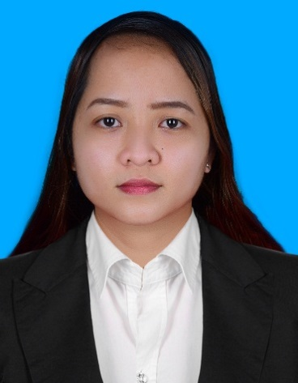

MELAINETTE M. DOJOLES
San Gabriel Subdivision
Barangay Balingasag, Bago City
Negros Occidental, Philippines
Mobile No.:+639616547270
Email Add:ahmber.1990sz@gmail.com

Highly organized and responsible individual with good communication skills and has an experience in ensuring the proper delivery of documents and updating records to show new information.

PERSONAL INFORMATION:

BORN: FEBRUARY 06, 1990 (NEGROS OCCIDENTAL) PHILIPPINES
CITIZENSHIP: FILIPINO
MARITAL STATUS: SINGLE

WORK HISTORY;

November 1, 2017-Sept 23, 2020 - AL SAYER GROUP
FIVE GUYS BURGERS AND FRIES
MUSCAT, OMAN

- Performing essential duties like Inventories and cash handling
- Preparing the tools and equipments and receiving the Orders and handling the customer service.
- Cooperating with the team members with a leadership.

January 19, 2014-Sept 3, 2017 - MCDONALD’S KUWAIT
SERVICE CREW
AL MAOUSHERJI CATERING COMPANY

- Analyzing customer feedback and providing strategic direction to continuously improve overall rating.
- Respond to guest needs and anticipate their unstated ones
- Guest service orientation and drive
- Coordinate and manage communication between guest and staff and follow up to ensure complete service recovery.

Jan 10, 2013- Jan 9, 2014 - COMBINATION WELDER
Machine Shop, Maintenance Department
Universal Robina Corporation
Sonedco Central Sugar Division
Kabankalan City, Neg. Occ.

- Responsible for handling the machines for operation
- Preparing the tools and equipments
- Measuring and preparing the cutting materials
- Ensuring and apply the safety procedures
- Cleaning the workplace

Feb 21, 2012- Jan 1, 2013 - COMBINATION WELDER
Precise Engineering Services
Araneta St., Singcang, Bacolod City

- Manage and operate the machine that manufactures and repairs metal structures, tools and equipments
- Measuring and cutting materials
- Cleaning the workplace

Feb. 16, 2008-Apr. 16, 2011 - Service Screw
Golden Arches Development Corp.
Mcdonalds, 6th Street Lacson,
Bacolod City, Negros Occidental

- Taking the orders and inventories
- Preparing the food and provide the customer service
- Handling the cash policy

EDUCATIONAL BACKGROUND:

VOCATIONAL: (QUEST) Quality Educational Service Training
YEAR GRADUATED: 2011-2012
PROGRAMS: (SMAW) Shielded Metal Arc Welding with NC I
(FCAW) Flux-cored Metal Arc Welding with NC I
(FCAW) Flux-cored Metal Arc Welding with NC II
COLLEGE: Bachelor of Science in Business Administration
MAJOR: Financial Management Accounting
(Under Graduate)
(2009- 2010)

KNOWLEDGE AND SKILLS:

* Documentation management
* Communication
* Efficient
* Exceptional listener and communicator who conveys information verbally and in
writing.
* Resourceful team player who excels at building trusting relationship with
Customers and colleagues.
* Interpersonal skills
* Work Ethic
* Time management
* Analytical Skills

I hereby certify that the above information is true and correct to the best of my knowledge and beliefs.

MELAINETTE M. DOJOLES

