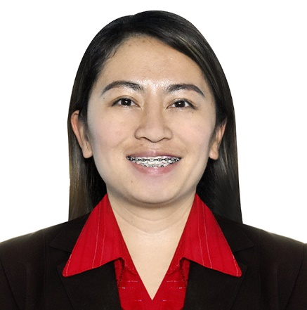
MAVELLE B. ROSALES
Natunuan North, San Pascual, Batangas, Philippines
09171405063
Mavellerosales9@gmail.com
LET Passer April 2010

CAREER OBJECTIVES
To hone my capabilities on becoming an efficient Preschool educator equipped with extensive background in versatile education environment and valuable experiences in classroom administration and professional development; and to contribute immensely to the main goal of Preschool Education of helping children holistic development, academic and social progress during crucial stage of their development.

HIGHLIGHTS OF QUALIFICATIONS
- Can handle students in pre school or primary level
- Hardworking, responsible, trustworthy, compassionate and efficient
- Goal oriented and competent in performing independently or as a member of the team.
- Can communicate in oral and written English proficiently
- Highly motivated to improve skills and competence in teaching

TEACHING EXPERIENCES

Name of School: Natunuan North Elementary School
School Address: Natunuan North, San Pascual Batangas
Position: Teacher II
Ancillary Services: Kid Scout Coordinator, Twinkler Coordinator, School Feeding Coordinator, School Planning Team Member
Subject Taught: All Subjects for Kindergarten
Service Duration: July 15, 2015 up to present

EDUCATIONAL BACKGROUND

Master’s Degree:
Pacific Intercontinental College 2022- Up to Present
Master of Arts in Education
Major in Educational Management

Tertiary:
St. Bridget College 2005-2009
Bachelor of Elementary Education
Major in Preschool Education

Secondary:
Bauan High School 2001-2005

Elementary:
Natunuan North Elementary School 1995-2001

SKILLS
- Computer Processing – Word, PowerPoint, Spreadsheet and Publisher
- Public Speaking
- Making reports and narratives

TRAININGS AND SEMINARS ATTENDED

- Region Wide Training on Early Language , Literacy and Numeracy Program: Professional Development Component
Deped Ed
October 09-16, 2017

- Outdoor Training Course
Girl Scout Of The Philippines
September 29-October 01, 2017

- Technology Integration and Instructional Materials Development/ Preparation in English Language
Online Webinar via Google Classroom
March 19, 2021

- Interactive Instructional Materials
Online Webinar via Google Classroom
March 18, 2021

PERSONAL INFORMATION
Birthday: April 9, 1989
Place of Birth: San Pascual, Batangas
Citizenship: Filipino
Sex: Female
Civil Status: Married
Father’s Name: Virgilio R. Bauan
Mother’s Name: Maria D. Bauan
Permanent Address: Natunuan North, San Pascual Batangas

CHARACTER REFERENCES
Mr. Christopher A. Dalisay
Principal II
Natunuan North Elementary School
0968 497 1964

Mrs. Felicisima D. Cueto
Guidance Counselor
Natunuan North Elementary School
0948 949 6929

I hereby certify that the above information is true and correct to the best knowledge and belief.
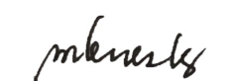
MAVELLE B. ROSALES
Applicant

