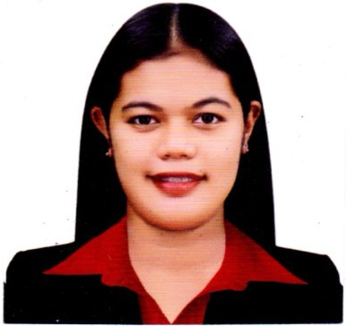

LYRA MAE RODRIGUEZ REBOLLEDO
Blk 19 Lot 12 Ph4 Golden City Salawag
Dasmarinas, Cavite.
09105092319
lyramaerebolledo@yahoo.com

CAREER OBJECTIVE:
To obtain a position that will enable for me to use my skills and ability to work well with people, to continuously enhance my knowledge and have a good life opportunity where I can start to build a better foundation for my future.

I-EDUCATIONAL BACKGROUND

Tertiary
2012-2017 STI College Dasmarinas Bachelor of Science and Business Management
Major in Operation Management

Highschool
2008-2007 Paliparan National Highschool

II- WORK EXPERIENCE

Position: Service Crew
RSA Food Service, Mc Donald’s SM Dasmarinas
Feb 11, 2016 – March 1, 2017

Duties and Responsibilities
- Responsible for providing courteous and efficient food and beverage services to the guest.
- Greet customers, settle them down and take order.
- Process the order, generate bills and answer guest queries about deal offers and service time.
- To perform general housekeeping and cleaning duties, including sweeping, mopping, cleaning glasses, furniture & fitting, laying of tables and up-keeping of rest room etc.

Continued…
Lyra Mae Rodriguez,
page 2

Position: Assistant Department Manager
Isabel Kristin Food Service, Mc Donald’s Nueno
March 16, 2017- November 7, 2022

Duties and Responsibilities
- To manage people, product and equipment
- Delivering outstanding QSC&V (Quality, Service, Cleanliness and Value)
- Plan and work to budgets, maximise profits and achieve sales targets.
- Prepare reports and other performance analysis documentation
- Train and develop new staff and existing staff.

Position: Assistant Branch Manager
Merrymart Grocery Centers Inc
May 8, 2023 up to present

Duties and Responsibilities
- Supervising Employees
- In-charge on daily stores sales
- Sending store reports
- Engaged with customers in a sincere and friendly manners
- Assigned employees to specific duties to best meet the need of store.

III- SEMINAR ATTENDED

“People Development Management”
Held Carlos Palanca, Makati City
August 19 - 21 2019

“Customer Experience and Food Quality Management”
Held Carlos Palanca, Makati City
April 1 - 5 2019

Continued…
Lyra Mae Rebolledo
page 3

IV- PERSONAL BACKGROUND

Language Background : English
: Tagalog

Computer Skills : Skilled in Major relevant computer applications like MS Word,
MS Excel and MS PowerPoint.

V- CHARACTER REFERENCES

I hereby certify that the above information is true and correct.

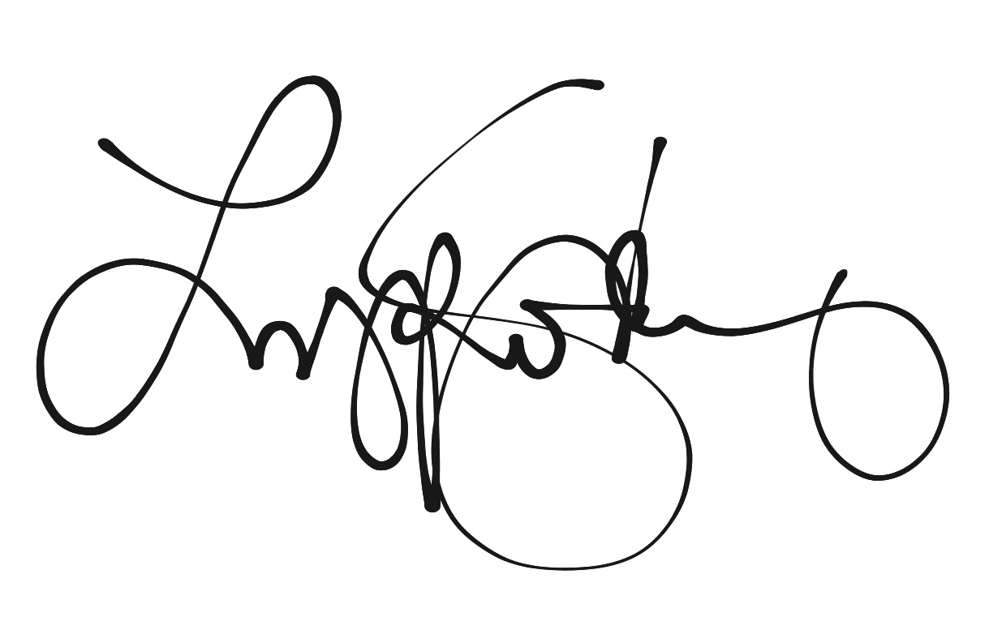

Applicant’s Signature

