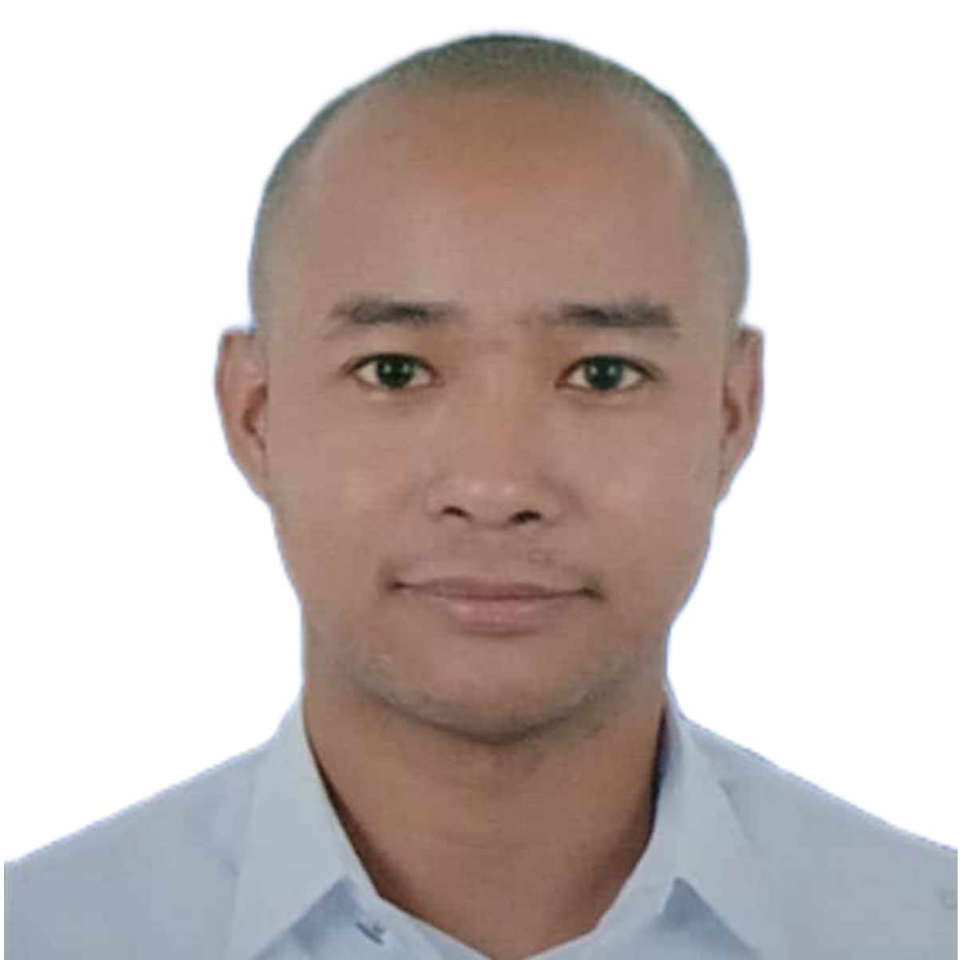 |  | LEVIN m. ARANDA  Senior Customer Associate
Profile  I am eager to learn, reliable, self-motivated and hardworking person. Working at LANDBANK for 22 years have molded me to become diligent. capable, and resilient. My integrity and honesty are what make me aligned with my personal and work values.  Contact  PHONE:  09173614446  EMAIL:  onzearanda@gmail.com  Hobbies  Riding a motorcycle  Listening to audiobook  Reading online books  Playing basketball  Bicycling  Jogging |  | EDUCATION  Philippine Christian University  2023- present  Master of Business Administration  San Beda College - Manila  1996 – 2000  Bachelor of Science in Accountancy  WORK EXPERIENCE  Landbank of the Philippines  Landbank Plaza, 1598 MH Del Pilar cor. J. Quintos Sts. Malate, Manila  2002- present  Presently, I am a Senior Customer Associate – New Accounts Clerk at East Ave Branch. I have handled various positions such as Clearing Assistant, Loan Bookkeeper, CASA Bookkeeper, Tellering and Cashiering functions.  SKILLS  Basic motorcycle troubleshooting  Computer literate  Book keeping  Accounting  Typing

