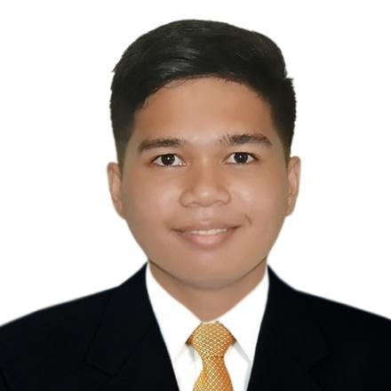
MAGAHIS, JOHN PATRICK E.
005 Roadside Cayponce, Balayan, Batangas
0919-232-3736
JohnPatMagahis@gmail.com

________________________________________________________________________________________________________________________________________________________________________________________________________________________________________________________________________________________________________________________

CAREER OBJECTIVE:
I am looking for a suitable job opportunity where I could practice my knowledge and career and develop my personality as a career person while utilizing my skills. In return, I offer my service and determination to be an asset to your company throughout the duration of my employment period.

WORK EXPERIENCE:
November 2017 – March 2018
On-The-Job Training
DENR-RIV-A-Community & Environment and Natural Resources Office (CENRO)
- Updating: records/documents/receipts.
- Generating/facilitating transaction documents.
- Assisting clients in their transactions.
- Encoding: records and documents.

May 2018 – March 2024
NOC Network Monitoring L1
Royal Cablevision Corporation
- Deploying and inspecting IT network systems.
- Monitoring the performance and capacity of computer systems.
- Performing regular checks on network hardware and software.
- Responding to network alerts and hardware malfunctions.
- Diagnosing and troubleshooting network errors.
- Tracking and documenting network issues and compiling incident reports.
- Ensuring all support requests are up to date and in hand at the end of each shift, handing over any outstanding issues to shift staff.

EDUCATIONAL BACKGROUND:
Secondary : Balayan National High School
103 Paz St., Balayan, Batangas
2010 – 2014

Tertiary : Bachelor of Science in Information Technology
STI College Balayan
PED Plaza Business Center, Ermita, Balayan, Batangas
2014 - 2018

PERSONAL INFORMATION
Birthday : December 23, 1997
Age : 20 yrs. old
Gender : Male
Marital Status : Single
Language Spoken : English and Filipino
Religion : Roman Catholic
Height : 5’3”

SKILLS:
- Knowledgeable in computer networking.
- Knowledgeable in database manipulation and connection using Microsoft SQL Server.
- Knowledgeable in web designing (HTML, PHP, CSS, JAVASCRIPT).
- Knowledgeable in programming using java and C#.
- Knowledgeable on basic OOP.
- Knowledgeable on SDLC.
- Knowledgeable on IP and network protocols (TCP/IP).
- Knowledgeable in maintenance and management of Linux based servers.

RESEARCH PAPERS/PROJECTS PREPARED:
- February 2015 - Grading System for Primary Schools (C#)
- October 2016 - HISTORIANS QUEST: An Educational Game in Philippine History (C#)
- October 2017 - 2018 - ROBO-QUATION: An Educational Game for The Grade 7 Students of Pedro A. Paterno National High School (C#).
- August 2019 to present - LibreNMS (Linux-based network infrastructure monitoring tool)

SEMINARS/TRAININGS ATTENDED:
- February 3, 2015
- 20th STI National Youth Convention (Aliw Theater, Pasay City, Philippines)

- November 15 to 16, 2018
- Philippine Cable Television Association INC. (Microtel Inn and Suites, FPIP Sto. Tomas, Batangas

- July 14 - 15, 2022
- PhNOG 2022 Hybrid – RPKI, BGP Security, DNSSEC and DNS Privacy Workshop (New World Hotel, Makati City, Philippines)

CHARACTER REFERENCES:
- Mrs. Richelle Q. Abiad
Program Head (BSIT)/ IT Instructor
STI College Balayan
0975-794-9119

- Ms. Maria Teresa J. Olea
IT Instructor
STI College Balayan
0995-623-6265

I hereby certify that the following information are true and correct to the best of my knowledge and belief.



___________________________
JOHN PATRICK E. MAGAHIS
APPLICANT

