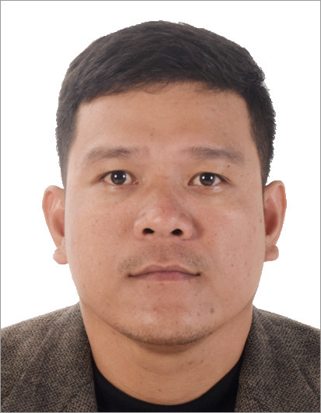
John Fritz Camay
Address: 115-1 Bowers St. NE, Airdrie, AB, T4B OR4
Phone: 403-990-7947
Email: johnfritzcamay@gmail.com
Skype ID: live:.cid.46d115a4baa5c474
Marital Status: Married
Number of Children: 0
Ages of Children: N/A
Birthdate: October 9, 1995

____________________________________________________________________________

POSITION SOUGHT

Dedicated and results-oriented cashier and marketing associate seeking to leverage my proven track record of accurate cash handling and exceptional customer service skills to contribute to a vibrant team in the retail or hospitality sector in Canada.

SUMMARY OF QUALIFICATIONS

- Over 7 years of experience in cash handling and maintaining accuracy in transactions.
- Over 3 years of experience in food handling and preparation.
- Strong background in customer service.
- Proven skills in marketing.
- Demonstrated ability to drive sales growth and promotional strategies.
- Professional communication skills include fluency in English and Tagalog.

____________________________________________________________________________

WORK HISTORY

Cashier and Marketing Associate 08-2016 to Present
Eight Under Par (Palawan Pawnshop)
Cebu, Philippines

- Managed cash transactions accurately for various services, ensuring compliance with company policies.
- Maintained meticulous records of transactions and inventory.
- Promoted additional services to customers, such as loyalty cards and insurance.
- Provided exceptional customer service, resolving inquiries and issues promptly and professionally.

Part-Time Cook 10-2012 to 07-2016
Chowking
Cebu, Philippines

- Prepared ingredients and cooked dishes according to established recipes and quality standards.
- Followed food safety regulations to ensure food freshness and minimize waste.
- Collaborated with kitchen team members to streamline operations and maintain efficiency.
- Assisted with inventory management and kitchen organization tasks.
- Demonstrated reliability and punctuality by consistently showing up for scheduled shifts.

____________________________________________________________________________

EDUCATION HISTORY

Bachelor of Science in Accounting Technology 2012-2016
Cebu Roosevelt Memorial Colleges, Cebu, Philippines

____________________________________________________________________________

CERTIFICATIONS AND TRAININGS

Basic Pawnshop Operations- Level 1 06-2016
PPS Academy, Philippines

Basic Pawnshop Operations- Level 2 08-2016
PPS Academy, Philippines

Basic Jewelry Appraising 11-2016
PPS Academy, Philippines

Basic Money Changing 06-2017
PPS Academy, Philippines

Basic Occupational Safety and Health Standards Training 04-2021
COSHEMAP Academy of Safety and Technology, Philippines

Recognition in Performing On-Ground Marketing Activity 11-2022
Palawan Pawnshop, Philippines

____________________________________________________________________________

REFERENCES

Mario Gera
63975-221-2956

Francis Joseph Tenorio
780-204-2552

Rowen Yhapon
63956-147-5828

