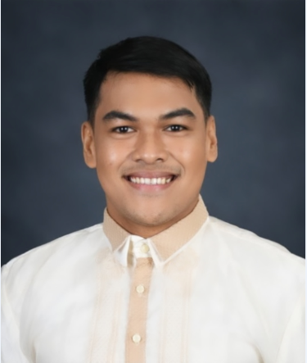


CONTACT:
Blk. 4 Lot 5 Sampaguita St., Brgy., Salinas II, Camella Homes, Bacoor City, Cavite, 4102
+63 926 646 8803
vistajhorell21@gmail.com
PERSONAL DATA:
Age: 26 years old
Date of Birth: February 21, 1997
Civil Status: Single
Height: 5’11”
Citizenship: Filipino
SKILLS:

- Performs collection of blood samples
- Performs collection of nasopharyngeal and oropharyngeal Covid-19 RT PCR swab testing
- Operates machines in clinical chemistry and hematology
- Analyzes different body fluids under microscope
- Strong analytical and documentation skills
- Broad knowledge of basic chemistry techniques
- Exceptional organizational skills and attention to detail
- Ability to properly clean and maintain equipment
- Willingness to work in a team

Jhorell Quierrez Vista
OBJECTIVES: To work towards achieving the greater success in my career through hard work, consistency, accurate, reliable, diligent and focused on the timely, quality completion of all laboratory procedures. Work well under pressure and time constraints within high-volume environments.
PROFESSIONAL EXPERIENCE:
- Accenture Philippines
11th Drive, Uptown Bonifacio, Taguig City
Position: Health Clinical Services Analyst (QDS)
Date Hired: December 08, 2023 to present
- Southern Tagalog Regional Hospital
Barangay Habay 2, Bacoor City, Cavite
Position: Laboratory Technician II
Date Hired: May 17, 2023 to December 08, 2023
- Hi-Precision Diagnostic
Lot 2, D1 to 3, Alabang-Zapote rd., Las Piñas City
Position: Junior Customer Care Phlebotomist
Date Hired: September 22, 2022 – May 15, 2023
- Paredes Medical Center and Hospital
MI Paredes Bldg., Aguinaldo Highway, Bayan Luma 4, Imus City, Cavite
Position: Laboratory Technician
Date Hired: February 01, 2021 – May 14, 2022
MEDICAL TECHNOLOGY INTERNSHIP:
Victor R. Potenciano Medical Center
163 Epifanio de los Santos Ave, Mandaluyong, 1501, Metro Manila, Philippines
EDUCATIONAL BACKGROUND:
TERTIARY: Bachelor of Science in Medical Technology (Underboard)
- Our Lady of Guadalupe Colleges, SY: 2018 – 2020
- Our Lady of Fatima University, SY:2017 – 2018
- Centro Escolar University, SY: 2014 – 2017
SEMINARS AND TRAININGS:
- Quality Documentation Specialist (December 2023)
- Standard Precautions: Waste Management (May 2020)
- Covid-19: Tackling The novel Coronavirus (May 2020)
- Issue in Vaccine Development for Coronavirus (May 2020)
- Phlebotomy Training Program (October 2023)
- Bloodborne Pathogen (October 2023)

CHARACTER REFERENCE:
Available upon request.

