  Jennifer Hernandez Laberon |  |  |  |  |  | Objective:
 |  |  |  |  |  | To secure a position in your firm that offer growth, self-development and carrier opportunity that would continually challenge me to strive for excellence and contribute to its success.
Experience |  | Quality Assurance Technician Asurion Techlog Center Philippines- August 2022 - Current  - Executes and maintains containment action on internal/external quality issues.  - Verifies implementation of corrective action and validates effectiveness.  - Performs defect verification activities triggered by internal.  - Conducts inline sampling radiographic inspection, content validation, and other QA testing.  - Supports senior technician in qualification audits for product and parts.  - Collects samples for failure analysis from various parts and product range to perform technical, product / parts and statistical analysis.  - Assist and Support Quality Engineer on problem resolution both internal and/or external quality issues.  - Performs other related duties as maybe required.  Senior Technical Inspector Asurion Techlog Center Philippines- March 2019 – September 2022  - Updates Material Review Board Database and Quarantine database  - Generate Material Review Board Report  - Daily Material Review Board Cost and Quarantine updates  - Encode to Material Review Board tracker for every issue discuss in Material Review Board meeting.  - Monitor all action to be taken in every issue discussed during Material Review Board meeting.  - Facilitate Weekly Inventory of Material Review Board and Quarantine parts.  - Minutes taker for urgent and regular Material Review Board meeting  - Ensure quality of major parts is prioritized through following stipulated procedures.  - Contributes to solving problems on her function through recommendation and suggestion.  - Performs generation, revision, and processing of IPC related document.  - Performs internal audit, provides internal audit result, and update internal audit Calendar.  - Conduct periodic review of existing document for possible revision or update.  - Provide monthly documentation report. Support on conducting awareness/ training of approved documents.  QA Inspector Asurion Techlog Center Philippines- August 2010 - March 2019  - Performing visual and functional test of phone manufactured in TCP/ TRC to ensure the product or service meet client criteria,  - create and follow the goals to achieve high standard.  - Reassure the quality and service are legally compliant.
Education  June 2007 - May 2009  Industrial Electronic Technology- 2YRS  Laguna Science and Technology College |  |  |  | Skills  - Microsoft excel  - Problem Solving/ Decision Making  - Communication  - Core: Customer satisfaction, Teamwork,  - Technical: Knowledge in handling some electronic devices such as TESTER (VOM), Breadboard & Soldering.  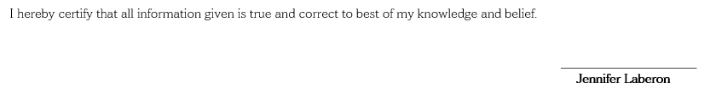 |  |  |  | Interests  Volunteering and giving back to the community. |  |  | Contact  B13L23 Phase 1 Sampaloc St. South Fairway HMS. Landayan, San Pedro, Laguna  +639757202474  jenniferlaberon07@gmail.com

