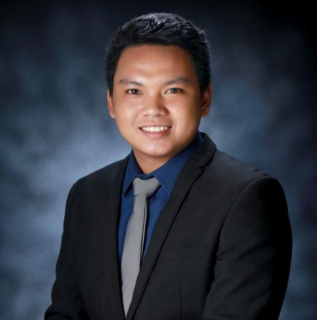
JOHN DERICK V. CAJALA, ECT
Punit, Benito Soliven, Isabela
09552982322 / 09104814143
E-mail address: cajalajohnderick@gmail.com

OBJECTIVE

A CSC-PPT(Professional) Passer. Seeking a position where I can apply my abilities related to my degree and work experiences, and to contribute in the Agency’s development and succes in accordance to their Core Values and Objectives.

EDUCATIONAL BACKGROUND

Tertiary : University of Saint Louis Tuguegarao
Tuguegarao City, Cagayan
Course : Bachelor of Science in Electronics Engineering (BSECE)
Major in Electronics Communication
2014-2019

Secondary : Reina Mercedes Vocational and Industrial School
Reina Mercedes, Isabela
2010 – 2014

Elementary : Benito Soliven Central School
District 2 Benito Soliven, Isabela
2004-2010
Personal Qualities
•Flexible with shifting schedules
•Can work efficiently for long hours of duty
•Productive in high volume, high stress environment
•Interact with co-workers and other people in an efficient and friendly manner
•Goal oriented
•Assertive and willing to learn
•Can work under minimum supervision
•Hard working and honest

Work Experience

Network Engineer 2
June 2023 - Present
Converge ICT Solutions Inc.
Cauayan City, Isabela

Network Engineer 1
August 2021 – June 2023
Converge ICT Solutions Inc.
Cauayan City, Isabela

Boiler Control Room Operator
May 2020 - July 2021
Green Future Innovation Inc.
Sta. Filomena, San Mariano Isabela

RBC Master Cable System Trainee
July 2018
Tuguegarao City, Cagayan

Seminars Attended
Anti - Bribery and Anti – Corruption Policy Training 2023
DATA Privacy Annual Training, Confirmation and
Assessment 2023
Seminar Networking Engineering 2016
Regional Electronics Engineering Convention 2017
The Z-zoned 2018

PERSONAL DATA

Gender : Male
Age : 25
Date of birth : June 8, 1998
Place of birth : Benito Soliven, Isabela
Citizenship : Filipino
Civil Status : Single
Height : 5’11”
Weight : 90 Kgs.
Religion : Roman Catholic
Language : Tagalog, Ilocano, English

CHARACTER REFERENCE

Engr. Recto Z. Valdoz Jr. Joseph Harvey Yap Alex Angco Monforte
0920-595-242 09477543054 09459721975
Boiler Supervisor Network Engineer Network Engineer

