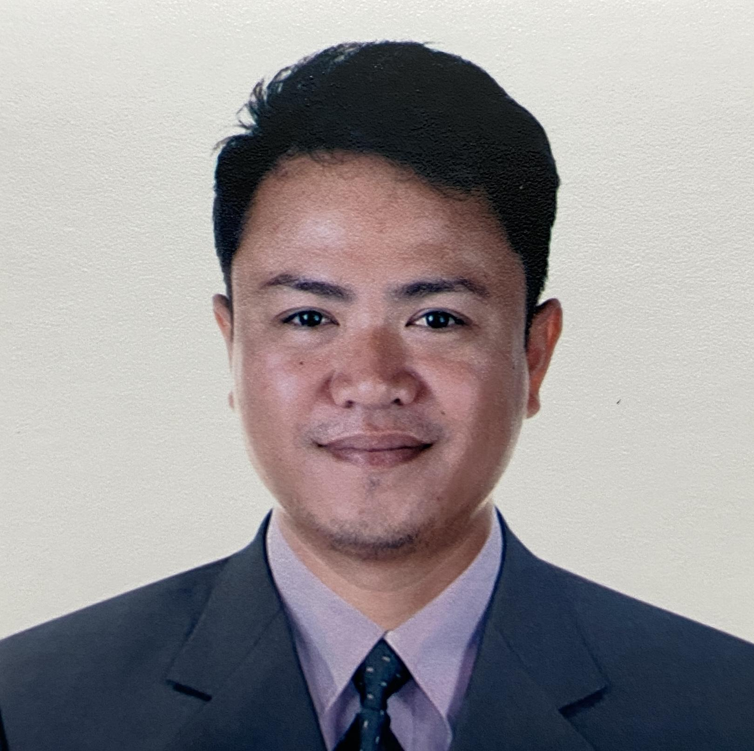
Ferrer, Johmer D.
Purok 4 Sevilla Center City Of San Fernando La Union
Johmerferre33@gmail.com
+63947-210-9570

Objective
To work in a challenging environment demanding all my skills and efforts to explore and adapt myself in different fields and realise my potential where I get the opportunity for continuous learning new programs and ability to establish strong productive relationships with the other company members and bring my passion to further the mission of the company.

PERSONAL DETAILS
Date of Birth : January 3,1992
Nationality : Filipino
Gender : Male
Marital Status : Married
Height : 157 cm
Weight : 60 kg
Language Known : English,Filipino,Ilocano

Soft Skills:
- Interpersonal skills
- Ability to work in a team environment
- Negotiation
- Communication
- Problem-solving

Hard Skills:
- Blueprint reading
- Cut materials
- Construction materials knowledge
- Safety compliance knowledge

EMPLOYMENT HISTORY
Construction
Construction Worker/ Welder / Electrician
2010-2024
- Reading blueprints and other engineering and architectural documents
- Installing foundations and other structural components
- Installing electrical and plumbing systems
- Applying drywall and other finishing materials
- Painting and decorating surfaces
- Assisted the team to achieve the daily construction targets
- Involved in steel fabrication, framing and roof installation
- Assisted loading and unloading operations under supervisory instructions
- Spreaded concrete for 100 cubic meters slab with other construction workers
- Hands-on experience working with multiple power tools such as drills, power saws, breakers, and grinders
- Has extensive training in electrical wiring and welding.
- Performed minor repairs and maintenance on construction equipment.
- Managed the daily activities of construction worker and ensured completion of projects on schedule.
- Cleaning the construction sites

Educational Attainment

VOCATIONAL EDUCATION:
Electrical Installation and Maintenance
Manantan Technical School
Urdaneta City, Pangasinan
2021-2022

Shielded Metal Arc Welding SMAW
TESDA Region I
City of San Fernando, La Union
2022

BACHELOR’S DEGREE:
Electromechanical Technology
Don Mariano Marcos Memorial State University
Mid-La Union Campus, Catbangen, City of San Fernando, La Union
2018-2021
SECONDARY :
La Union National High School
Catbangen, City of San Fernando, La Union
2008-2011
PRIMARY :
Sevilla Elementary School
Sevilla Purok 3, City of San Fernando, La Union
2003-2008

CERTIFICATION AND TRAINING

- Shielded Metal Arc Welding National Certificate SMAW NCIl
TESDA Region I, City of San Fernando, La Union,2022
- Electrical Installation and Maintenance National Certificate EIM NCII
TESDA Region I , Lingayen, Pangasinan 2021-2022
- Practical Driving Course Driving NC II
RJ Ilocandia Technical And Vocational School

CHARACTER REFERENCES

Eng. Jeff Millares Ferrer
Engineering Construction Development incorporated
Civil Engineer
+63906 3291 351

Mr. Carreon, Jerry
Electro-Mechanical Technology Professor
Class Advisory
+63947-162-2529

I hereby certify that the above-mentioned information is true and correct on behalf of my knowledge in beliefs.

JOHMER D. FERRER
APPLICANT

