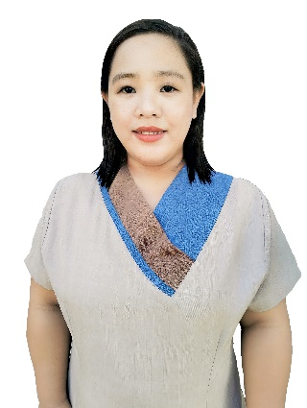
JING JING PADAY-OS KIWAS

Naguirangan Road, Poblacion, San Gabriel, La Union, Region I, Philippines
Contact No.: 09669177898
Email Address: jing28padayos@gmail.com

OBJECTIVE:
To work in Saskatchewan, Moose Jaw, Canada as an Early Childhood Educator and Assistant and to share my knowledge and skills that will contribute to the growth and development of the school that I will be joining.

S K I L L S:
- Computer Literate
- Teaching
- Good Communication and Writing Skills
S T R E N G T H S:
- Highly Motivated
- Active and knows how to socialize with others
- Flexible
- Willing to learn new things for personal improvement
- Can take initiative to find extra tasks when scheduled duties are completed

E D U C A T I O N:
Institution: OSIAS Educational Foundation
Major: Masters of Arts in Education

Institution: University of Baguio
Major: Bachelor in Elementary Education- General Education

Institution: Saint Mary’s School of Sagada
Major: High School

Institution: Bagnen Oriente Elementary School
Major: Primary

P E R S O N A L D E T A I L S:

Date of Birth: November 28, 1993
Gender: Female
Marital Status: Married
Nationality: Filipino
Languages Known: English, Tagalog, Ilokano

R E F E R E N C E S:

Ms. BRENDA A. BACASEN Mrs. Ailyn L. Camiňo
School Head Teacher III
Contact No.: 09274589521 Contact No.: 09171238892

