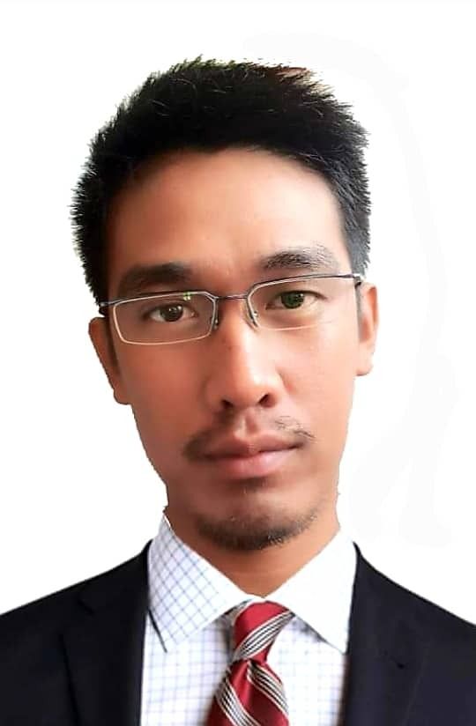
Jay-ar Valenzuela
valenzuela.jayar.v@gmail.com
+63 9667717921
Summary Dynamic and creative engineer with over 12 years’ hands-on experience in overseeing all aspects of civil infrastructural engineering projects from inception to completion. Adept at leveraging expertise in process optimization and project management to facilitate safe and cost-effective operations.
Career history Civil Engineer / Manager / Cosultant / Supervisor at JVVBuilder's
Feb 2021 - Present (3 years 1 month)
My first own construction business scope of works , Design & Build
Cost Estimate
Estimate of Materials
Workflow Scheduling
Rebar Estimates / BBS
Cutting List
AutoCAD Set of Plans
Rendering
Structural
Plumbing
Architectural / Finishing
Safety Management
Environmental Protection
Rebar engineer at ASIAPRO MULTI-PURPOSE COOPERATIVE
Mar 2019 - Mar 2020 (1 year 1 month)
Preparation of billing / man hour monitoring during installation and supervision of quality on site inspection / walkthrough oriented / site inspection for rebar quantification actual vs installed managing inventory of scraps ( rebars that are scaling / rebars that can be used on site ( managing the fabrication if the cutters and benders are in good condition
Field Engineer II at Makati Development Corporation
Feb 2017 - Feb 2019 (2 years 1 month)
Technical, Oriented on site supervisions quality assurance / cleanliness of each aspect for better workplace / ehs oriented / concreting / formworks/ rebar
Land Development at Makati Development Corporation
Feb 2017 - Feb 2019 (2 years 1 month)
Technical, Soil testing / equipment and man power oriented on site supervision / esh oriented / cleanliness of working area
Form works / concreting / rebar related / schedule monitoring / site supervisions
Project Engineer at ETS Construction & Supplies
Mar 2014 - Feb 2016 (2 years)
Technical, Critical thinking & interpersonal skill relevant to area in order to communicate effectively with Engineers, Head Supervisor, and Construction team members.
Autocad Operator at Juan Engineering Construction and Services
Jun 2012 - Jul 2012 (2 months)
Technical, Software / hardware oriented / 2D plot / 3D plot / Lumion software rendering / sketchup plotting / microsoft programs ( excell / word / powerpoint )
Skills AutoCAD 2D/3D, Rebar Engineer, Formworks Engineer, Concreting Engineer, Land Devt. Engineer, Sketchup Pro, Lumion, D5 RENDER
Languages English, Filipino
Education Bachelor of Engineering (Civil) from Panpacific University North Philippines
Finished 2013

