JAY ALLAN Z. SUNGUAD II
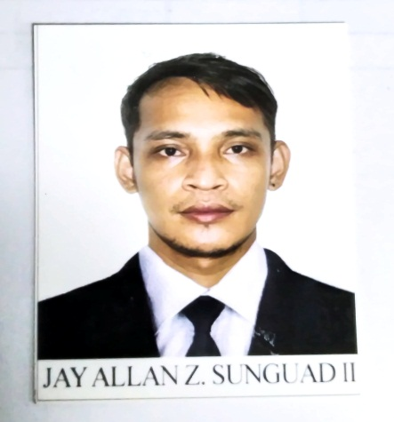
ADDRESS
3rd fl. 523 Katrina bldg. Corner B.Francisco Brgy. New Zaniga, Mandaluyong City

TELEPHONE
+639567600922

EMAIL
sunguadiijay@gmail.com

DATE OF BIRTH
June 10, 1991

NATIONALITY
Filipino

CIVIL STATUS
Single

SKILLS
Welding
Driving

REFERENCES

Ranicca Jane Santos
JCD HR Head Department
09507911677

Jhonamel S. Concepcion
Team Leader – JCD Infosearch
09612098581
SUMMARY OF STATEMENT
A hardworking individual with excellent skill in operating machine and able to train others. Get along well with people, work well under pressure, honest, trustworthy, efficient and reliable with good communication skill.

WORK EXPERIENCE

Messenger/Liaison
JCD INFOSEARCH & GEN SERVICE
Aprl 2021-Present

WELDER
GMA Kamuning Quezon City
Steel Welder
2015 - 2021

DRIVER
JC4 Enterprise
June 2021 – 2022

EDUCATION

SUPANG – DATAG NATIONAL HIGH SCHOOL
Datag Caramoran Catanduanes
SY 2013-2014

Supang Elementary School
Supang Caramoran Catanduanes
SY 2010-2011

TRAININGS AND SEMINARS ATTENDED
SHEILD METAL ARC WEILDINF (SMAW) NCII
Saint Peter Velle Technical Trainig Center
May 3, 2021 – July 2, 2021

