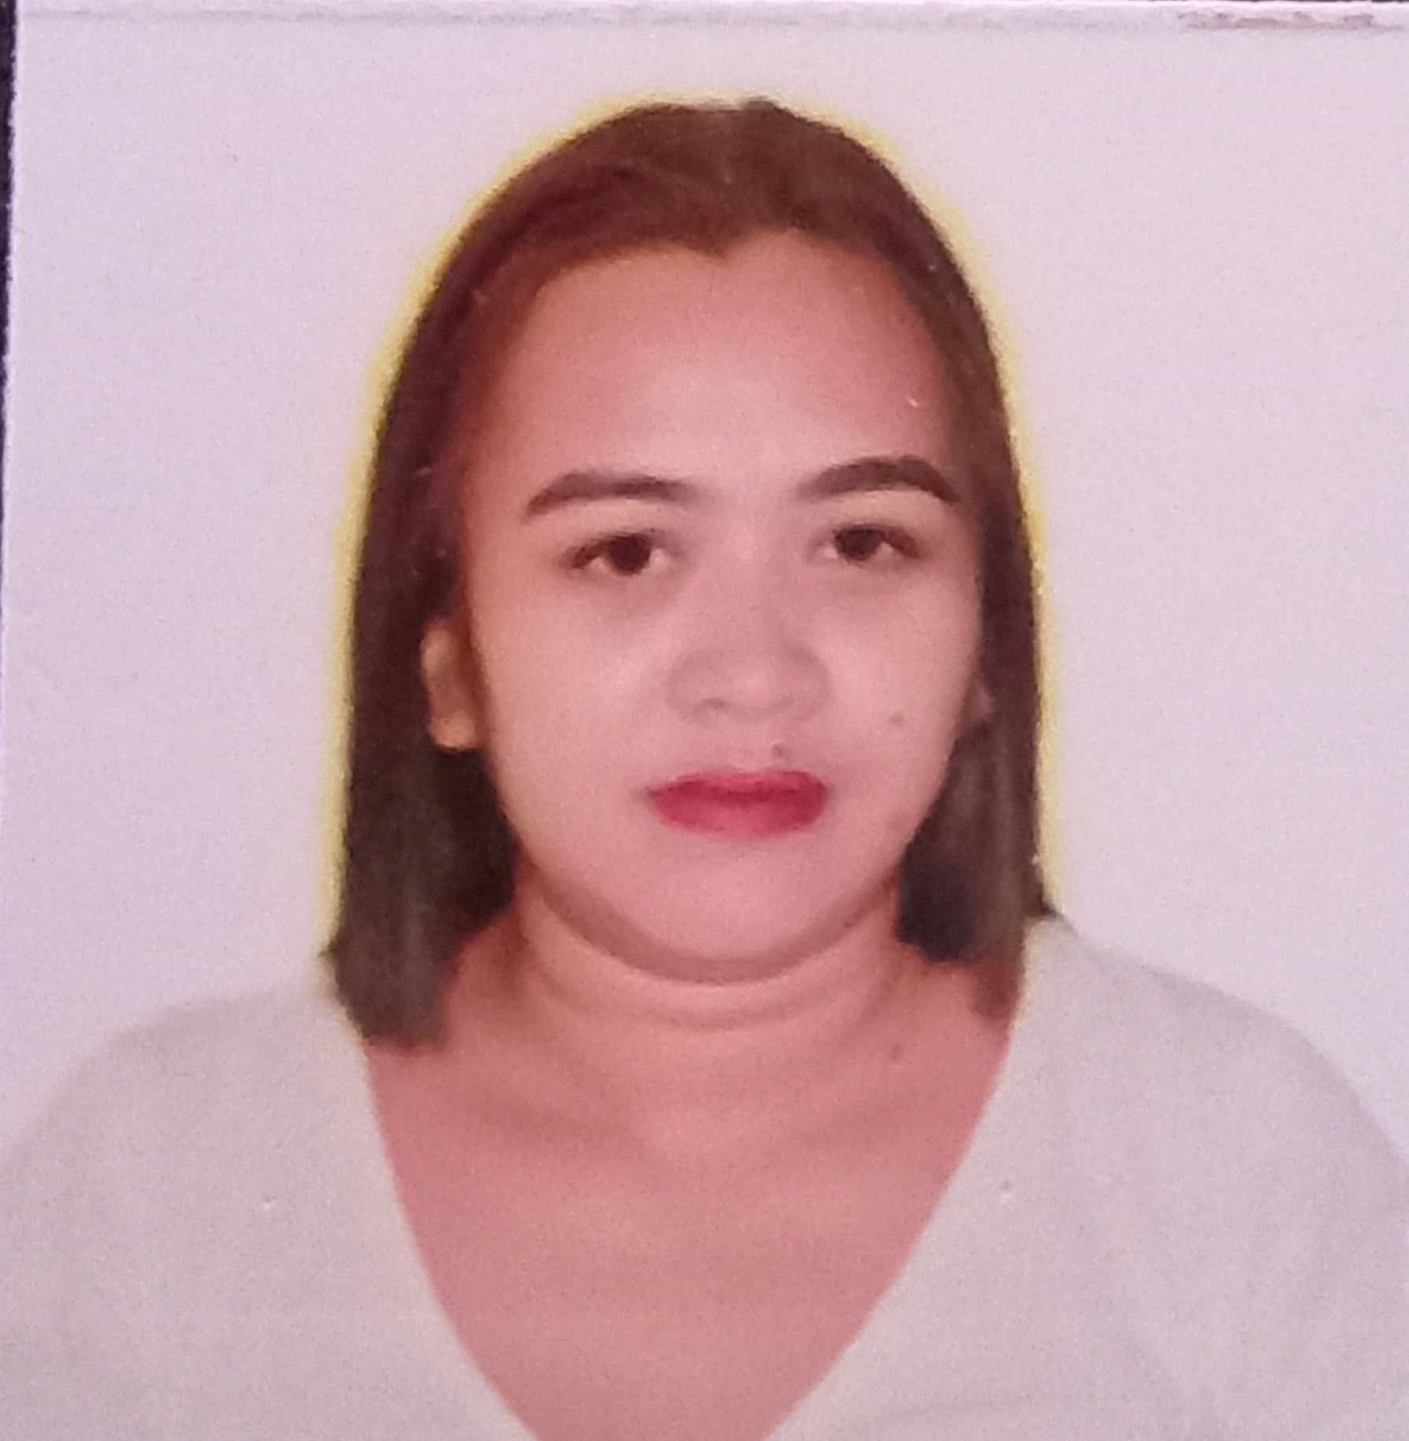
JANIESA E. SUMALINOG
Zone 7 Block 1 , Kabina BonBon
9000, CDO, Philippines
Cellphone Number: 09261495235
Email address: jjaniesa@yahoo.com

Personal Background:

Age 32
Sex Female
Nickname Jan/Janice
Birthday September 28, 1991
Nationality Filipino
Civil Status Single

OBJECTIVES:

>To apply to any position that fit my qualifications
>To apply what I have learn in my course

PERSONAL INFORMATION:

Date of Birth: September 28, 1991
Place of Birth: Sominot Zamboanga Del Sur
Gender: Female
Age: 32 years old
Citizenship: Filipino
Religion: Roman Catholic
Civil Status: Single
Weight: 69 kg
Height: 5’2”
Father’s Name: Bernicito J. Sumalinog
Mother’s Name: Mary Jane E. Sumalinog

QUALIFICATION:

> Dedicated and hardworking individual
>Determination and willingness to be trained
>Acquire the ability to communicate and entertain people
>Ability to do and accomplish the said tasks

SKILLS:

>Computer literate
>Expert listening skills and meticulous attention to details

EDUCATIONAL BACKGROUND:
Tertiary Education: Liceo de Cagayan university
2010-2011
Misamis university, ozamis city
2008-2009
Secondary Education: Poblacion Sominot National High School,
Poblacion Sominot, Zamboanga del Sur
2004-2008

Primary Education: Poblacion Sominot Central Elementary School
Poblacion Sominot Zamboanga del Sur
1998-2004

Work Experience:

March 15, 2014 – May 10, 2016 – Montery meatshop
Customer Service/ cashier/ MEAT CUTTER

July 3, 2018 – March 1, 2020- City Lodge
Customer service/ cashier

November 2, 2020 – November 15, 2023 – Teleperformance
Customer service representatives/ Billing/ troubleshooting/ account/
apps troubleshooting

COLD CALLER (REAL ESTATE)
FLORIDA
NOVEMBER 20, 2023- JANUARY 15, 2024

CHARACTER REFERENCE:
ANGELIE PIAÑER
Teleperformance
Supervisor
09261781160

