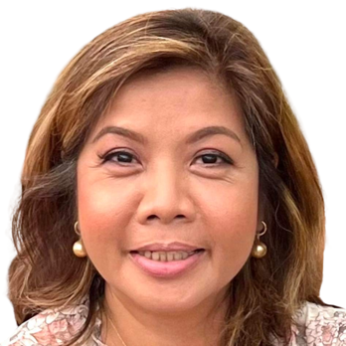
IMELDA RAMIREZ
Quezon City, Philippines 1105
+369604642147
imeldaramirez@myyahoo.com

———————————————— SUMMARY ————————————————

Motivated Dentist with 30+years of progressive experience. Energetic self-starter and team builder. Navigates high-stress situations and achieves goals on time and under budget.

——————————————— EXPERIENCE ———————————————

SINGLE PROPRIETOR
Quezon City, Philippines

General Dentist 01/1990 to Current
- ﻿﻿Maintained up-to-date skills through regular performance of advanced modern dentistry.
- ﻿﻿Worked sympathetically with clients to formulate well-suited treatment plans.
- ﻿﻿Proficiently performed all phases of dentistry within a busy team practice.
Used excellent communication skills to network with other professional and practices, to increase referrals and grow business.
- ﻿﻿Performed root canals, surgical extractions and filled cavities for patients and supervised pain management.
- ﻿﻿Treated infections caused by chronic and acute diseases and diseases within soft oral tissues.
- ﻿﻿Promoted oral health care and disease prevention by educating patients on proper oral hygiene.
Monitored growth and development of teeth and jaws.
- ﻿﻿Collected information from parents and guardians about dental care and issues of concern.
- ﻿Supervised dental assistants during procedures to guarantee high quality patient care.
Provided emergency dental treatment when needed to manage pain and reduce further complications.
Built loyal patient list and established rapport to boost patient retention.
- Prepared comprehensive treatment plans tailored to individual patient needs.
- ﻿﻿Adhered to appointment schedule to avoid delays and keep patients happy.
- ﻿﻿Captured and interpreted radiographs for further investigations, providing patients with accurate and personalised care plans.
- ﻿﻿Obtained consent from patients prior to starting treatment, adhering to practice guidelines and policies.
Carried out preventative, general and cosmetic dentistry services to provide surgery patients with comprehensive dental services.
- ﻿﻿Advised on and performed tooth extraction procedures and offered alternative treatment to patients where possible.
- ﻿﻿Diagnosed tooth infections and gum disease to provide patients with appropriate treatment plans.
- ﻿﻿Treated patients with empathy, offering reassurance to minimise anxieties and enhance patient experience.
Maintained required professional registration and insurance and regularly participated in further training.
- ﻿﻿Administered anesthetic proficiently with all client groups, including phobic clients.

———————————————— SKILLS —————————————————

- Team-focused
- ﻿﻿Client rapport
- ﻿﻿Placing crowns
- Tooth defect repair
Teeth cleaning
Instrument handling
- ﻿﻿Patient examinations
- ﻿﻿Root canal procedures
- ﻿﻿Pain management
- ﻿﻿Bleaching agent application
- ﻿﻿Dental radiographs mounting

——————————————— EDUCATION ————————————————

DOCTOR OF MEDICINE: DENTAL MEDICINE 06/1983 to 03/1989
Manila Central University, Manila, Philippines

