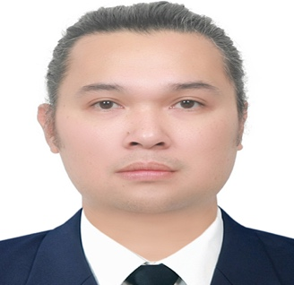
HEWLETTE CRISTIAN MENDOZA
hewlette_mendoza@yahoo.com / +8210 5115-6514
Youngnam Theological University and Seminary

Objective:
I am seeking opportunities to join a company that can help me in enhancing my skills, strengthening my knowledge, and realizing my potential. I am looking for opportunities to incorporate my skills and training to help the company grow. I am looking forward to roles that will help me realize my potential by exploring the various aspects of this field that can help me gain perspective.

Education:
• Tertiary
Bachelor of Science in Social Welfare
Youngnam Theological University and Seminary
26 bonghoe 1-gil, jillyang eup, Gyeongsan-si Gyeongsanbuk-do
March 2018 –June 2023

• Korean Language course
Youngnam Theological University and Seminary
26 bonghoe 1-gil, jillyang eup, Gyeongsan-si Gyeongsanbuk-do
March 2016 – December 2017

• University of Perpetual Help System, Biñan, Laguna
Undergraduate of Bachelor of Science in Electronics and Communications Engineering
2003 – 2005

Trainings / Vocational Courses:

• Holding Korean Driver’s License
• Autocad Designing
Informatics Alabang, Muntinlupa City, Philippines
​May 2008 – July 2008

Skills:
• Excellent communication and interpersonal skills
• Proficient in MS Office and social services software
• Excellent problem-solving abilities
• Emotional intelligence and resilience
• Excellent organizational and multitasking abilities
• Teamwork

Experience:
Parttime Job:

MP Express Cargo
Gimhae, Hallim Myeon
010-9269-0986/010-3026-0986
Position: Customer Service Relation/Driver
Duration: August 2020 up to present

Hanaro and Spider Food Grab/Pedal
Chilgok, Daegu
Position: Delivery Rider
Duration: September 2019 – July 2020

Dongjin Dogum
Seogu, Daegu
Position: Machine Operator
Duration: December 2016 – April 2019

SV Guitars, Singapore
Peninsula Shopping Centre
3 Coleman Street #B1-16 Singapore 179804
Position: Assistant Sales Manager
Duration: October 2011 – March 2015

Global Lighting Phil., Inc
Carmona, Cavite Philippines
Position: Quality Assurance Inspector​​​​​​
Duration: August 2010 – August 2011

El Badri and Al Hassawi General Construction
Dubai, U.A.E.

Position: Document Controller
Duration: July 2008 – July 2010

Memberships
• President of Namsan English Ministry, Daegu from 2021-2022
• Assistant Leader of Music Ministry in Namsan English Ministry from 2022 up to present.

