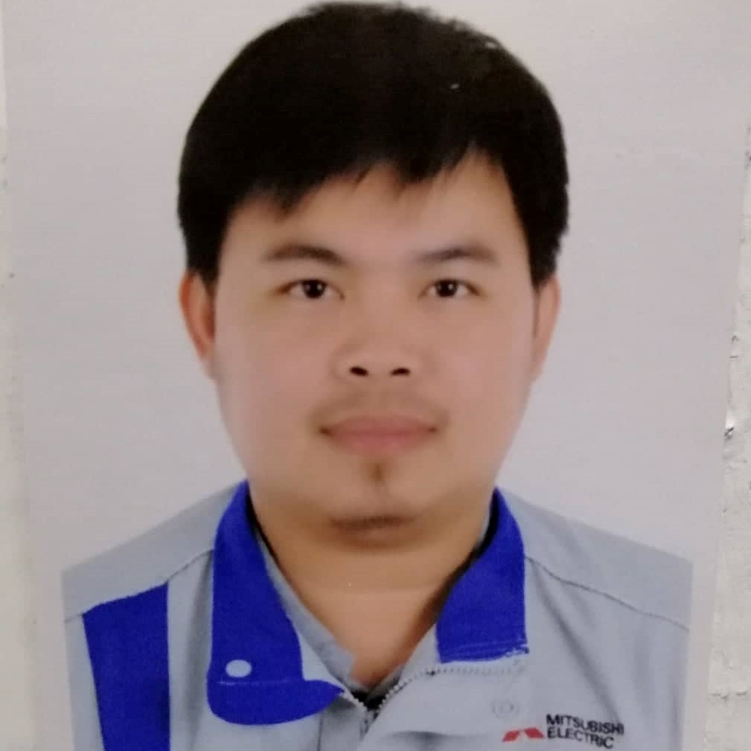
Henie de Luna Poquiz
8164 Rakah St. Al Dugheither Village District, Al Khobar 34611 Kingdom of Saudi Arabia (present)
#45 Brgy. Canan Sur, Malasiqui Pangasinan, Philippines 2421
Mobile: +966504357239
+966531524434
E-mail: henie1163@gmail.com
Poquiz.Henie@nj.melsa.com.sa

Hardworking and experienced quality control engineer in elevator and escalator field and with a demonstrated history in the construction industry. Skilled in machining for manufacturing components using conventional hand-controlled methods and CNC lathe machine.

EDUCATIONAL ATTAINMENT:

College
B.S. in Electronics and Communication Engineering June 1999 – March 2004
Central Colleges of the Philippines
52 Aurora Blvd., Quezon City, Phils.

Secondary June 1995 – March 1999
Malasiqui Catholic School
Malasiqui, Pangasinan, Philippines 2421

Primary June 1989 – March 1995
Canan Elementary School
Malasiqui, Pangasinan, Philippines 2421

CAREER HISTORY:

Mitsubishi Electric Saudi Ltd. Sept 14, 2008 - Present
Elevator and Escalator
C4P9+M88, Al Tubayshi, Dammam 32233

Quality Control Engineer

(Installation and Maintenance - Quality Control Inspector)
Lead, support and conduct installation and maintenance quality inspection, guide technicians for safe practice of work procedure to guide and provide the necessary drawings/manuals needed in small and big projects of Mitsubishi Elevator and Escalator throughout the Central and Eastern of Saudi Arabia.

Enlin Steel Phils. Corporation Feb. 18, 2008 - July 18, 2008
CEZ Rosario, Cavite Phils.
Flanges Fabrication

CNC Programmer/Operator - Machinist
⮚ Operates using conventional hand-controlled methods and program CNC lathe machine using G-codes for FANUC Series control and SMTCL 100 (Shenyang Machine Tool Computer Lathe Numerical Control 100).

Mikado Philippines Corporation - Nakashima June 26, 2006 – Feb. 14, 2008
2nd St. North Drive CEZ Rosario Cavite, Phils.
Propeller Fabrication

CNC Programmer/Operator - Machinist
⮚ Operates using conventional (horizontal and vertical lathe machine) by hand-controlled methods and using FANUC Series machines, program the CNC lathe machine using G-codes command and to operate the desired specification of the customer.

Asaba Manufacturing Phils. Inc. Dec. 5, 2005 – May 5, 2006
Blk. 15 Lot 9, Phase III CEZ Rosario Cavite, Phils.

Production Worker
⮚ Operates press machine, tapping, drilling and threading.

Philippine Seven Corporation May 6, 2005 – Oct. 6, 2005
7-11 Mini-mart
Del Monte Branch, Quezon City, Phils.

Sales Associate/Cashier
⮚ Orient and accommodate customers with satisfaction.

On-the-Job Training Experience:

K@y Kuy@ Information Tech. Computer Learning Center April 2005
#51 Shaw Blvd., Mandaluyong City Phils.

⮚ Assembly operation, networking and installation of computer hardware and software. Proficient in most MS Office ( Microsoft Word, Excel and Powerpoint ).

Philippine Long Distance Company (PLDT) June 23, 2003 - Sept.19, 2003
GMM-Network surveillance Data control
Sampaloc Branch, Manila Phils.

⮚ Installing and disconnecting telephone lines.

PERSONAL INFORMATION:

Date of birth : March 12, 1982
Place of birth : Malasiqui Pangasinan
Age : 42 yrs. old
Sex : Male
Height : 168 cm
Religion : Roman Catholic
Citizenship : Filipino
Status : Married
Spouse Name : Mary Jane Orias Poquiz (April, 14, 1982)
Children : 1. Hannah Mae O. Poquiz (August 14, 2008)
2. Mikhail Yousef O. Poquiz (June 3, 2012)
3. Markus Yuan O. Poquiz ( December 27, 2018)
4. Hanz O.Poquiz ( December 23, 2023)
Languages : Tagalog, English, Arabic and Pangasinense

Character Reference:
Pausto Marcelino Leslie Corporation
Accounting Manager
+63 995 758 3763

I hereby that the above information is true and correct to the best of my knowledge.

