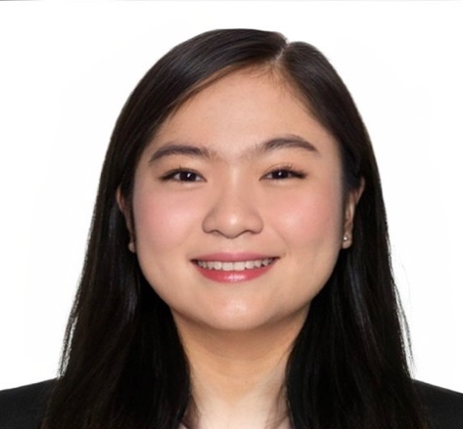
HARRIET B. MANALO, RMT

265 San Pablo, Magalang, Pampanga, 2011, Philippines
Contact No.: + 63919-005-2957
Email Address: harrietmanalormt@gmail.com

OBJECTIVES

- Seeking career that provides an opportunity to capitalize my skills and abilities in the field of Medical Technology
- To expand my knowledge in a clinical laboratory set up by means of utilizing my skills to help promote your vision and mission in providing quality health care services

______________________________________________________________________________

ELIGIBILITY

Professional Regulatory Commission
Republic of the Philippines

Passed the Licensure Examination for Medical Technologist given by Republic of the Philippines on March 13-14, 2019
Registered Medical Technologist, (License No. 0093388) valid until October 18, 2025

PROFESSIONAL EXPERIENCE

Angeles University Foundation Medical Center
MacArthur Hi-Way, Angeles City, Pampanga, Philippines, 2009
Telephone No.: (045) 625 2999

- June 13, 2019- May 31, 2021
Position: Staff Medical Technologist

- June 1, 2021-May 31,2022
Position: OIC, G6PD/Newborn Screening

- June 1, 2022- May 2, 2023
Position: Section Head, G6PD/Newborn Screening

DUTIES, RESPONSIBILITIES AND MACHINES USED PER SECTION

- Collects and prepares specimens and performs laboratory procedures used in the diagnosis, treatment and prevention of disease
- Operates and maintains laboratory instruments and equipment used, and can precisely set up, calibrate, maintain, operate and troubleshoot such instrument. Responsible for the accuracy, interpretation and reporting of all test results according to laboratory policies
- Executes and analyzes tests in areas including blood banking, chemistry, hematology, clinical microscopy, serology, immunology and microbiology to aid physicians in diagnosing and treating disease.
- Maintains the laboratory including keeping equipment and work areas in a clean, orderly, and safe manner
- Maintains clinical competency and current professional knowledge by attending clinical training sessions for continuing professional education (CPE)
- Performs routine preventive maintenance, run daily controls , cleans and calibrates instruments and equipment. Resolves technical problems using proper troubleshooting techniques
- Trained to perform Platelet Apheresis donation

Hematology
- Sysmex XN 1000- hematology analyzer
- Sysmex Ca-50- coagulation studies
- Sysmex KX21- hematology analyzer
- Sysmex 600 series -coagulation studies
- Nycocard reader-HBa1c
- Siemens DCA 1000+ HBa1c, albumin/creatinine ratio

Blood Bank
- Abbott Architect i1000/Chemiluminescent-Immuno Assay
- Comtec Apheresis Machine, Intermitent flow
- Sorvall Refrigerated centrifuge/ Differential centrifugation
- Immuspin Antibody screen
- Clay Adams Serofuge
- Fresenius blood collection mixer
- Sanyo Blood Bank refrigerator and plasma freezers
- Terumo tube sealer

Immunology/Serology
- Abbott Architect i1000/Chemiluminescent-Immuno Assay
- Nycocard reader

Microbiology
- Automated Blood Culture system Bactec 9050
- BBL Crystal ID
- Fisher Acculite colony counter
- Autoclave machine
Clinical Chemistry
- ABX PENTRA 400
- Selectra Pro-M
- Easylyte
- Getein FIA 8000 cardiac reader
- Finecare cardiac reader

Clinical Microscopy
- Reagent strips/kits
- Microscope
- Centrifuge

Phlebotomy
- Syringe, Vacutainer
- Terumo blood bags

EDUCATION

Tertiary
2014-2018
Angeles University Foundation
Mac Arthur Hi-Way, Angeles City, Pampanga, Philippines, 2009
Bachelor of Science in Medical Technology

Secondary
2010-2014
Pampanga Agricultural College
San Agustin, Magalang, Pampanga, Philippines, 2011

Primary
2004-2010
San Agustin Elementary School
San Agustin, Magalang, Pampanga, Philippines, 2011

CLINICAL INTERNSHIP

- Angeles University Foundation
Mac Arthur Hi-Way, Angeles City, Pampanga, Philippines, 2009
November 13, 2017 - May 13, 2018

- Bataan General Hospital
City of Balanga, Bataan
May 28, 2018- November 28, 2018

TRAININGS AND SEMINARS

- Operators Training on Fresenius Kabi COMTEC Cell Seperator for:
- Plateletpheresis
- Therapeutic Plasma Exchange
October 9, 2019

- Basic Operator’s Training, Architect C4000
November 4, 2019

- Online Training on Newborn Screening- DOH
July 5-7, 2021

- COVID-19 Surveillance, Specimen Collection with Donning and Doffing of Personal Protective Equipment Training- DOH
August 25, 2021

REFERENCES

LAMIEL R. SANGALANG, RMT, MLS, (ASCP_{i} ^{)CM}
Assistant Chief Medical Technologist
Angeles University Foundation Medical Center
San Pedro II, Magalang, Pampanga, Philippines, 2011
+ 63916-683-3144

I hereby certify that the above information is true and correct to the best of my knowledge.

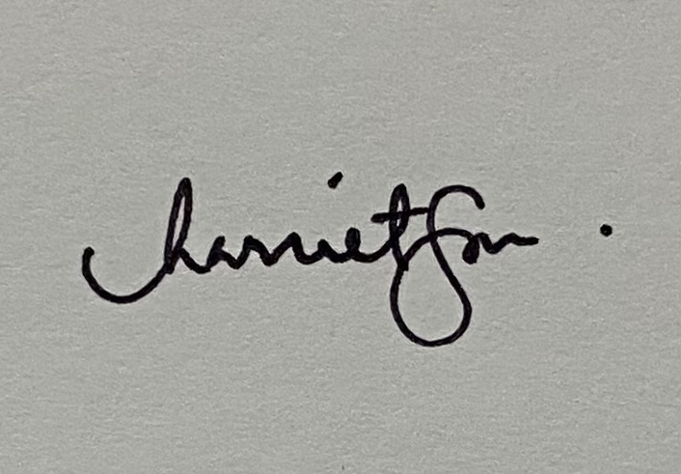

HARRIET B. MANALO, RMT
Applicant

