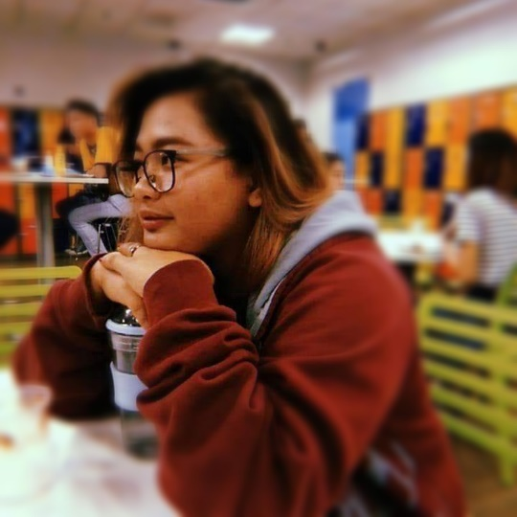

Objective
To be an asset and help to organization, gain experience and to use my skills and experience to achieve my goals and the company’s goals.

SKILLS
- COMPUTER SAVVY
- PHOTOSHOP CS6
- MUSICIAN
Gisele
Morcilla

C O N T A C T
0 9 6 9 1 7 8 6 0 1 0
MORCILLAGISELE997@GMAIL.COM

S O C I A L M E D I A
FACEBOOK: /GISELEMORCILLA
TWITTER: @GIGIMORCILLA
INSTAGRAM: @CHUBS_2797

Education
ELEMENTARY:
PINAGBUHATAN ELEMENTARY SCHOOL (SY: 2006-2012)

HIGHSCHOOL:
PINAGBUHATAN HIGH SCHOOL (SY: 2012-2014)

ALTERNATIVE LEARNING SYSTEM (ALS)
PASSER: (SY: 2014-2015)

COLLEGE:
RIZAL TECHNOLOGICAL UNIVERSITY
2nd YR BSBA MARKETING MANAGEMENT

work experience
MCDONALDS
SERVICE CREW (2017 - 2018)

SYKES ASIA INC.
CUSTOMER REPRESENTATIVE (2018 - 2019)

QBE Insurance
POLICY OFFICER 1 (2019 - PRESENT)

