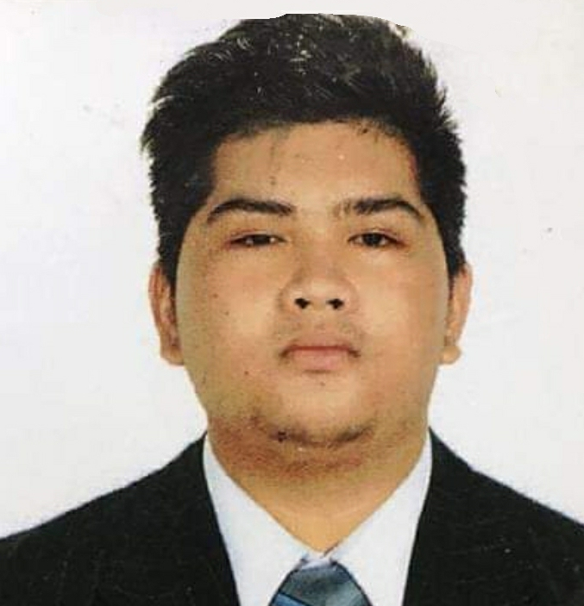
SUMMARY OF QUALIFICATIONS

- General kitchen skills including knife skills, kitchen organization, safe and sanitary food handling
- Eager to learn new things and I easily familiarized myself with things
- Capable of working in a high-pressure environment
- Strong attention to detail developed in working at the hospitality industry
- Great work ethics and positive team attitude

EDUCATION

Bachelor Science in International Hospitality Management: 2018-2023
Cruise Line Operations in Culinary Arts
Lyceum of the Philippines University- Cavite Campus
High School Diploma 2016-2018
Immaculate Conception Academy, Philippines

EXPERIENCE
Line Cook/ Prep Cook July 2022 – Present
Hilton Manila
- Have a positive attitude and work well with the seniors and staff.
- Sanitize working surface, utensils, and kitchen equipment in accordance with kitchen safety regulations.
- Prepared food items consistently and in compliance with recipes, portioning, cooking and waste control guidelines.
- Prepped and cleaned equipment before shift start.

Housekeeping February – March 2018 – Hotel Immersion (Internship)
Volets Hotels & Resort
- Room cleaning
- Room preparation
- Tending to clients request and orders

CERTIFICATIONS
- Sign Language Seminar at The Bayleaf Hotel Manila (May 8 2019)
- Image Enhancement Seminar at The Bayleaf Cavite (May 7 2019)
- Seminar at Sky Kitchen (November 2018)
- Seminar at Alba Restaurant (November 2018)
- Seminar at The Bayleaf Hotel Cavite (November 2018)
- PRACTICUM/ON-THE-JOB TRAINING – FOOD PRODUCTION DEPARTMENT
Astoria Culinary and Hospitality Institute | March - July 2021

Personal Skills:
- Cooking
- Fast Learner
- Multi-Tasking
- Hard Working
- Attentive

Reference:
Mr. Jorge Adeodatus M. Bautista
Teacher- Chef
Lyceum of the Philippines University- Cavite
(63+) 9178577179
Chef_jorge@yahoo.com

I hereby declare that the information stated above are true to the best of my knowledge and that I will be held responsible to any particulars.

