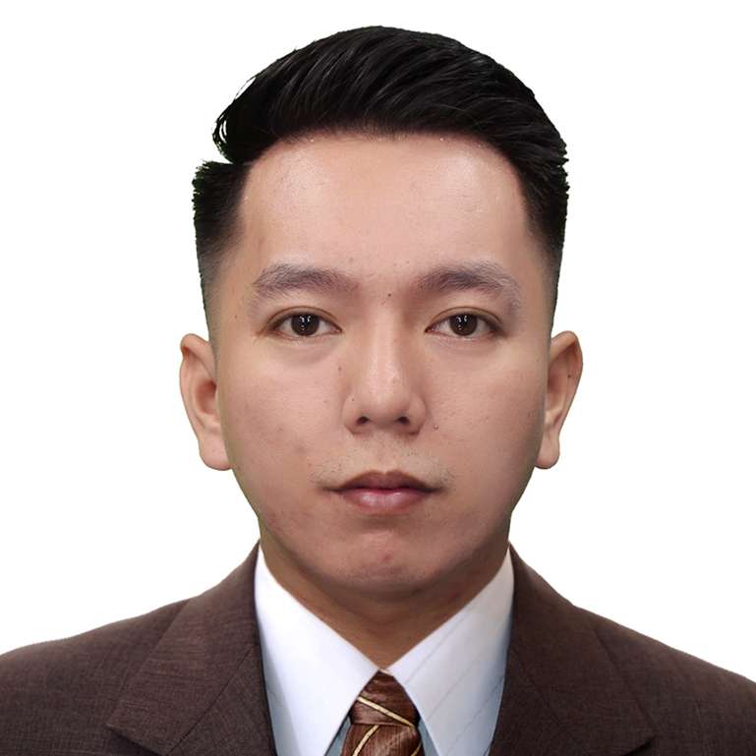
FUKUDA, ARNOLD G.
General Luna St. Brgy. Wawa Lumban, Laguna
arnoldfukuda@yahoo.com
09153898409

OBJECTIVE:

To be able to work in a career oriented and challenging environment that promotes personal growth and uplifts professional development.

PERSONAL DATA

Date of Birth : October 21, 1993
Place of Birth : Lumban, Laguna
Height : 5’6”
Weight : 61 Kg.
Religion : Roman Catholic
Civil Status : Single

Citizenship : Filipino

EMPLOYMENT HISTORY
- Florabel Group of Restaurant: Sisa’s Secret
Server
December 14, 2016 – November 15, 2017

- Din Tai Fung BGC
Section Leader
December 22, 2017 – October 27, 2019

- Royal Caribbean cruises ltd
Galley Steward
December 15, 2019 – Present

EDUCATIONAL ATTAINMENT
Elementary : Little Shepperd Integrated Montessori
Lumban, Laguna
S-Y 2005-2006
Secondary : Little Shepperd Integrated Montessori
Lumban, Laguna
S-Y 2009-2010

Tertiary : Philippine Women’s University (CDCEC)
Sta. Cruz, Laguna
SY 2012-2016
Course : Bachelor of Science in Hotel and Restaurant
Management

On the Job Training
Royal Bellagio Hotel

Room Attendant: 160hrs April 14, 2014 – May 9, 2014

Royal Bellagio Hotel (Arabian Nights Cocktail Lounge)

Bartender: 260hrs May 12, 2014 – June 4, 2014
Food Server

Royal Bellagio Hotel (Arabian Nights Cocktail Lounge)

Bartender: 720hrs November 24, 2015 – February 29, 2016

REFERENCES:
Ms. Mechelle Sarmiento Digo Aseron
Store Manager
Sisa’s Secret
09178371347

Mr. Rafael Araneta
Captain Waiter
Din tai Fung
09219737898

Ms. Melody B. Diones
HRM Instructor
PWU – Sta. Cruz
09282465201

I hereby certify that the foregoing information is true and correct.

ARNOLD G. FUKUDA
Applicant

