CONTACT  SKILLS  - Microsoft Word, Excel, PowerPoint.  - Map Info, AutoCAD, Gemcom- Basic only.  - Operates XRF (for immediate grade analysis of Minerals).  - Operates Geo Magnetometer.  - Core logging (geological, structural, and Geotech logging)  - Surface mapping (geological and structural).  - Underground mapping (ore drive and development drive).  - Grade Control management  - Vein interpretation and analysis  - Internal Audit team member for ISO: 9001, ISO: 14001, and ISO: 18001 (2016-present)  - Document controller for ISO: 9001, ISO: 14001, and ISO: 18001 (2016-present)  ADDITIONAL INFORMATION  - Willing to Relocate: Yes  - Wiling to Travel: Yes,  - Availability to work: 1 month after the interview will be made
  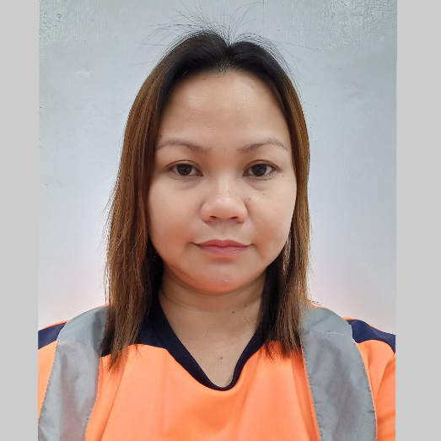
   | Purok 6, Balugo, Valencia, Philippines, 6215
   | +639688548741
   | flordelinedelatorre@gmail.com
  Flordeline dela Torre - Glodove
  PROFESSIONAL SUMMARY
  I am an experienced Geologist professional with strong leadership and relationship-building skills. I have been in the Exploration and Mining Industry for 12 years with a diverse background in both Surface exploration and underground mining operations. Dedicated and committed to applying extensive knowledge of geological operations and geophysical methodologies in performing assigned tasks.
  WORK HISTORY
  Surface Geologist 10/2020 - Current
  Mine Geologist 02/2013 – 10/2020
  Grade Control Geologist 11/2013 – 10/2014
  Apex Mining Company Incorporated - Masara, Maco, Davao de Oro
  Commodity: Epithermal Gold and Silver
  - Surface Exploration: Oversee corehouse daily activities and gave immediate solution on problems and other complications at work. Performed quick log, detailed geological logging, sampling, vein interpretation and analysis, and submitted daily, weekly and monthly reports. Prepared terminal report in every end of the project.
  - Mine Geology: Conducted underground mapping, projection and interpretation of veins.
  - Supervised the daily activities of underground mappers and samplers.
  - Coordinated with the Mine Operations Division whenever changes on vein projections are made and new openings are recommended.
  - Prepared daily and monthly mine geology update/report.
  - Monitored daily the underground geology activity and gave immediate solutions on complications at work.
  - Grade control: Controlling Daily Stockpile Material Movements.
  - Ensured a high-quality control of sample collection is maintained.
  - Ensured that the Target mill head will be attained.
  - Determined the blend of ore to be fed to the mill from different headings considering the established procedure on grade control.
  - Prepared daily inventory of ore at various stockpile areas.
  - Evaluates any discrepancy that may arise between the Mine and Mill data in terms of tonnages and grade and prepares reports on the results of evaluation.
  - Prepared monthly/semi-annual/annual reconciliation reports on tonnages and grades.
  - Submitted daily the ore fed to crusher report, daily ore production, delivered to mill, mine yard inventory, and mine grade vs mill head report.
  Project Geologist 02/2012 - 02/2013
  Philco Mining Corporation - Camanlangan, New Bataan, Davao de Oro Commodity: Copper and Gold (Skarn deposit)
  - Core logged diamond drill core and RC chips.
  - Conducted geological mapping and trenching in order to delineate the cu/au ore deposit in the area.
  - Update database daily.
  - Generate daily, weekly and monthly updates of the drill holes logged.
  Project Geologist 04/2011 - 02/2012
  Selenga Mining Corporation - Sitio Lamarian, Hinobaan, Negros Occidental Commodity: Porphyry Copper -Molybdenum
  - Core logging: geological, structural and geo technical logging.
  - Submit daily, weekly and monthly updates/reports.
  - Assist the senior geologist in drill holes interpretation and projections.
  Project Geologist 01/2011 - 04/2011
  ANSECA Development Corporation - Bayog, Province of Zamboanga del Sur, Sur
  Commodity: Iron Ore Floats
  - Used geological knowledge and expertise in prospecting iron ore in the area.
  - Meticulously examine iron ore floats before buying.
  - Wrote daily, weekly, and monthly reports in line with the daily geological activities.
  Junior Geologist 06/2010 - 12/2010
  TSGS Mineral Investment Corporation – Midsalip and Bayog, Zamboanga del Sur
  Commodity: Iron ore
  - Conducted Geological Mapping and Geo Magnetic Survey.
  - Assisted the Geophysicist in Geo Electro (Resistivity) Survey (results of Geo mag and Geo electro were interpreted by the Geophysicist).
  - Supervised drilling activities.
  - Core logged and prepared ore samples for cutting.
  - Produced reports and updates of the mapped/surveyed area.
  Junior Geologist 01/2010 - 05/2010
  Northern Access Mining Incorporated - Tolosa, Leyte
  Commodity: Magnetite Sand
  - Implemented Exploration/ Drilling Work Program according to approved plan.
  - Assigned in the Laboratory operation of magnetite sand.
  - Laboratory Operation includes weighing of samples from drill site, drying, screening, and prepared composite sample of sand.
  - (separate the pumice).
  - Collected drilling updates every day.
  - Produced drilling and laboratory weekly and monthly reports.
  - Assist in the preparation of Ore Resource Estimation.
  Junior Geologist 01/2009 - 03/2009
  Mt. Sinai Exploration and Development Corporation - Homonhon Island, Guiuan, Samar
  Commodity: Chromite
  - Conducted mapping, supervised drilling, logging, used xrf for grade analysis and reporting.
  - Prepared daily, weekly and monthly reports/updates.
  Junior Geologist 09/2008 - 01/2009
  Island Bay Mining Corporation - Culandanom, Aborlan, Palawan
  Commodity: Nickel Laterite and Chromite ore
  - Supervised drilling activities; core logging, sample preparation, etc.
  - Produced weekly and monthly reports of the exploration/drilling activities.
  - Constructed drill hole location map using map info (basic only).
  - Constructed geological profile of the laterization in the area.
  - Conducted geological field mapping, test pitting and trenching.
  Assistant Resident Geologist 02/2008 - 09/2008
  SR. Metals, Inc.- La Fraternidad, Tubay, Agusan del Norte
  Commodity: Nickel Laterite
  - Planned the exploration work program.
  - Implemented the exploration work program according to approved plans.
  - Produced daily, weekly and monthly updates of the exploration activities.
  - Conducted geological field mapping.
  - Analyzed some ore samples in exploration using portable XRF (Niton).
  - Responsible for supervising the activities of the drilling and auger supervisors (geologist).
  - Constructed cross sectional profile of the drilled holes.
  Junior Geologist 04/2007 - 02/2008
  SR. Metals, Inc.- La Fraternidad, Tubay, Agusan del Norte
  - Supervised drilling activities; core logging, sample preparation, etc.
  - Provided drilling needs and sent to the machine shop all worn out and damaged parts.
  - Reported the daily report sheet with assay results and the operator's monitoring report to the Superintendent of the Exploration section.
  - Collected assay data daily for the updated map presentation, geological report and ore resource estimation.
  - Recommended improvements of the exploration/drilling activities.
  Professional Medical Rep 06/2005 - 11/2005
  Lakeside Pharmaceuticals, Inc - Cebu City, Province of Cebu
  - I was part of the team that sells their company's products, which include medicines, prescription drugs and medical equipment, to a variety of customers including general practices, hospitals and pharmacies.
  - Liaise with and persuade targeted doctors to prescribe our products utilizing effective selling skills and performing cost-benefit analysis.
  - Provide product information and deliver product samples.
  - Monitor and analyze data and market conditions to identify competitive advantage.
  - Kept accurate records and documentation for reporting and feedback.
  - Pursue continuous learning and professional development and stay up to date with latest medical date.
  EDUCATION
  Bachelor of Science : Geology 2000-2004
  Bachelor's Degree
  Negros Oriental State University
.

