Profile
ADDRESS: Villa Franda San Nicolas San Fernando Pampanga
AGE: 52
HEIGHT: 5’7
BIRTHDAY: April 28, 1970

Contact
PHONE:
00639763388084
00639669061940

WEBSITE:
FB Dario B. Pineda

EMAIL:
Pinedadario70@yahoo.com

Hobbies
Playing games basketball
Watching movies
Driving car

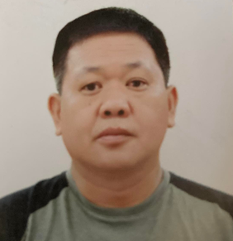 |  | Dario b. pineda  Objective: I seek challenging opportunities where I can fully use my skills for the develop and Success of Company  Expertise  - Cnc press brake  - Cnc punch machine and plasma  - Cnc Water jet and little laser machine  - Steel Fabricator or assembler

EDUCATION

FAR EASTERN UNIVERSITY
Mechanical Engineering ( Under Graduate )
1986 _1990
East Central College ( Secondary )
1982_1986
St. Scholastica’s Academy ( Primary )
1976_ 1982

Mega Computer College
AUTOCADD Course

WORK EXPERIENCE
WESCOSA LTD ( Draftsman )
October 1995_1997
WESCOSA LTD ( CNC PROGRAMMER AND OPERATION )
1997_ 2001
WESCOSA LTD ( TEAM LEADER )
2001_ 2006 ( MAN OF THE YEAR )

AL SHUWAYER ( Steel Fabrication Supervisor )
Feb 2006 _ Oct 2006

Metal Fabrication Factory LLC ( CNC PROGRAMMER AND PRODUCTION SUPERVISOR with SITE VISIT INSPECTION )
January 2007 _ June2021

Job Description : ( Steel Fabrication and Cnc )
- Review the drawing on cutting list and materials list
- Checking the tools to be used in cnc ( punch machine and laser )
- Checking the finish product from cnc output
- Checking the fabrication drawing to be done by fabricator or assembler
- Checking the power coat by using micro
- Checking the final assemble or finish product

Job Description : Installation of Laboratory cabinet and Structural Steel
- Preparing the work permits on site
- Review the plan to be done
- Preparing the work requirement of proper ppe
- Checking the hazard and precaution on area
- Preparig the Barricades and warning post on site
- Checking the tools to be used and color coding
- Review the proper plan before fproceeding om work

SKILLS
Leadership Experience
Fabrication Analyzer
Problem solving Abilities in steel work
Organizational know how
Flexibility and Adaptability on work

