DARWIN AMBA LIBARDOS

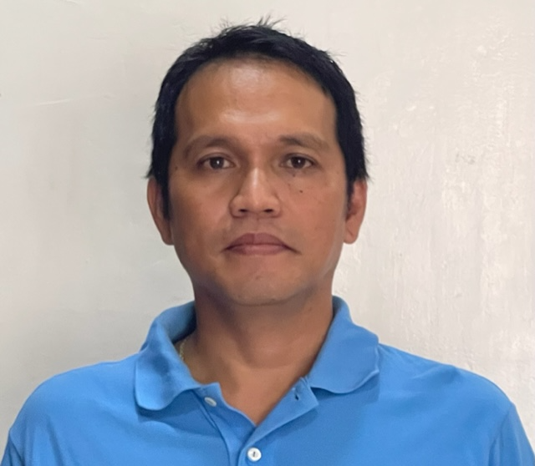
PHOTO
(At least 6 months old)
Mobile No.: +63 9618330218
Current Address: P-2 Balagatasa Maigo, Lanao Del Norte
Email Add: darwinlibardos_77@yahoo.com

PROFESSIONAL SUMMARY

A top performer with exceptional inter personal, communication and public relation skills. I am seeking a position that will challenge and utilize my work experience, education and acquired skills to positively impact company performance and profitability while providing personal and professional growth.

Twenty years of working experienced in Maintenance and Repair for Ministry of Defense Kuwait and US Base Camp now seek a position that has a consistent high level of performance dealing with people and services that requires solid management.

I pride myself on a professional attitude with energetic and assertive personal performance and the ability to develop strong rapport with individuals on all levels; experiences of which I have gained from my previous work experience.

SKILLS

- Professionalism and strong work ethic
- Teamwork and collaboration
- Critical thinking and problem solving
- Oral and written communication skills
- Leadership

EXPERIENCE (From Current to Past)

Proprietor, Automotive Mechanic, Refrigeration and Aircon Technician
Sept. 2021 – Present
RALL Automotive Repair Services / Aircon and Refrigeration Repair Services
Purok 2 Balagatasa Maigo Lanao Del Norte, Philippine
Job Description/ Duties and Responsibilities:

- Troubleshooting and repairing all types of wheeled vehicles and air-conditioning system.
- Oil change and lube maintenance, service and repair.
- Tubeless vulcanizing and pneumatic tire changing.
- Electrical repair and modification.
- Installing auxiliary and mini-driving lights.
- Refrigeration- maintenance, service and refrigerant charging.
- Train, monitor and develop newly graduate mechanic and TESDA OJT’s.
Fuel and Electric Repairman (FMS-B)
June 2013 – June 2021
Vectrus Systems Corporation
Camp Buehring, Kuwait

Job Description/Duties and Responsibilities:

- Troubleshooting and repairing all types of wheeled vehicles electrical and mechanical fault.
- Troubleshooting and repairing all types of power generator and light sets.
- Load Testing the Generator to complete the procedure for repair.
- Troubleshooting and repairing Air condition (A/C) on all types of vehicles, ECU, Refrigerators.
- Certified in universal HVAC technician EPA Clean Air Act Section 608 and 609.
- Acting Lead in Automotive shop.
- Acting Lead in Engineering and Special Purpose Equipment (ESPE).

Automotive/Vehicle Mechanic
March 2011- May 2013
Souk Zed Company
Fahaheel, Kuwait

Job Description/ Duties and Responsibilities:

- Working as mechanic in a fully equipped, modern workshop.
- Diagnose and troubleshoot mechanical issues efficiently.
- Conduct preventive maintenance to ensure vehicle reliability.
- Uphold safety protocols and maintain a safe working environment.
- Perform routine mechanical and preventive maintenance duties in the inspection and repair of vehicles.
- Repair and adjust brake mechanism, replace brake shoe lining, wheel cylinder and master cylinder.
- Coordinate maintenance and repair with relevant Managers.

Senior Wheel Mechanic Vehicle (FMS Service Team)
August 2008-Dec 2010
Combat Support Associates Limited, (CSA LTD.)
Camp Arifjan, Kuwait

Job Description/ Duties and Responsibilities

- Perform maintenance and repair work such as, M977, M984A1, M932, M925, M1070, M1000, M872 and more.
- Operates and inspect equipment and diagnose defects.
- Troubleshoot equipment, make adjustment, remove and replace parts, accessories and components such as: generator, alternator, fuel pump, engines, differentials, transmission, transfers, hydraulic fluid and electric system.
- Repairs such as fixing engines, generators, starters and fuel injection.
- Repair and adjust brake mechanism, replace brake shoe lining, wheel cylinder and master cylinder.
- Service such as: changing and lubing oil, grease, cooling system and filters.
- Perform maintenance and repairs on diesel – powered vehicle.

- Responsible for diagnostic procedures, inspection, troubleshoot, and overhaul and rebuilding of diesel - powered internal combustion engines to include Lombardini LDW903/1003, Kubota, D905, Mitsubishi L3E, Perkins 1000 and 1300 series, Caterpillar and others.
- Complete adjustment and minor repair or replacement of attached electrical, lubrication and fuel subsystem and any parts of Generator.
- Responsible in initial overhaul and report unserviceable parts
- To install engine in light set and engine cart for initial test run to final.
- Load Testing the Generator

- Perform maintenance and repair work such as M114, M977, M984A1, M932, M925, M1070, M1000, M872 and more.
- Operates and inspect equipment and diagnose defects.
- Troubleshoot equipment, make adjustment, remove and replace parts, accessories and components such as: generator, alternator, fuel pump, engines, differentials, transmission, transfers, hydraulic fluid and electric system.
- Repairs such as fixing engines, generators, starters and fuel injection.
- Repair and adjust brake mechanism, replace brake shoe lining, wheel cylinder and master cylinder.

Automotive/Vehicle Mechanic
September 2007 – July 2008
Souk Zed Company
Fahaheel, Kuwait

Job Description/ Duties and Responsibilities:

- Operates and inspect equipment and diagnose defects.
- Troubleshoot equipment, make adjustment, remove and replace parts, accessories and components such as: generator, alternator, fuel pump, engines, differentials, transmission, transfers, hydraulic fluid and electric system.
- Repairs such as fixing engines, generators, starters and fuel injection.
- Repair and adjust brake mechanism, replace brake shoe lining, wheel cylinder and master cylinder.

Turret Technician (Certified Line 1 and Line 2 Course)
September 2001 – August 2007
Ministry of Defence
Kuwait

Job Description/ Duties and Responsibilities:
- Maintaining electronic and sighting turret system.
- Calibrating and repairing sighting system.
- Purging and charging sighting system.

EDUCATION

Electronic and Computer Technology (Diploma)
1996 – 1998 Asian College of Science and Technology
Automotive Mechanics (Diploma)
1990 – 1994 Maigo School of Arts & Trades (MSAT

PERSONAL INFORMATION

Date of Birth: February 18, 1977
Nationality: Filipino
Passport # P8558003B
Driving License: Valid Philippine Driving License

SEMINAR AND WORKSHOP

- KBOSS Test, Measurement and Diagnostic Equipment Training – June 24, 2019
- Ground Guiding – November 13, 2018
- Incident Reporting / RCA – October 15, 2018
- LockOut/ TagOut Training – May 16, 2018
- Environmental Officer Refresher Training Course – October 14, 2017
- Area Support Group Kuwait Key, Lock and Protective Seals Class – March 21, 2017
- For Customer Service: At A Glance Training – March 2, 2017
- For PWS: At A Glance Training – March 2, 2017
- Environmental Officer Refresher Training Course – October 22, 2016
- Area Support Group Kuwait Key, Lock and Protective Seals Class – August 31, 2016
- Safety Representative Training Course – July 19, 2016
- Environmental Officer Training Course – November 25, 2015
- Warehouse/ Material Handling Safety Training Program –
June 14,2015
- Abrasive Grinding Wheel Safety Training Program – June 9, 2015
- Welding, Cutting & Brazing Training Program – June 9, 2015
- Hazard Communication – May 13, 2015
- Powered Industrial Forklift Training – May 13, 2015
- Fire Extinguisher Education & Awareness Program – April 22, 2015
- Customer Service Training: At A Glance – March 29,2015
- OSHA Hazard Communication Standard – June 8, 2014
- HAZWOPER Training Program – February 11,2014
- Desert Warrior Turret Technician Skills – May 24, 2003

REFERENCES

Felix Battle
Supervisor – Allied Trade
Vectrus Systems Corporation / Camp Arifjan, Kuwait
+965 65598752

Rommie Little
Supervisor – Engineering and Special Purpose Equipment
Vectrus Systems Corporation / Camp Buehring, Kuwait
+965 66839637

Richard Cameron
Lead – Electronic and Appliance
Vectrus Systems Corporation / Camp Buehring, Kuwait
+965 98569348

