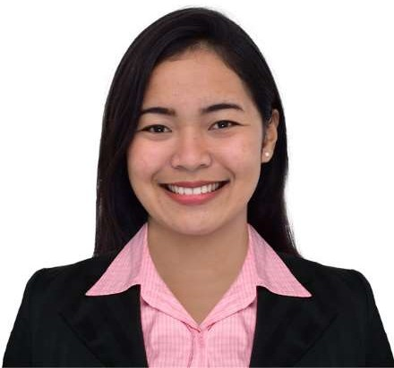
ROSSARAH GRENIO
REGISTERED CIVIL ENGINEER

Greenville Subdivision, Bugo, Cagayan de Oro City | 0975-941-9652 | greniorossarah27@gmail.com

- To pursue my professional career as civil engineer in a company where they can help me develop my skills and at the same time contribute to their excellence.
- To build a long-term career with opportunities for career growth.
- To bring my strong sense of dedication, motivation, and responsibility

EDUCATION

Bachelor of Science in Civil Engineering (2012 – 2017)

University of Science and Technology of Southern Philippines (USTP) Cagayan de Oro City

Bugo National High School (2008 – 2012)

Cagayan de Oro City

Bugo Central School (2002 – 2008)

Cagayan de Oro City

INTEREST

- DRAWING
- AUTOCAD AND CIVIL 3D
- DISCOVER NEW KNOWLEDGE

CERTIFICATES

BOSH – SAFETY OFFICE 1

IP CDD PEACE AND DEVELOPMENT TRAINING

LAND ACQUISITION REHABILITATION AND RESETTLEMENT

EXPERIENCE

Quantity Surveyor (February 2023 – Present)
Jejor’s Construction Corporation

*Performs the quantification of actual quantity based on actual surveyed data gathered in the project site.
*Prepares the Back-up Computation for As-staked and As-Built Plan.
*Responsible for the contractual and financial side of construction.
*Prepares the A-staked Plan Drawing
*Prepares the As-Built Plan Drawing
*Performs any necessary tasks that the immediate supervisor will give.

Project Engineer (April 2022 – January 2023)
MT Global Engineering and Services, Inc.

*Supervised and monitored the project for retrofitting, both civil and mechanical works for M.Montes Claros Piggery Farm Project.

*Makes daily reporting and daily activities.

Project Engineer (August 2020 - April 2022)
JMP Concrete Specialists, Inc.

*Assigned as a project engineer at STEAG State Power, Inc. for the project for Jetty Rehabilitation and Chemical & Lubricant Storage.
*Provides technical assistance and ensures that the project was well conducted.
*Monitor the project and the safety of the workers.
*Makes Daily reports and Project Monitoring Reports.

Technical Facilitator (April 2019- December 2019)
Department of Social Welfare and Development (Region X)

*Provides technical assistance to the Area Coordinating Team, Municipal Coordinating Team and the community volunteers of the different barangays on the implementation of the Community Empowerment Activity Cycle.
*Ensure that community infrastructures built and managed by volunteers meet KC-prescribed design, construction and procurement processes and Project standards.

SKILLS

  - Computer Literate
  - Estimate Background
  - Project Management
  - Time Management
  - Civil 3D
  - Autocad

