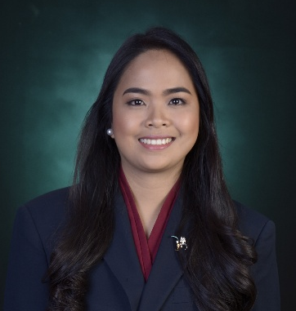

JESSICA LANAO TOLENTINO
Address: #033 San Roque Sto. Tomas Batangas
E-mail add: ecahlanao@gmail.com
Mobile no: 09565714567

Objective:
To apply in a position where my education and skills will be beneficial to the company, and to gain more knowledge and experience on the chosen field and to have a big part of the company’s development.

Personal Data:

Civil status : Married
Height : 5’4 ft.
Weight : 135 lbs.
Age : 28 years old
Birth Place : Bitin Bay, Laguna
Birth Date : July 21, 1994
Sex : Female
Religion : Roman Catholic
Citizenship : Filipino

Skills
- Have a good communication skill
- Computer Literate (MS Word, Excel, and PowerPoint 2010 etc.)
- Capable of working under pressure time.
- Passionate and enthusiastic in gaining new experiences; eager to work in a challenging environment
- Highly trustworthy
- Smart working ability

Working Experience

- Asiapro Multi-Purpose Cooperative
Client: MDC Technology Center- MCI Precast
Position: HR Admin Officer
Brgy. San Felix Sto. Tomas City Batangas
November 7 2022- up to present

Duties and Responsibilities
- Contact potential candidates to hire and schedule an interview with them.
- Tend to employees’ questions and provide the best solutions.
- Provide a regular update on Payroll Information of employees.
- Ensure timely updates of HR policies and procedures alongside their documentations.
- Maintain and organize new employee orientation, training, and documentation.
- Edit, update or change the employee records and their relevant paperwork.
- Maintain bank account information of employees and salary processing.

- TG Services Inc.
Client: Thermaprime Drilling Corporation
Position: Camp Clerk/Purchasing Officer
Brgy. Bitin Bay, Laguna
November 19, 2020- September 30, 2022

Duties and Responsibilities
- Performs clerical duties including typing, filing, and completion of simple forms.
- Evaluate and facilitate approval on all purchase orders and coordinate with assistants and buyers to ensure accuracy of all deliveries.
- Coordinate with vendors to maintain optimal product quality and recommend improvements to all pricing.
- Monitor monthly budget
- Encoding monthly mess expense
- Issuance of every day needs of kitchen.

- Lan-ja Industrial Supplies and Service
Position: HR Staff / Site Coordinator
MAK-BAN Geothermal Site, Mabini St.
Brgy, Bitin Bay, Laguna
August 27, 2019- June 01, 2020

Duties and Responsibilities
- Contact potential candidates to hire and schedule an interview with them.
- Tend to employees’ questions and provide the best solutions.
- Provide a regular update on Payroll Information of employees.
- On site duty to coordinate client request and other concerns.

- On-the-job Training (600hrs.)
Maibarara Geothermal Inc. – Logistic Station
Brgy. Santiago Sto. Tomas, Batangas
January 14- April 27, 2019

Educational Attainment:

Tertiary

Lipa City Colleges
G. A Solis Lipa City, Batangas
Bachelor of Science in Business Administration
Major on Human Resources Development Management
SY 2015- 2019

La Consolacion College-Tanauan
Tanauan City, Batangas
Bachelor of Science in Business Administration
Major on Human Resources Development Management
SY 2011-2012

Seminars and Trainings Attended:

- HR Hitting the Road: Defying Gravity and Acquiring Top Talents
March 10, 2018
Batangas State University- Malvar, Batangas

- Pre-Employment Seminar 2019
Position Yourself for the Future: Building Plans for Success”
April 26, 2019
Lipa City Colleges-Lipa City, Batangas

- Philippine Red Cross Safety Services
Occupational First Aid and CPR/AED
January 16-17, 2020
Union Galvasteel Training Center

Membership/Organizational Affiliations:

- Member of Junior People Management Association of the Philippines (JPMAP)

Character References

Trazarra I. Tolentino
Tolentino Gravel and Sand
0935-5866-715

Eden C. Lizardo
Team Leader
TG Services Inc.
0938-672-0008

Virginia Federizo
Member Supervisor
Asiapro Multi-purpose Cooperative
0936-5208-731

I hereby testify that the above information was true and correct to the best of my knowledge and belief.
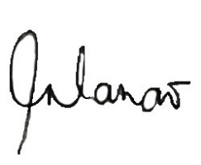

______________________
Lanao, Jessica N
Applicant

