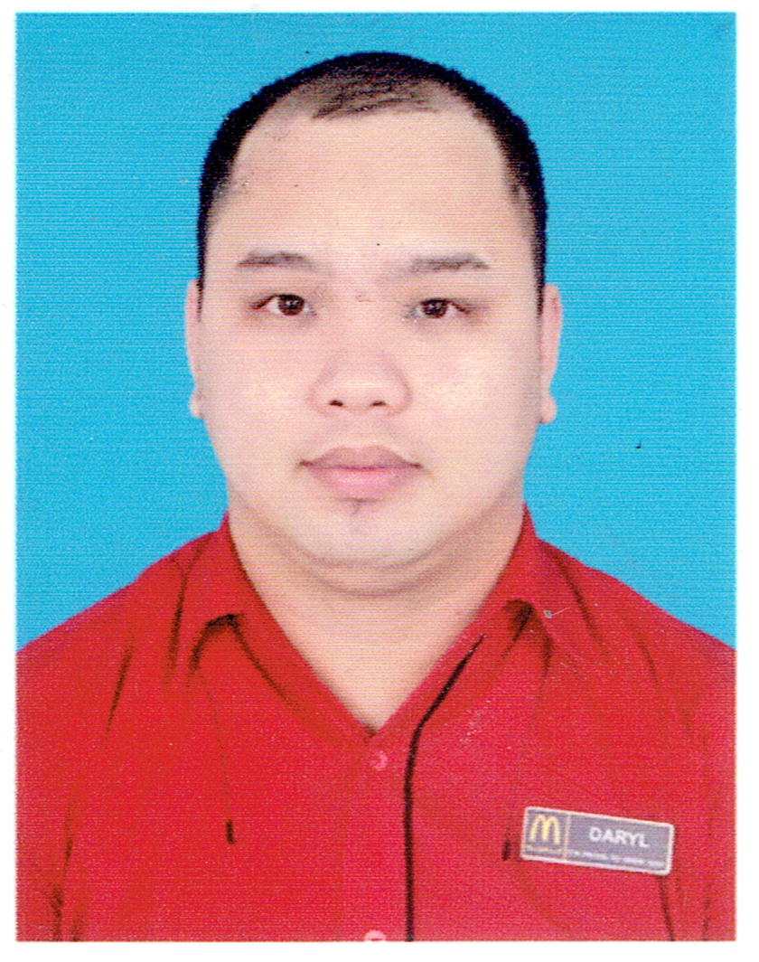
DARYLL ECIJA
Blk 35 Excess Lot Soldiers Hills Village Brgy Putatan Muntinlupa City
+ 09276925080
daryllecija0531@gmail.com

A dedicated, passionate and committed to giving something back to the company I am working with, using the knowledge, skills and experiences over the course of life so far. A great team member who can stand the test of time, polite, respectful, trustworthy and happy to take instructions as well as work under own initiative.
work experience
DECEMBER 02, 2009 - MAY 02, 2010
SERVICE CREW
JOLLIBEE FOODS CORPORATION
-Ensured restaurant cleanliness and the quality of the food that we served in accordance with the standards that we serve. Make our valued customers happy and satisfied.
MAY 14, 2014 - AUGUST 31, 2016
service crew MCDONALDS OMAN (AL DAUD RESTAURANT LLC)
MUSCAT SULTANATE OF OMAN

-Provide an energetic atmosphere for customers and staff.
-Deliver a total customer satisfaction and help the restaurant in terms of cleanliness, sales and profitability.

SEPTEMBER 01, 2016 - JULY 31, 2017
CREW CHIEF MCDONALDS OMAN (AL DAUD RESTAURANT LLC)
MUSCAT SULTANATE OF OMAN

-Guaranteed quality of service through effective communication with our guests.
-Received and checked materials of the restaurant marketing merchandizers.
-ensured the cleanliness of the store and provide an outstanding customer service.

AUGUST 01 2017 - FEBRUARY 29, 2020 -
SWING MANAGER MCDONALDS OMAN (AL DAUD RESTAURANT LLC)
MUSCAT SULTANATE OF OMAN
- ORDERING MANAGER
- SCHEDULING MANAGER
- PREVENTIVE MAINTENANCE MANAGER

MARCH 01 2020 - NOVEMBER 29 2021
2ND ASSISTANT MANAGER MCDONALDS OMAN (AL DAUD RESTAURANT LLC)
MUSCAT SULTANATE OF OMAN
- MONTH END INVENTORY MANAGER
- OVERALL IN CHARGE IN FSC AND PNL
- DRIVE THRU MANAGER

December 13 2021 to February 05, 2022
TECHNICAL SUPPORT REPRESENTATIVE - TELEPERFORMANCE GREENFIELD DISTRICT EDSA

SEPTEMBER 17 2022 – CURRENT
2ND ASSISTANT MANAGER MCDONALDS OMAN (AL DAUD RESTAURANT LLC)
MUSCAT SULTANATE OF OMAN

CREW OF THE MONTH - SEPTEMBER 2014
MCDONALDS OMAN GRANDMALL BRANCH

CREW OF THE MONTH - JUNE 2015
MCDONALDS OMAN GRANDMALL BRANCH

CREW OF THE MONTH - FEBRUARY 2016
MCDONALDS OMAN GRANDMALL BRANCH

SPILL KIT AND ALLERGEN TRAINING - AUGUST 2018
AL AMERAT MCDONALDS OMAN

DEVELOPING THE LEADER IN ME (DLIM CLASS) – MAY 8 – 10, 2023
MUSCAT SULTANATE OF OMAN

SOLDIERS HILLS ELEMENTARY SCHOOL
MUNTINLUPA CITY, METRO MANILA

-Graduate (2005)
PEDRO E DIAZ HIGH SCHOOL
MUNTINLUPA CITY, METRO MANILA

-Graduate (2009)

KEY SKILLS
- Excellent in customer service and relationship  - Adaptability, flexibility and a quick-learner | - Handling pressure  - Proficient in Microsoft Office including Power Point and Word

ADDITIONAL INFORMATION

DATE OF BIRTH: May 31, 1992
PLACE OF BIRTH: Sta Maria Province of Bulacan
GENDER: Male
AGE: 31
NATIONALITY: Filipino
RELIGION: Roman Catholic
MARITAL STATUS: Unmarried

