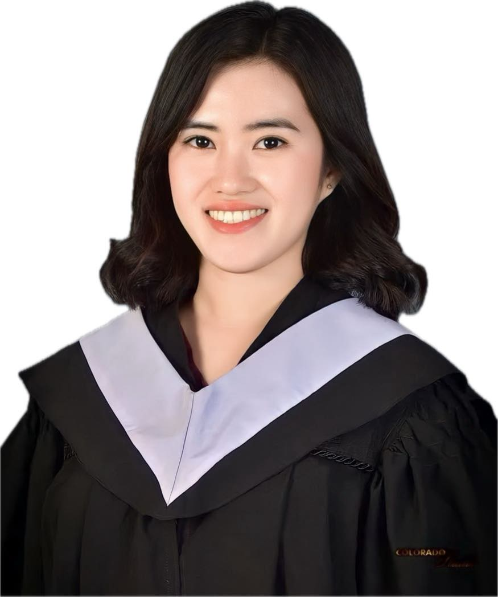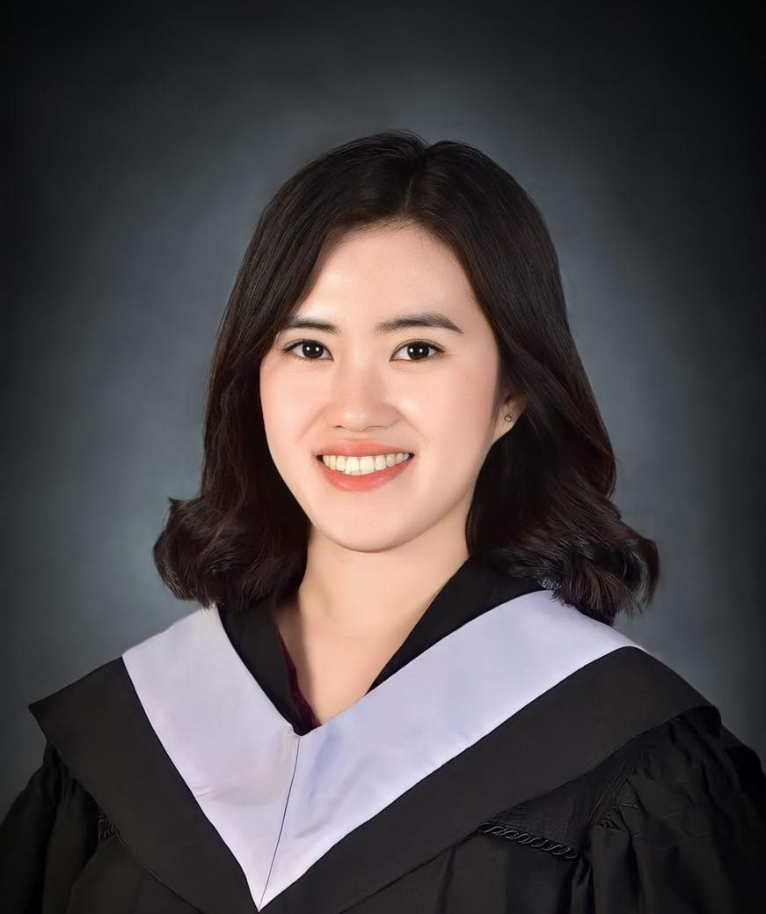

PERSONAL DATA
Nickname: Mil
Age: 25
Birthday: March 21, 1998
Religion: Catholic
Nationality: Filipino
Gender: Female
Civil Status: Single
EDUCATIONAL BACKGROUND

- College of Our Lady of Mt. Carmel
TESDA - Caregiving
August 2023-January 2024

- TERTIARY:
Don Honorio Ventura State University
Batchelor of Science in Business Administration
Major in MArketing
2014-2018

SKILLS AND CAPABILITIES
- Highly motivated and willing to undergo training.
- With a sense of responsibility and positive work attitude.
- Can work under pressure and fast learner person.
- Able to get along with co-workers and accepts supervision.
- Willing to try new things and interested in improving efficiency on assigned tasks.

CAMILLE D. MENESES
Blk 28 Lot 16 Sabanilla, Mexico, Pampanga
milestone21998@gmail.com
0976-388-5974

OBJECTIVE
Seeking a challenging job that utilizes my skills in my area of competence and enriches my knowledge and give myself a chance to be a part of a team that contributes towards the growth of an organization, thereby yielding the twin benefits of job satisfaction and convenient professional growth.

JOB EXPERIENCE
- Receptionist cum Admin Assistant
LULU GROUP INTERNATIONAL
Abu Dhabi, UAE
April 2022-February 2023
- Answered multi-line phone system, routing calls, delivering messages to staff and greeting visitors.
- Executed record filing system to improve document organization and management.
- Restocked supplies and placed purchase orders to maintain adequate stock levels.

- Fraud and Dispute Specialist
CNCENTRIX, Phil.
July 2021-April 2022
- Evaluated customer data to identify and prevent fraudulent activities.
- Reviewed reports and individual transactions which appeared suspicious to uncover possible fraudulent activity.
- Performed risk assessments to determine level of fraud risk and prioritize investigations.

- Collections Specialist
RMS Collect Phil.
June 2018-February 2021
- Delivered exceptional customer service on collection calls and maintained calm and professional demeanor.
- Process payments and applied to customer service.
- Negotiated to collect balance in full.

I hereby certify that the above information is true and correct to the best of my knowledge and ability.

Camille D. Meneses Applicant

