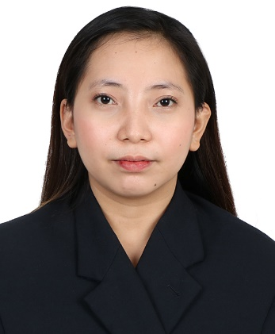

ANGELICA ROSE R. CANAPI
PHLEBOTOMIST/ LABORATORY TECHNICIAN

  ABOUT ME  I am currently working as a Phlebotomist and Laboratory Technician. Dedicated medical laboratory technician who remains calm under pressure and is already given the freedom to handle the majority of tests and equipment work alone by supervisors. Obtained a Phlebotomist license. Eager to continue honing skills in the workplace.    PERSONAL INFORMATION  Address: Purok#4 Sta. Filomena San Mariano  Isabela  Phone: [+63] (999)1590299  Email: angelicaroseee14@gmail.com  CAREER OBJECTIVES  - To apply my knowledge, attitudes, and skills in performing clinical and anatomic laboratory procedures needed to help the physician in the proper diagnosis, treatment, prognosis, and prevention of disease.  - To develop my critical and analytical thinking skills in the Medical Technology profession.  - To become more accurate, reliable, diligent, and focused on the timely, quality completion of an assigned task. Work well under pressure and time constraints within a high-volume environment.  ACADEMIC BACKGROUNDS  - TERTIARY: University of Saint Louis- Tuguegarao  Mabini Street Tuguegarao City Cagayan,  2014- 2019  - SECONDARY: Benito Soliven National High School  District 2 Benito Soliven, Isabela  2010-2014  - ELEMENTARY: Benito Soliven Central School  District 2 Benito Soliven, Isabela  2010-2014 |  |  | COMPETENCIES & SKILLS  - Proficiency in observing safety precautions and handling infectious specimens and understanding laboratory procedures.  - Has a Phlebotomy license  - Knowledgeable in operating laboratory machines.  - Knowledgeable in running or performing quality control in laboratory machines.  - Knowledgeable in performing routine testing.  - A responsible and socially well-adjusted person  - Excellent interpersonal skills to interact courteously and effectively.  - Computer Literate  WORK EXPERIENCE  - PHLEBOTOMIST & LABORATORY TECHNICIAN  Sto. Domingo Diagnostic and Medical Center  February 2021 – Present)  As Phlebotomist and Laboratory Technician I am responsible for supporting Medical Technologists in testing and laboratory maintenance. My duties include recording of test results, sterilizing equipment, and organizing supplies. Below is the list of my duties and responsibilities.  - Collecting blood samples from patients for testing.  - receiving, labeling, and safely storing specimens to be tested.  - Organizing samples in accordance with all safety and other requirements to ensure the safety of personnel and the integrity of specimens.  - maintaining equipment records and daily work logs.  - LABORATORY ASSISTANT  San Mariano Rural Health Unit  November 2020- February 2021)  As a Laboratory Assistant, my work includes organizing laboratory needs, maintaining the laboratory, and performing different laboratory tests for patients according to physician’s requests under supervision. In addition to my work experience below is the list of my task in the institution.  - Collecting and preparing specimens or samples for testing  - Performing laboratory tests.  - Conducting quality checks.  - Maintaining cleanliness and orderliness in the laboratory.  - Checking of laboratory supplies
SEMINAR & TRAINING ATTENDED
- Phlebotomy Training
FDM Training Center for Allied Health Professionals, inc. Quezon City, Philippines
February 2021
- SIX MONTHS OF CLINICAL LABORATORY INTERNSHIP
Cagayan Valley Medical Center
August 2018- January 2019
- HEALTH RESEARCHERS’ CONVERGENCE 2018: “Treasuring Scholarly Works towards Strengthened Evidence-Based Health Practices”
University of Saint Louis- Tuguegarao
April 18-20, 2018
- Basic Life Support Training
Red Cross- Cagayan Chapter
December 2017
- First Aid Training
Red Cross- Cagayan Chapter
December 2017
- 1st Medical Technology Scientific Seminar “Medical Technology Intelligence: Transcending
New Heights Through Connection, Expansion, and Advancement”
July 11-12, 2017
St. Paul University Philippines

CHARACTER REFERENCES
- MRS. ELEONOR VALOIS
Branch OIC
Sto. Domingo Diagnostic and Medical Center (Baclaran Branch)

- MS. IRENE VEJARASCO, RMT
Chief Medical Technologist
Sto Domingo Diagnostic and Medical Center (Baclaran Branch)

- MRS. JONALYN DUMLAO, RMT
Laboratory Head
San Mariano Rural Health Unit

I hereby certify that the above information is true and correct to the best of my knowledge. Thank you for reviewing my application.

ANGELICA ROSE R. CANAPI

