
CHRISTIAN BAYANG AGUSTIN
#45 Tandang Sora St. Victory Norte
Santiago City, Isabela 3311
E-mail: cba122490@gmail.com
Cellphone Number: 0905-1876460

OBJECTIVE:
- Hardworking and energetic Butcher with strong meat cutting expertise and attention to detail interested in obtaining employment; Eager to support the company with meat cutting, preparing and storing activities.

PROFESSIONAL & EMPLOYMENT SKILLS:
- Sanitation standards
- Meat preparation techniques and cuts
- Knife handling and sharpening
- Meat quality inspection
- Deboning and portioning meat

EDUCATIONAL BACKGROUND:
Tertiary:
HRM-Hotel Restaurant Management
Southern Isabela College of Arts and Treads
Santiago City, Isabela
S.Y 2008-2010
Secondary:
Jesus Christ Saves Global Outreach
Santiago City, Isabela
S.Y 2002-2006
Primary:
Santiago South Central School
Santiago City, Isabela
S.Y 1995-2001

TRAININGS ATTENDED:
Santiago City Modern Abattoir
Technical Education and Skills Development Authority (TESDA) – Santiago City Isabela
Slaughtering Operations (SWINE) – NCII
ULI-ACB-90-464-02031-001
Issued on September 25, 2023
Valid until September 24, 2028

WORK EXPERIENCE:
Santiago City Modern Abattoir
- Wear personal protective equipment (PPE’s) as prescribed by the slaughterhouse for proper hygiene before carcass.
- Sanitize and clean the slaughterhouse including tools, equipment, and facilities before and after the operation.
- Bath the swine to avoid getting contaminated
- Move the swine from lairage to stunning area/restraining box
- Sharpening and sanitizing knives.
- Perform sticking at the sticking area
- Removing excess hair & hooves of the swine.
- Perform counter ring bung
- Wash and trim the internal organ
- Performing evisceration
- Perform singeing
- Wash the carcass and label

SCALDING VAT AREA
- Perform of sharpening knives and work safely with knives.
- Bath the swine from handle gently.
- Shackle and lift swine
- Stick and bleed the swine
- Perform de-hairing according to work place
- Scrap-off residual hairs using knives.
- Remove hooves using hooves remover
- Cut the meat according to customer needs
- Sanitizing equipment and production areas all the time to enforce health and safety measure.
- Prepare and place meat cut and products on the display counter so they are keen to shoppers eyes.
- Prepare handling and processing of products to prevent contamination
- Cleaning and washing all materials and equipment used after the operation
- Perform slaughtering procedures before delivering products to meat shop or customers like sticking, evisceration, washing of carcass and internal organs.
- Proper wearing of complete apparel and proper hygiene before handling the meat.

Hours of work per day 8 hours
Working Hours 8:00 p.m to 5:00 a.m
Day worked per week 7 days a week
Salary Php 600.00

Mery Grace Lacaden Tandas (Meat Vendor)
Butcher – Centro East Old Public Market Santiago City Isabela
March 10, 2010 to October 16, 2025

Duties:
- Ensuring the availability of wide range of quality well cut meat for customers.
- Cutting, boning and trimming meat in a way that keeps wastage to a minimum.
- Carrying out temperature checks on meat and recording the readings accordingly
- Using cutting machinery to cut and prepare meat so that it looks appealing
- Weighing portions of meat, wrapping it up and then handling them to customers.
- Taking cash as well as credit card payments from customers who wants to buy meat.
- In quiet periods carrying out various cleaning and administrative duties.
- Making sure the fridge is at the correct temperature to store meat so that it’s safe.
- Dealing with customers who want refunds or who are making complains.

KEY SKILLS AND COMPETENCIES
- Reducing meat wastage wherever possible by cutting skillfully and carefully.
- Able to work in cold, refrigerated rooms where the meat has to be stored.
- Giving customers advice on how to properly wrap up and store the meat they buy.
- Sound knowledge of all meat related Health and Safety, COSHH and legislation.
- Have high standards of personal hygiene, ethics and professionalism.
- Always smartly dressed to impress & know how to wear safety clothes like hairnets and aprons.
- Maximizing customers interaction at every opportunity by carefully listening to them.
Hours of work per day 9 hours
Working Hours 2:00 a.m to 11:00 a.m
Day worked per week 7 days a week
Salary Php 500.00

CHARACTER REFERENCES:

Atty. Alyssa Sheena P. Tan, CPA Mery Grace Lacaden Tandas
City Mayor Meat Vendor
LGU – Santiago City, Isabela Old Public Market Centro East, Santiago City
0909-687-1928
Mr. Arsenio Purugganan
Slaughterhouse Trainor
Technical School, Inc.
Maharlika Highway San Placido Roxas Isabela
0916-160-9521

IDENTIFICATION INFORMATION:
- Driver’s License No. B12-12-000425
- Expired Date December 24, 2027
- Passport No. P5236202C1
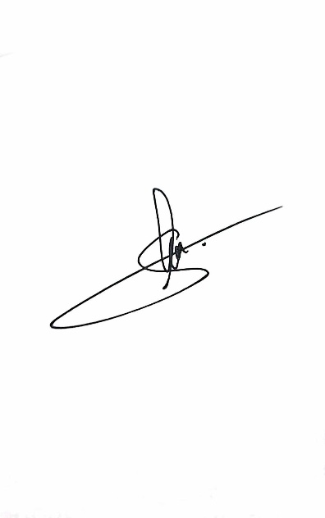
- Expired Date September 11, 2033

I hereby certify that the information above is correct and accurate.

Christian B. Agustin
Applicant

