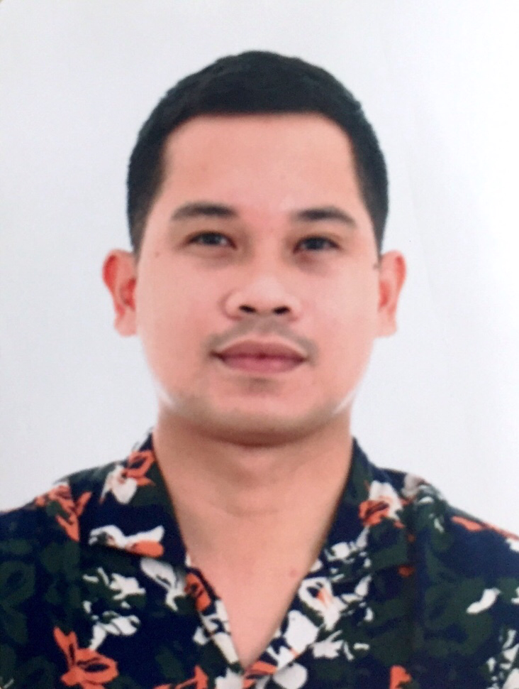
BOBBY PACHO CABILADAS
WELDER ASSEMBLER
Present Address: 1119 Rue Papineau Longueuil, QC
Mobile Number: +1 581 688 4532
Email: bobbycabiladas2@gmail.com
Skype ID: live:.cid.afd43d394a388d64

OBJECTIVE
To gain employment at your company, which will inspire me to enhance my skills in a stable and dynamic workplace, and work as a team player in a positive atmosphere with a good safety practice.

ABILITY
Can handle and weld stainless steel, carbon steel, aluminum, alloy and galvanized in any forms especially in steel structural and even in pipes and plates using (FCAW) Flux Cored Arc Welding, (SMAW) Shielded Metal Arc Welding and (GMAW) Gas Metal Arc Welding with horizontal, vertical, overhead and 6G/6GR position. Can also use (GTAW) Gas Tungsten Arc Welding process in basic positions. Can operate Forklift, Overhead crane, band saw and drill press machines.

EDUCATIONAL ATTAINMENT
High School
School: St. Michael’s College
Address: San Miguel, Iligan City, Philippines
Year: 2007-2011
Elementary
School: Iligan City Baptist Church-New Life Christian Academy
Address: Brother Jeffrey Road, Iligan City, Philippines
Year: 2005-2007
School: Iligan City East Central School
Address: Tambo, Iligan City
Year: 2001-2005

PERSONAL INFORMATION
Civil Status: Co habitation
Sex: Male
Date of Birth: June 7, 1994
Place of Birth: Iligan City, Philippines
Age: 29
Height: 168 cm
Weight: 65 kg
Religion: Roman Catholic
Citizenship: Filipino
Dialects: English, Tagalog, Bisaya
Hobbies: Basketball, Gamefowl breeder

SUMMARY OF DUTIES
• Skilled welder with more that six years of extensive on-the-job experience with the proficiency in Arc welding on different types of Steel on Structural & Pipe metals and also has the ability to work as a Steel Structural Assembler, Welder-assembler, Refractory caster. A flexible and a hard-worker specialized in using FCAW, SMAW, MIG welding, Gas cutting, Plasma arc cutting and different types of power tools with the capability of reading and interpreting drawings in a dynamic workplace with a high standard of good safety practice.

EMPLOYMENT RECORD
Company: EPIQ MACHINERIE
Position: Welder Assembler
Project: Fabrication & assembly of primary metals
Location: Quebec, Canada
Duration: May 29, 2023 to present
Job description:
• Pre start meeting prior to work
• Annalyze the project drawing before doing the fabrication
• Assembly of different metals components with specific design use for pulp & paper machines
• Turn over to the assembly inspector for him to sign PPS (ready to weld) if approved
• After approved by the assembly inspector, full welding using FCAW, GMAW and the symbols & dimension of the weld must be followed precisely
• Then after full weld, the welding inspector will see it if it’s approved or not
• Once approved, I will put a code on in that requires for painting
• Then assembly again another projects, vice versa
• Assembly of structures and componets of the anodes, pulp & paper machines produced by the company
• Operate Forklift used for the transportation of the fabricated metals
• Operate overhead crane used also for the lifting the fabricated heavy metals
• Operate drill press machine used for doing holes in metals base on the specific dimension
• Operate band saw used for cutting different angles of metals based on the plan
• Housekeeping before and after

Company: Freyssinet International Manila Inc.
Position: Lead-man (Welder Assembler)
Project: Retrofitting of Silo’s 1-6 & Installation of Stay Cable Post Tensioning
Location: Republic Cement- Norzagaray, Bulacan, Philippines
Duration: April 5, 2022 to December 17, 2022
Job description:
• Conduct a Pre-star meeting prior to start work
• Assembling and full welding of steel forms use for the concrete deviator of the post tensioning cables
• Assembling and fabrication of hoisting beam which will be use for the transportation of heavy materials
• Installation of counter weight and full welding of hoisting beam parts
• Assembling and fabrication of trolly’s for the oxygen acetylene cage
• Installation of wood forms
• Installation of Rebars
• Perform Stay Cable Post Tensioning
• Housekeeping

Company: Freyssinet International Manila Inc.
Position: Lead-man (Welder Assembler)
Project: Retrofitting of FM1 Material Storage Column, hoopers, posts and walls
Location: Republic Cement- Kiwalan, Iligan City, Philippines
Duration: August 13, 2021 to April 4, 2022
Job Description:
• Conduct a Pre-start meeting prior to work
• Safety briefing of my team members and discuss to them the proper procedure of our task to do which is also given by our Project Engineer.
• Gas cutting of MS steel plate with specific sizes based on the drawing given to me which will be use for the jacketing of the newly repaired existing columns.
• Perform lay out for the design plan position of the MS Steel plate for jacketing.
• Assembling of parts, Tact every corner and full welding of the Horizontal, Vertical and overhead position of the newly jacketed design for the retrofitting of FM1 material storage Columns and walls using SMAW welding process.
• Bending and Assembling of reinforced rebars use for the retrofitting of FM1 material storage walls and columns
. • Chipping of the specific portion of the column, hoppers and walls for the Retrofitting procedure of Material Storage FM1.
• punch list
(Note: I was a former Welder assembler in this company for 3 months and then the Project Manager appreciated my hard-work and flexible ability on site, that is why he promoted me as a Lead-man.)

Company: Concrete Restoration and Repair Technology Inc.
Position: Welder
Project: Material storage truss frame retrofitting
Location: Republic Cement Kiwalan, Philippines
Duration. May 4, 2021 to June 4, 2021
Job Description:
• Reading and familiarized the blueprint of the designed plan
• Mobilization of materials and tools to be use for the work activity
• Lay out and cutting of square tube and Ms plates using Gas cutting torch
• Assembling of the square tubes and Ms plates for the beam support
• Full welding using 7018 high tensile rod with SMAW process
• Punch-list

Company: Kisen International Construction Inc.
Position: Welder Erector
Project: NEPC Power Construction Corp. “HUAWEI PROJECT”
Location: National Capital Region, Philippines
Duration: January 16, 2020 up to November 20, 2020
Job Description:
• Unloading of tower materials from the trailer truck down to the cell site using mobile crane (25 tons capacity)
• Inventory of the tower materials & parts with its code numbers written on the checklist form
• Segregation of tower materials, separation of each segment for the pre assembly preparation
• Assembling each segment, from segment 7 to 1 which is 42 meters high portion of the 4-legged Gt Tower
• Assembling each segment, from segment 6 to 1 which is 38 meters high portion of the 4-legged Gt Tower
• Installation of grounds, cable trays and electrical panels
• Bolt tightening using hand tools

Company: Kisen International Construction Inc.
Position: Pipe Welder
Project: Cement Mill Expansion (Pre-Grinder)
Location: Republic Cement-Kiwalan, Iligan City, Philippines
Duration: October 26, 2018 up to January 15, 2020
Job Description:
- Assembling of rebars for the Piles foundation for the construction of the Pre-Grinder
- Full welding of the rebars member and joints before it will be installed into the pile’s excavation for foundation
- Installation of anchor bolts and checking the final elevation of pedestal
- Pre assembly and installation of structural materials for the Pre-Grinding project at the Republic Cement Iligan Inc
- Assembling and fabrication of Dust collectors, then full welding of parts
- Assembling and fabrication of Mechanical ductings and steel chimney, then full welding of parts
- Full welding of de-dusting pipes
- Full welding of air compressor pipes and flanges of air slides
- Full welding of air compressor pipes & flanges at the cement silo storage
- Full welding of gusset plates and bracing of mechanical structure
- Perform Punch list

Company: Engel Anlagen Technic, Phil Inc.
Position: Welder Assembler
Project: Roto Packer 4
Location: Lafarge Holcim – Lugait, Mis. Or. Philippines
Duration: May 14, 2017 up to May 31, 2018
Job Description:
• Assembling and installation of structural materials for the Roto Packer 4 project at the Lafarge Holcim Cement Plant
  - Pedestal beams
  - Girders
  - Bracing’s
  - Checkered plates for flat-forms
  - Ladders and it’s railings
  - Ducting’s (square to round)
  - Hooper
  - Air slides
  - Air compressor
  - Conveyors
  - Mechanical parts
  - Purlins
  - Roofing’s

- Full welding of hoopers
- Full welding at the joints and bracings of the conveyor bridge which will be used use for the transportation of cement from roto packer to warehouse
- Assembling and fabrication of surge bin for roto packer 4, then full welding of parts
- Assembling of pipes and flanges of air compressor, then full welding
- Assembling of square to round de dusting parts from the vibrating screen to the bucket elevator of the roto packer, then full welding
- Pre assembly and installation of tar-ping bay for the cement consumers trailer trucks
- Full welding of the joints and bracing of the I-beams
- Full welding of the tar-ping bay ladder and railings
- Perform punch list and restoration activities

Company: Gelvic Construction & Engineering, Services
Position: Welder Assembler
Project: Plant wide Mechanical maintenance
Location: Republic Cement – Kiwalan, Iligan City, Philippines
Duration: February 24, 2016 up to May 5, 2017
Job Description:
- Full welding of the newly replace plates during plant shutdown at the cooler area
- Full welding of the newly installed cooler beams and covers
- Full welding of screw conveyor parts during (PMS) preventive maintenance shutdown period at the finish mill area
- Replacement of belt bucket cans during PMS period at the pack house area
- Replacement of bucket cans and chains during PMS period at the finish mill area
- Re-alignment of raw materials conveyors at the burner area during PMS period
- Removal and replacement of sprockets, bearing and other mechanical parts during shutdowns of the cement plant
- Replacement of mud scrapers of the conveyors at the crusher area
- Restoration of mechanical equipment’s during shutdowns
- Preventive maintenance of plant’s heavy equipment parts
- Re assembling and full welding of heavy equipment parts used for the quarry operation (back hoe, dump trucks, pay loaders, forklift)

Company: Vedali Industrial Services
Position: Welder Assembler
Project: Plant wide maintenance
Location: Holcim Cement Luga-it, Misamis Oriental, Philippines
Duration: August 3, 2015 to January 29, 2016
Job Description:
•Assembling and fabrication of different designs of the signages frame, then full welding of parts
•Assembling and installation of Y anchors for the refractory activities around cooler area, then full welding using stainless rod (NOVA310)
•Mechanical and Refractory works during annual and preventive maintenance shutdown since this company is a maintenance contractor of the cement plant.

Company: EC Structural Composites Inc.
Position: Labor
Project: Building Construction
Location: Boracay Island Station 3 Malay, Aklan, Philippines
Duration: May 26, 2015 to June 29, 2015
Job Description:
• Bending and Installation or rebars
• Installation of different kinds of stirrups for slab and beams
• Installation of formwork for building post, beams and slabs
• Assign at the batching plant area for the preparation of pouring activities

Company: Vedali Industrial Services
Position: Welder
Project: Plant wide maintenance
Location: Holcim Cement – Luga-it, Misamis Oriental, Philippines
Duration: June 30, 2011 up to January 30, 2015
Job Description:
• Assembling and fabrication of different signages frame, then full welding of parts
• Full welding of Y anchors for the refractory activities around cooler using stainless rod (NOVA310)
• Assembling and fabrication of the safety park area proposed by the safety department of the plant, then full welding
• Assembling and full welding of the pathway railings at the Jetty pier area
• Assembling and full welding of a frames and purlins for the proposed roofing at the logistics are.
• Plant wide installation of safety signages proposed by the safety department of the plant
• Assembling and fabrication of Safety signages frames to be installed plant wide at Holcim Cement.
• Mechanical & Refractory works during Annual and Preventive maintenance shutdown since our company is considered as a maintenance contractor at Holcim cement plant
• Perform lay out for the designed plan of the pathways, gutters and pedestrian lanes for the painting projects designed for the Safety purposes of the plant
• Perform lay out for the designed and installation of Thermo plastic painting of roads around Holcim Cement designed for the Safety purposes of the plant

CAREER CERTIFICATIONS
Canadian Welding Bureau (CBW)
Process: FCAW/GMAW
Class: Flat & Horizontal
Valid until: 2025-10-19

- PHILIPPINE WELDING TECHNOLOGY SKILLS & SERVICES CENTER, INC.
• Gas Metal Arc Welding NC II
Welders Performance Qualification Test (WPQT)
July 19, 2022
Held at # 586 Gov. A Pascual St. San Roque Navotas City, Philippines

• Gas Metal Arc Welding NC II (Direct Assessment)
July 1, 2022
Held at # 586 Gov. A Pascual St. San Roque Navotas City, Philippines

• Shielded Metal Arc Welding NC II
Welders Performance Qualification Test (WPQT)
May 15, 2022
Held at # 586 Gov. A Pascual St. San Roque Navotas City, Philippines

• Gas Metal Arc Welding NC II (Refreshment Training)
May 15, 2022

Held at # 586 Gov. A Pascual St. San Roque Navotas City, Philippines

- SAFETY ORGANIZATION OF THE PHILIPPINES, INC. (SOPI)
• Control of hazardous energy (LOTOTO)
March 2, 2022
Held at Villaverde, Iligan City, Philippines
- TECHNICAL EDUCATION AND SKILLS DEVELOPMENT AUTHORITY (TESDA)
- Shielded Metal Arc Welding NC II (Direct Assessment)
September 23, 2017
Held at Ditucalan, Iligan City, Philippines

- SAFETY ORGANIZATION OF THE PHILIPPINES, INC (SOPI)
- Energy Isolation
- Confine Space
- Working at Heights
- Power tools
- Hot works
August 13, 2017
Held at Republic Cement Iligan City, Philippines
SAFETY AWARD
• Freyssinet International Manila Inc.
(Certificate of Recognition)
November 2021
Held at Republic Cement Iligan Inc. Philippines

REFERENCES
- LARA MELISSA PENUS
Freyssinet Project Manager
(0917) 864 6046
- ROY D. SABANAL
Freyssinet Project Manager
(0917) 803 8684

- NILDA C. HAMOY
Brgy. Captain of Dalipuga, Iligan City, Philippines
(063) 225-2473

- SIMEON I. MARQUEZ
Safety Practitioner at Republic Cement Iligan, Philippines
(0917) 569 1214

“A faithful man will abound with blessings.” Proverbs 28:20

