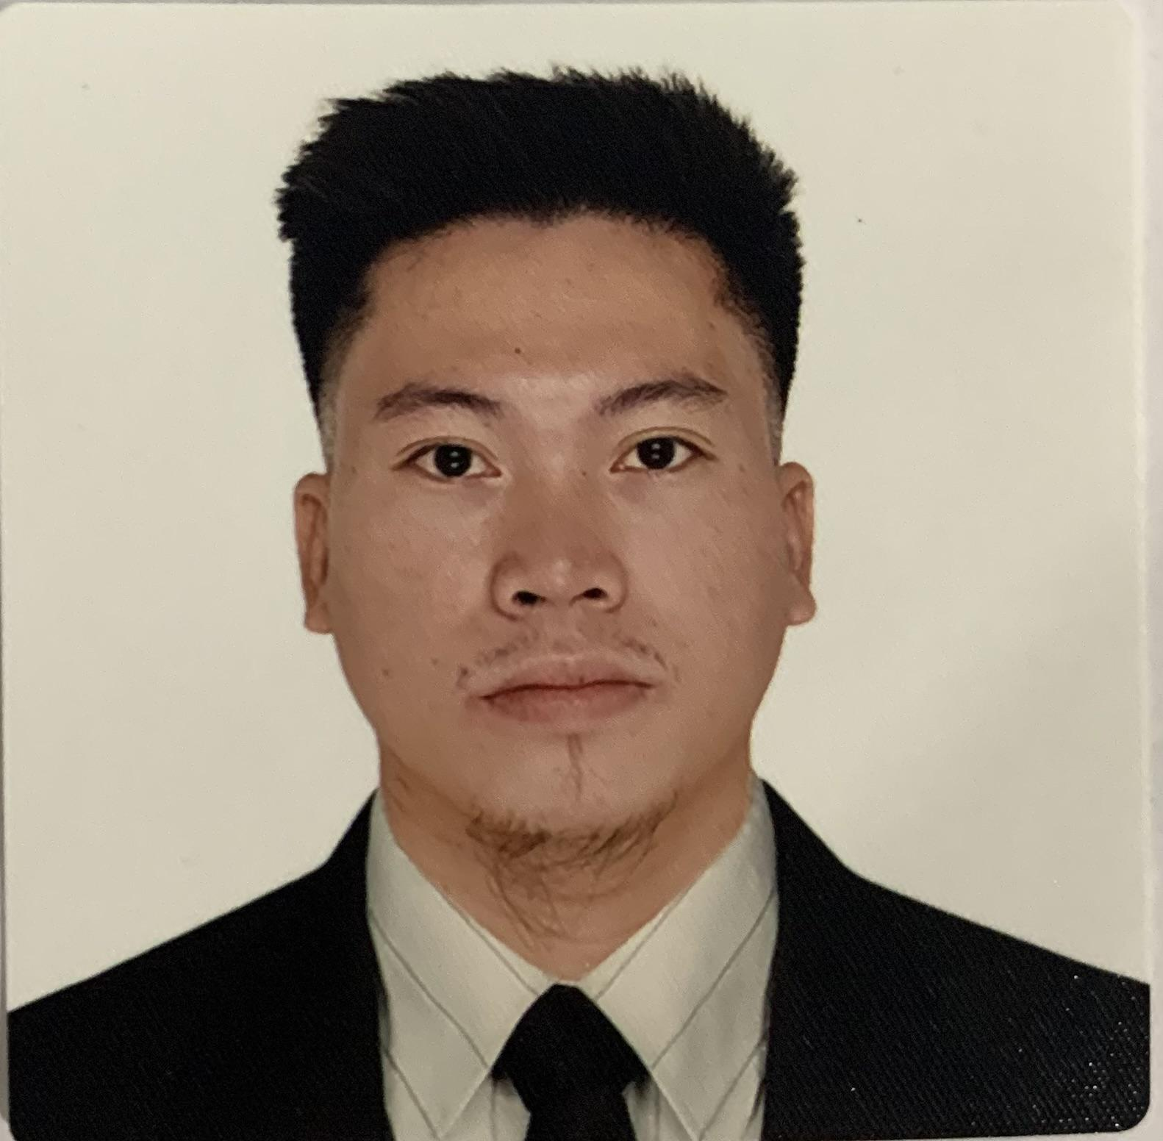

Bobby L. Gamil
Email Address: bobbygamil9@gmail.com,
Skype ID: bobby gamil Tel no. 418-332-7059
Current Address: 9 rue Des Èrables addstock Quebec Canada G0N 1S0

Position Applied:MIG FULL WELDER &TACK WELDER/ASSEMBLER

PERSONAL INFORMATION
Age: 26
Birthday: April 16,1997
Birth Place: R.T.R. Agusan Del Norte
Height: 168 cm
Weight: 61 kgs
Marital Status: Single
Nationality: Filipino
Language: Bisaya, Tagalog, English, Japanese
Mother’s Name: Rosalinda L. Gamil
Father’s Name: Rodolfo D. Gamil
Provincial Address: Buas Matanao Davao Del sur 8003

HIGHLIGHTS:
- expert of MIG WELDER (GMAW)
- Welder and assembler of snow blower and agricultural vehicle, frame loader
- Expert in stick welding and full welding
- Manufacturer welder
- Sheet metal welder
- Metal Press operator
- Forklift operator
- Able to work independently or team
- Strong communication and interpersonal skill
- Attention to detail and able to multi-task
- Able to read blueprints
- Wellingness to learn new skill
- Able to work under pressure with minimal supervision, can work on holiday, overtime, night shift and good team member and team leader's
- Able to weld different basic welding position such as
- Flat Position (1F,1G,1GR)
- Horizontal Position (2F,2G)
- Vertical Position ( 3F, 3G,5G)
- Overhead Position(4F,4G,6G)

WORK EXPERIENCE :

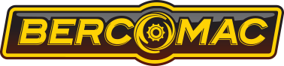
Company Name: Bercomac Ltée
Address: 92 Fortin Nord, Adstock Quebec, Canada G0N 1S0
Position: MIG FULL WELDER&Tack welder/ Assembler
Department: Manufacturer
Duration (MONTH DATE & YEAR): November 8,2022- up to present
Working Hours per week: 40 hours + OT

Job Description:
- Welder and assembler of small and big parts of Snow Blower and Agricultural Vehicle
- Weld tuck Carbon, metal sheet of Snow Blower and Agricultural Vehicle, blade of snow truck
- Hanging a materials for painting
- Buffing
- Drive forklift
- Packaging
- Metal press operator
- Operate Slinging overhead Crane, Grinding
- Able to work under pressure, can work on holiday, Overtime, night shift and good team member
- Weld quality production
Duties and Responsibilities:
- Checking the model type for production of the day, all parts that will be used to build the Snow Blower or Agricultural vehicle
- Establishing a safety environment to minimized accident and hazard within the work place.
- Checking machine current voltage, setting up semi-automatic machine
- Operate the overhead slinging crane for lifting raw materials for preparation of plate parts and to transfer to the work area. Weld carbon steel Semi-automatic welding to joint and assemble part with the use of molding to fit up
- Perform manual welding base on the blue print and welding symbol, conduct visual inspection on welded parts to ensure the quality of production.
- Checking every part assembled in structural form fit to molder and no part is left unassembled.
- Keeping work area clean and organized during work time. Established and understand proper maintenance and care of the equipment used after production
- Quality and quantity of work and time management, punctuality

Tools/Materials/Equipment/Machine used:
- Semi-automatic welding machine and manual
- Overhead slinging crane magnetic and cable wire
- Angle grinder, mini grinder, chalk, flashlight, chipping hammer
- Welding fliers, tape measure, welding clamp, hook, wire brush, marker, cutter wire, Screw drivers
- Air blow machine, metal press machine, Robotic welding machine, blue print
- Manual forklift, Mold, Cold chisel, electrode, hard hat, center punch.
- Leather gloves, safety shoes, welding cable, metal chop saw, welding mask, welding blanket

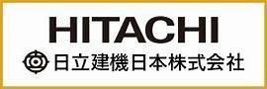

Company Name: Hitachi Construction Machinery Co.,Ltd
Address: Ryugasaki shi Ibaraki ken
Company Industry: Exporter of quality heavy construction equipment in Japan
Position: MIG FULL WELDER&TACK WELDER/assembler
Department: Manufacturer
Duration (MONTH, DATE & YEAR): July 3,2017- May 29,2020
Working hour per week: 40 hrs/week + OT

Job Description:
- ZW100-ZW300 side frame loader,tack and full welder
- Robot welding machine operator
- Weld thick carbon metal sheet frame,
- Slinging Overhead crane operator, metal sheet press, grinding and gauging
- Able to work under pressure with minimal supervision, can work on holiday, overtime, night shift and good team member and team leader’s
- Weld quality inspector/Trainor for newly hired welder

Duties And Responsibilities:
- Checking the model type for production of the day, material code, parts. Understand the basic layout.
- Establishing a safe environment to minimized accident and hazard within the workplace by checking machine current, voltage, gas robot semi-automatic machine, setting up, and preparation of tools. Prepare metal surface by cleaning with wire brushes to remove impurities such as rust grease and moisture.
- Operate the overhead slinging crane for lifting raw materials for preparation of plates, parts for transfer to work place area
- Weld carbon steel Semi-automatic welding tack welding to joint and assemble parts, molding to fit up in a frame plates.
- Conduct inspection if every part is assembled in structural forms, fit according to molder no parts is left unassembled. Program robotic machine welding, repaired defective welds by gauging, grinding
- Perform grinding, remove slags, operate manual welding and semi-automatic to fuse inside parts of structure. Conduct visual inspection on welded parts to ensure weld quality.
- Keeping work areas clean and organized during work time. Established and understand proper maintenance and care of the equipment used after production.
- Quality and quantity of work and time management,punctualtiy
- Supervise newly hired trainees in making frame structure
- Attend training for Crane Special Education, Dust works special education, Industrial robot special Education, Free Grinding and Wheel replacement special education.
- Obtained certificate foreign welding skill evaluation conducted by Japan Welding Engineering Society.

Tools/Materials/Equipment/Machine used:
- Semi-automatic welding machine and manual
- Overhead slinging Crane magnetic and cable wire
- Angle grinder, mini grinder, chalk, flashlight, Chipping Hammer,
- Welding fliers, tape measure, welding clamp, hook, wire brush, marker, cutter wire, Screw drivers
- Airblow machine, Metal press machine, Robotic welding machine, blue print
- Manual forklift, Mold, Cold chisel, Electrode, Hard hot, Center punch
- Leather Gloves, safety shoes, welding cable, metal chop saw, welding mask, Welding blanket
- Respirator mask, face shield, testing plate, squaring tools, safety glasses, welding table, adjustable
- Carbon steel, cast iron, steel
- Wire
- Metal

Company Name: Gilbert Anenias Welding Shop (local)
Address: Brgy. San Gregorio San Pablo City, Laguna
Position: SMAW&MIG welder
Duration (MONTH, DATE & YEAR): January 18, 2016-February 6, 2017
Working hour per week: 40hrs/week

Duties & Responsibilities:
- Stick welding, aluminum, carbon steel welding
- Repair side car
- Fabricate gate steel, window grills

Tools/Materials/Equipment/Machine used:
- Manual Welding machine, chipping hammer,
- Welding fliers, tape measure, steel wire brush, cold chisel marker,
- welding table, metal chop saw, Angle grinder, mini grinder, leather Gloves, safety shoes, welding cable, welding mask, googles
- metal sheet, steel, welding blanket
- metal bender machine

Employment Gaps:
Duration: June 2020 up to present
Reason: due to COVID 19 travel restriction
EDUCATIONAL BACKGROUND

Elementary:
School Name: Matanao Elementary School
Address: Matanao Davao Del Sur
Duration (Month & Year): June 2004-May 2009
High School:
School Name: Matanao National High School
Address: Matanao Davao Del Sur
Duration (Month & Year): June 2009- March 2013
Vocational:

School Name: Carmelo C. De Los Cientos Sr. National Trade school
Course Taken: SHIELDED METAL ARC WELDING (SMAW) NC II
Location: Padada Davao Del Sur
Duration (Month & Year): June 24, 2015 to December 13, 2015

School Name: PHIL-NIPPON TECHNICAL COLLEGE
Course Taken: Basic Japanese Language Course which includes Cross Culture Study and Work
Ethics
Duration (Month & Year): May 13,2016- July 14,2016

TRAININGS AND SEMINARS ATTENDED:
School Name: Globe Maritime Training Center
Training: Basic Training
Issued on July 23, 2021
Date of Expiry: July 23, 2026

Scholl Name: Globe Maritime Training center
Training: Ship Security Awareness Training and Seafarers with Designated Security Duties
Issued on July 23, 2021
Date Expiry: Unlimited

School Name: TESDA
Course/Training: NC II in Flux Cored Arc Welding (FCAW)
Issued on March 5,2021
Valid until March 4,2026
Certificate No: 21031402004623

School Name: TESDA
Course/Training: NC II in Gas Metal Arc Welding (GMAW)
Issued on March 4,2021
Valid until March 3,2026
Certificate No: 21031402004538

School Name: Japan Welding Engineering Society
Course/Training Taken: Basic Welding Skill
Location: Japan
Duration (Month & Year): Feb.14,2018
No:S1A 170491

Certificate Of Completion of Special Education
Certificate of Completion No: 17-04-001
Education subject: Industrial Robot Special Education
Duration: February 5th and 10th 2018
Name of Educator: 3 Ryugasaki City, Ibaraki Prefecture
KCM Human Resources and General Affairs Department

Certificate of Completion of Special Education
Certificate of completion No: 17-01-031
Education Department: Crane Special Education
Duration: July 6- 7, 2017
Name of Educator: 3 Ryugasaki City, Ibaraki Prefecture
KCM Human Resources and General Affairs Department

Certificate of Completion of Special Education
Certificate of Completion No: 17-08-029
Education Subject: Free grinding and wheel replacement special education
Duration: July 10, 2017
Name of Educator: 3 Ryugasaki City, Ibaraki Prefecture
KCM Human Resources and General Affairs Department

Certificate of Completion of Special Education
Certificate of Completion No: 17-05-015
Duration: July 3-4, 2017
Name of Educator: : 3 Ryugasaki City, Ibaraki Prefecture
KCM Human Resources and General Affairs Department

CHARACTER REFERENCE:

Romeo Becon
Welder NRC Industries
Telephone number: 450 531 5638

Name: Juneford Sollorano
Trainee Supervisor @ Friend Nippon
Dai 1 denpa building 7 floor 2
Chome-4-4 Sotokanda,
Chiyoda city, Tokyo 101-0021

Name: Ruth M. Jajectin
Position: President
Email Add: whitedove_recruitment@yahoo.com
Mobile/Telephone Number: (049) 530-1005, (049) 530-007
Address: Lot 7-14 Block 37- Calamba Tagaytay road, Madison South
Brgy. Batino, Calamba City , Laguna , Philippines
I hereby certify that the above information is true and correct to the best of my knowledge and belief

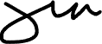
Bobby L. Gamil
FULL NAME and Signature

