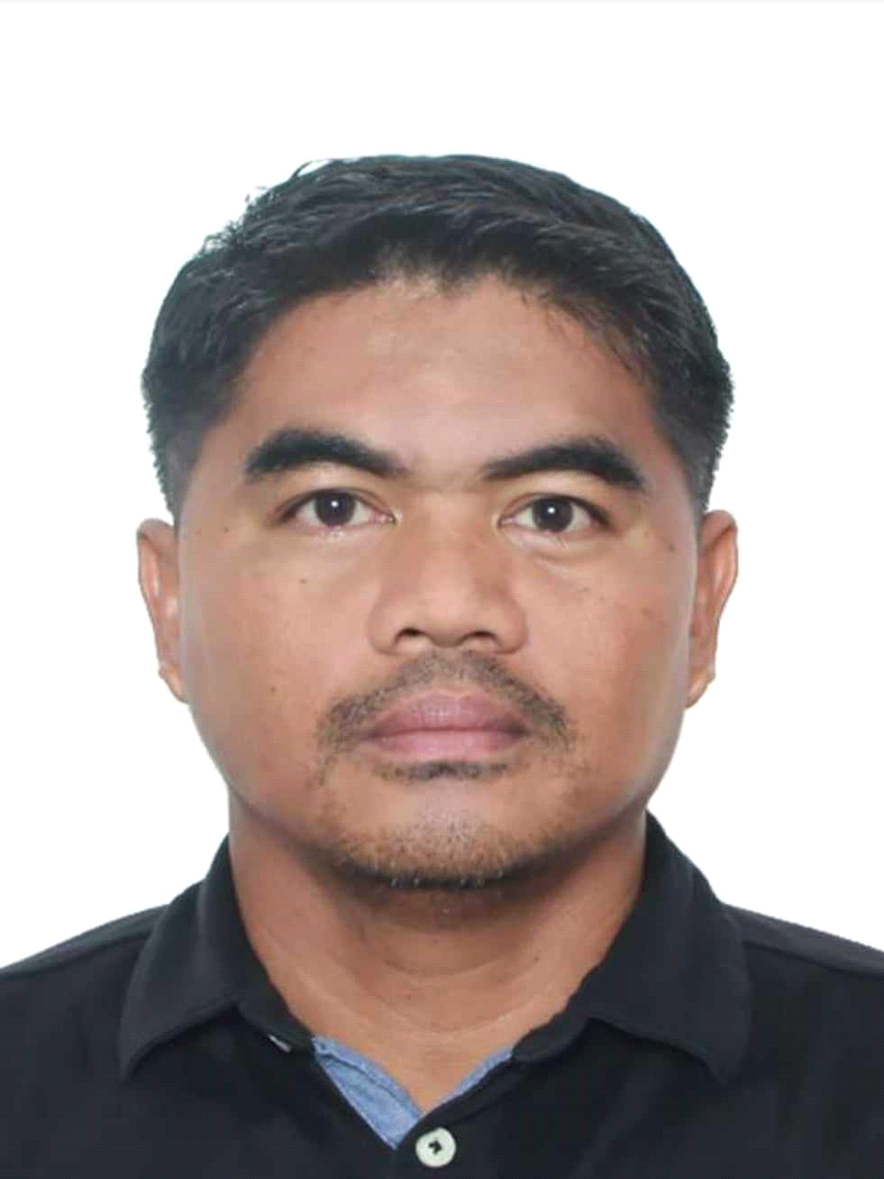
BRANDO R. GALANG
Contact No.: 0992-493-3870
Gmail: brandogalang844@gmail.com
Position: Heavy Equipment/Forklift Mechanic

Job Objective: As a Mechanic I would utilize my skills/knowledge and experienced to be able to make a positive contribution to the company.

Highlights of Qualifications:

- Strong experience in maintaining and repairing diesel and gas engine, heavy equipment, truck, light vehicles.
- Familiarity with pneumatic, hydraulic, electrical and mechanical repair.
- Ability to maintain records of schedule and preventative maintenance carried on equipment
- Ability to troubleshoot machine problem and repair accordingly.
- Has experienced to order parts needed to fix the machinery.
- Relates technical information easily, by using On-Board Diagnostic (OBD) tool.
- Multi-tasker, flexible and hardworking
- Can operate excavator, forklift, road compactor, scissor lift, pay loader and
skid loader
- Skilled to read and comprehend instruction provided by manufacturers
- Can do both stick welding and gas welding works.
- Can repair or overhaul concrete hydraulic breakers.

PERSONAL DATA

Date of Birth : January 12, 1981
Place of Birth : Quitang, Pasacao, Camarines Sur
Citizenship : Filipino
Height : 159 cms.
Weight : 65 kgs.
Marital Status : Married
Religion : Member: Church of God International (MCGI)
Languages Spoken : Tagalog and English
Passport Number : P5360672C

Address : Purok 4 Brgy. Calasgasan, Daet, Camarines Norte

In case of Emergency
Contact Name : Realyn A. Galang
Relationship : Spouse
Contact No. : 0921-6076-711

EDUCATIONAL BACKGROUND

Vocational : Camarines Sur Institute of Fisheries and Marine Sciences (TESDA)
Location : Camarines Sur
Course : Two-year Automotive Service Technician
Inclusive Date : June 2005-April 2007

College : Camarines Sur State Agricultural College (CSSAC)
Location : Camarines Sur
Course : Bachelor of Science in Marine Biology
Inclusive Date : June 2000-2004

Vocational : DBS Computer Center Inc.
Location : Barlin Street, Naga City, Camarines Sur
Course : One-year Computer Technician
Inclusive Date : June 1998- March 1999

High School : Pasacao School of Fisheries-CASIFMAS
Location : Camarines Sur
Inclusive Date : June 1994-April 1998

WORK EXPERIENCE (Present to Previous)

I.
Position : Field Service Mechanic
Date : October 12, 2018 up to present
Company Name : Marine Power Ltd.
CompanProfile : Distributor/ maintenance and repair
Location : 611 Marina Drive Grand Cayman, Cayman Islands.
: P.O. Box No: 1972 Grand Cayman KY1-1104 Cayman Islands.
: Tel. No.: 345-947-1945
Department : Fleet and Field Service Maintenance

Duties and Responsibilities:

- Secure safety at all times inside and outside the motor pool.
- Maintains all tools and equipment in the vehicle maintenance shop; maintain cleanliness and
safe work environment.
- Shop and Field preventative maintenance and repairs vehicles, forklifts and heavy equipment
- Verified vehicle serviceability by conducting test drives and adjusting controls and systems.
- Repairing and maintaining automotive transmissions and under chassis.
- Make parts requisition and assessment of equipment.
- Make evaluations and reports.
- Escort transportation of brand-new forklifts to customers' places from port.

Type/Brand/Model of Equipment Handled:
- Forklifts/PiggyBack
- M5000/M5500/Excavator
- KX121/Telehandler/Compressor/Generators.
- Toyota/ Hyundai 45DS-7/Crown C-5/SP/RR
- Low-bed Trailer.
- Skid loader Bobcat S220.

II.
Position : Light and Heavy Equipment Mechanic
Date : January 4, 2016 - September 2018
Company Name : Asian Aerospace Philippines International.
Company Profile : Private Aviation Company (Owner of Air Taxi.Ph)
Location : Lima Gate, Andrews Avenue, Pasay City, Manila
Department : Motor pool

Duties and Responsibilities:
- Secure safety at all times inside and outside motor pool.
- Maintains all tools and equipment in the vehicle maintenance shop; maintain cleanliness and
safe work environment.
- Performs preventative maintenance and repairs vehicles, ground equipment and equipment implement.
- Verified vehicle serviceability by conducting test drives and adjusting controls and system.
- Repairing and maintaining automotive transmissions and under chassis.
- Make parts requisition and assessment of equipment.
- Make evaluation and reports.
- Escort transportation of air craft parts and aviation gas.

Type/Brand/Model of Equipment Handled:
- Toyota Vios, Innova, Grandia and Hilux FX, Mitsubishi L300 (van and drop-side0, Isuzu Elf, Hyundai Starex, Honda Civic, Mitsubishi Multi-cab.
- Mitsubishi Canter, Mitsubishi Fuso Wing Van, Mitsubishi Forward Boom Truck
- Mitsubishi Drop-side Trailer, Mitsubishi Low-bed Trailer,
- Mitsubishi Fuso Self Loader and Tractor Head.
- Pay loader Komatsu WA-350, Hyundai Excavator R200W, Komatsu Mini Excavator PC-30
- Road Roller Compactor/Dynapac CA-215, Crane Kobelco R450 and R250, Forklift TCM/FD70
- Scissor lift-Isuzu, Man lift-Mitsubishi, Forklift-Daewoo BC30-S, Skid loader Bobcat S220

II.
Position : Hydraulic Mechanic/ Field Service Mechanic
Date : June 17, 2014 – January 3, 2016
Company Name : Good Morning International (Hyundai*Daewoo)
Company Profile : Branch Dealer of Hyundai Excavators and other Earth Moving Equipment
Location : (Legazpi City Branch) Lakandula Drive, Legazpi City, Albay
Department : Motor pool

Duties and Responsibilities:
- Perform PRE and POST delivery inspection of unit.
Type/Brand/Model of Equipment Handled:
Excavator Wheel loader Skid Loader
Breaker Vibro hammer R250LC-7 HL650-7A
HDB210 DPD350 R220LC-9s
HL730-7A HSL850-7A GM220
DPD600 R180W-9s R160LC-9s
R140W-9s

- Upheld top-quality workmanship and excellent customer service.
- Communicated effectively client’s operator and mechanic on future problems and repairs that might need attention
- Performed periodic maintenance system.
- Conducted routine and scheduled maintenance services such as oil changes, lubrications and tune-ups.
- 50-3000 hours. Warranty service (after sales).
- Diagnosed vehicle malfunctions and write repair orders.
- Inspection: inspect-investigate-picture-report.
- Troubleshoot: evaluate-findings-recommendation.
- Service: safety/preparation-dismantling-parts order-assemble-testing

III.

Position : Heavy Equipment Mechanic
Date : May 16, 2008-May 15, 2014
Company Name : D.M. Consunji Inc. (DMCI)
Company Profile : Triple “A” Construction Company/Contractors Engineers
Location : Levi Mariano Avenue, Ususan, Taguig City, Manila
Department : Motor pool/Earthmoving Section

Duties and Responsibilities:
- Perform safety procedures before a repair.
- Periodic and corrective maintenance of the following earth moving equipment: excavator, roller, skid loader, wheel loader, grader, breaker, vibro-hammer, front dumper.
- Inspect assigned equipment to ensure it is safe to operate
- Troubleshoot malfunctions to determine root causes.
- Disassemble engines and repair or replace defective parts.
- Removed and replaced component parts like belts, pumps, & brake systems.
- Perform equipment services and repair such as evaluation of unit.
- Fabricates and performs welding as necessary.
- Cleaning of unit.
- Re-sealing of cylinders.
- Replacement of busted hose and fittings.
- Operate and testing unit being repaired.
- Make a report.
- Secure cleanliness and orderliness of motor pool specially working place.

Type/Brand/Model of Equipment Handled:
Crawler/Mobile Excavator, Komatsu PC200 LC 7-8,
Caterpillar 320d, Hyundai R220LC-9,
R210LC-7 and R140W-7, Road grader (champion 710A),
Pay loader (Kawasaki 60Z111-IV), Front Dumpers (Benford 500APN Thwaites all
drive),
WUXTOPALL SD30-380, Terex PS3000,
Skid loader (bobcat S220), Scissor’s and man lift (pinguenly haulotte H18SDX,
Haulotte H25TPX), Compactor’s Vibratory Rollers

TRAININGS AND SEMINARS

Training Center : Vetasses contracted by Trades Recognition Australia(TRA)
Course: : Skills Assessment (Certificate III in Automotive Mechanical
Technology- heavy vehicle mobile equipment)
Location : Manila, Philippines
Date : January 31, 2013

Training Center : Lisam Enterprises Inc. (Nissan/Servitek Service Department)
Course : On-the-job training
Location : Naga City, Camarines Sur
Date : November 2007-March 2008

Training Center : Technical Education and Skill Development Authority (TESDA)
Course : National Certificate (NCII) no.080503021338
Location : Naga City, Camarines Sur
Date : December 13, 2007

Training Center : Universidad de Sta. Isabel, College of Arts and Sciences
Course : Seminar on “Clean Air Act: An Effort for Ecological Awareness"
Location : Naga City, Camarines Sur
Date : February 28, 2003

Training Center : Bureau of Fisheries and Aquatic Resources (BFAR)
Course : On the job training
(Brackish aquaculture and milkfish hatchery operation and management)
Location : San Agustin, Pili, Camarines Sur
Date : April 6 - May 4, 2004

CHARACTER REFERENCES

Name : Mr. Ricardo Lico
Company : Asian Aerospace
Position : Ground Transport Supervisor
Relationship : Supervisor
Contact details : 0998-587-2190

Name : Mr. Dave Mabazza
Company : Hyundai Heavy Industries (Philippines)
Position : After Sales Service Supervisor
Relationship : Supervisor
Contact details : 0947-050-0134

Name : Mr. Joel Molina
Company : D.M. Consunji Inc. (DMCI)
Position : Base shop Supervisor
Relationship : Supervisor
Contact details : 0923-591-1368

Name : Rowel V. Abad
Company : UNITED Forklift and Access Solution,Melbourne,Australia
Position : Mechanic
Relationship : Co-worker (DMCI company)

