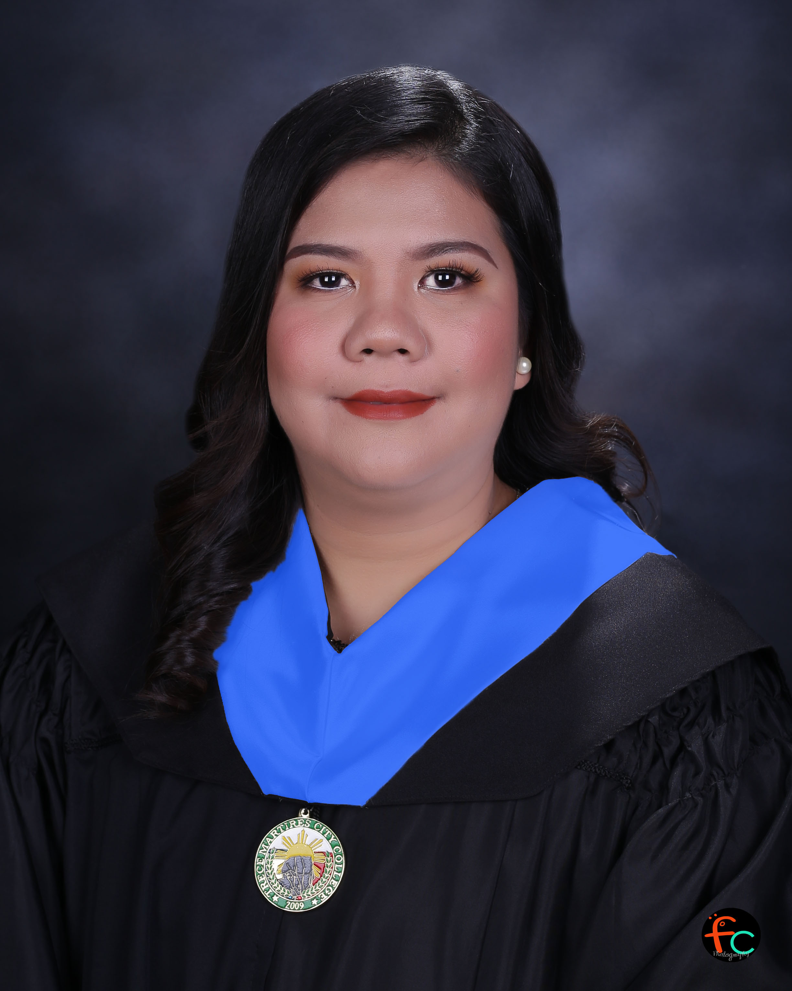 |  | angelica bolina  SECONDARY EDUCATION TEACHER MAJOR IN FILIPINO
B12 L2 Beverly Homes Cabuco,  Brgy.Cabuco, Trece Martires City Cavite Philippines  4109  mhine0788@gmail.com  Contact #: 09106933670  PERSONAL INFORMATION  Nickname  : Angel  Age  : 36y/o  Birthdate  : July 07, 1987  Place of Birth  : Manila  Sex  : Female  Civil Status  : Married  Citizenship  : Filipino  SSS NO.  :34-0306371-9  TIN NO.  : 266-324-548-000  PHIL. HEALTH NO.  : 08-050772355-5  PAG-IBIG NO.  : 1030-0142-9352  PRC NO.  :1980058 |  | EDUCATION  TERTIARY  : Cavite State University (BS Computer Science) Indang, Cavite  2004-2006 (undergraduate)  :Trece Martires City College  Bachelor of Secondary Education Major in Filipino Trece Martires City College  2016- 2020  SECONDARY  : Raja Soliman High School  La Chambre, Binondo, Manila  2000-2004  PRIMARY  : San Aquilino Elementary School  San Aquilino, Roxas Or. Mindoro  1994-2000  WORK EXPERIENCE  TIG WELDER  : SHOWA Aluminum Manufacturing Philippines Corp.  B1 L1 Phase 3 First Cavite Industrial Estate Langkaan, Dasmariñas, Cavite  NOVEMBER 28, 2006 – MAY 20, 2013  REAL ESTATE AGENT  : Rise and Shine Realty Inc.  (part time)  Manggahan, 4107 General Trias , Cavite  February 2009 – Present  PRACTICE TEACHING  : TRECE MATIRES CITY NATIONAL HIGH SCHOOL – CABUCO EXT.EXPERIENCE  NOV. 2019 – MARCH 2020  JHS- SHS TEACHER  : Gateway Integrated School of Science and Technology Sitio Tinungan Brgy. Manggahan Gen. Trias Cavite  AUGUST 17, 2020 – APRIL 30, 2021  SHS TEACHER  : Notre Dame of Trece Martitez  Don Bosco Executive Village, Brgy. Cabuco  Trece Martires City Cavite  SEPTEMBER 2021-JUNE 2022  FILIPINO INSTRUCTOR  : Trece Martires City College  Trece -Indang Road Brgy. Luciano, Trece Martires City Cavite  February-2023- Present
QUALIFICATION
- LET passer (Licensure Examination for Teacher)
- Computer Literate – can perform Microsoft Word, Microsoft Powerpoint

SEMINARS

SEMINAR ON VIOLENCE AGAINST
WOMEN AND CHILDREN
Trece Martires City College, Cavite
August 11, 2016

GENERAL ASSEMBLY OF PRIVATE SCHOOL

OWNERS, ADMINISTRATORS PRINCIPALS, SCHOOL HEADS, KEY TEACHERS, AND SENIOR HIGH SCHOOL TEACHERS, AND STUDENTS
Trece Martires City Gymnasium, Trece Martires City, Cavite
June 30, 2016

ENHANCING PROFESSIONALISM AMONG EDUCATORS
Trece Martires City College, Cavite
March 16, 2019

IN-SERVICE TRAINING (INSET) FOR JUNIOR HIGH SCHOOL TEACHERS
Gateway Integrated School of Science and Technology, Sitio Tinungan Campus NOVEMBER 2-4, 2020

CHARACTER REFERENCES

Mr. LOUIE ROASA : Planning Supervisor
SHOWA Aluminum
Manufacturing Philippines
Corp.
Contact #: 09171605521

Ms. Flora Camo : HR Manager
Kumkang Ceramics
Contact #: 09778518659
MS. Ria Flores : DEAN of College of
Management
Contact #: 09778491707

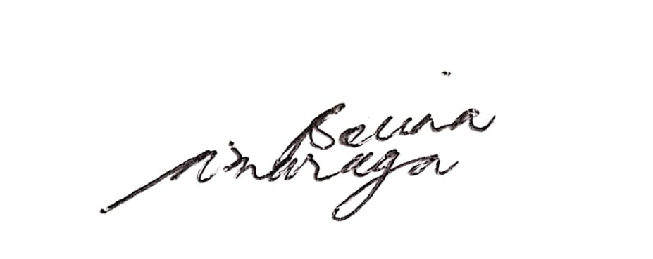
I hereby certify that all the above information is true and correct to the best of my knowledge and belief.

ANGELICA A. BOLINA
APPLICANT

