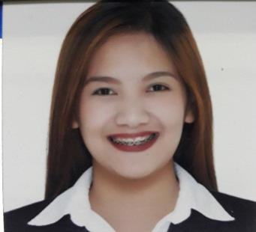
GOCE, APRIL ESCANO
#241 San Felipe Padre Garcia Batangas
Mobile no.: 0915-749-8248
Email Address: aegoce@gmail.com

OBJECTIVE: Highly experienced in providing online, virtual support in terms of customer support in an e-commerce business, with special talent in managing emails and scheduling duties with the aim of ensuring smooth office procedures.

EDUCATIONAL BACKGROUND:

TERTIARY Lyceum of the Philippines Univeristy-Batangas
Capitol Site, Batangas City
BS in Medical Laboratory Science
June 2012 – May 2016

SECONDARY Holy Trinity School
Marcelo H. del Pilar St. Padre Garcia Batangas
June 2008 – May 2012

PRIMARY Holy Trinity School
Marcelo H. del Pilar St. Padre Garcia Batangas
June 2002 – May 2008

WORK EXPERIENCE:

September 2016 - October 2018 Medical Laboratory Scientist
N.L. Villa Memorial Medical Center
F. Manalo St. Lipa City, Batangas

October 2019 – July 2021 Senior Medical Laboratory Scientist Dr. R. Rosales Memorial Medical Hospital Inc. Poblacion Padre Garcia, Batangas

Duties and Responsibilities
- Determines normal and abnormal components of body fluids by conducting chemical analyses of blood, urine, spinal fluids, and gastric juices.
- Analyzes blood cells by counting and identifying cells, using microscopic techniques and procedures.
- Prepares blood, plasma, and platelets for transfusions by conducting blood group, type, and compatibility tests.
- Ensures operation of analyzers and other laboratory equipment by calibrating; completing preventive maintenance requirements; following manufacturer's instructions; troubleshooting malfunctions; calling for repairs; maintaining equipment inventories; evaluating new equipment and techniques.
July 2021 Up to Present Rural Health Unit of Padre Garcia
Municipality of Padre Garcia
Poblacion Padre Garcia Batangas
Medical Technologist

Duties and Responsibilities

- Determines normal and abnormal components of body fluids by conducting chemical analyses of blood, urine, spinal fluids, and gastric juices.
- Analyzes blood cells by counting and identifying cells, using microscopic techniques and procedures.
- Prepares blood, plasma, and platelets for transfusions by conducting blood group, type, and compatibility tests.
- Ensures operation of analyzers, and other laboratory equipment by calibrating; completing preventive maintenance requirements; following manufacturer's instructions; troubleshooting malfunctions; calling for repairs; maintaining equipment inventories; evaluating new equipment and techniques.

CHARACTER REFERENCE:

Mrs.Teresita G. Lazarte, RMT
Chief Medical Technologist
Laboratory Department
N.L Villa Memorial Medical Center

Jocelyn L. Tan, RMT
Chief Medical Technologist
Laboratory Department
Dr. R. Rosales Memorial Medical Hospital Inc.

Annie M. Awat, RMT
Chief Medical Technologist
Laboratory Department
RHU-Padre Garcia

