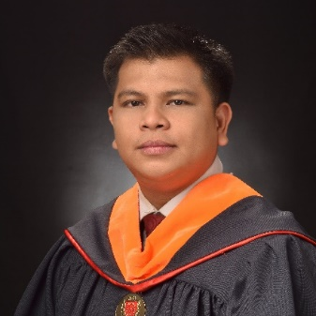
ALLAN DONAIRE
Block 24 Lot 8 Phase 2 Pamayanang Maliksi Pasong Kawayan 2 Gen. Trias, Cavite, Philippines
09692942237 | AllanDonaire30@gmail.com
SUMMARY

To be able to achieve a position in which my field of knowledge and technical expertise can be applied.

EXPERIENCE

02/2007 to Current Senior Equipment Maintenance Technician
Analog Devices Inc. – Gen. Trias, Cavite, Philippines
- Responsible in maintaining handlers’ proficiency in the line.
- Performing handler preventive maintenance and calibration.
- Conducts online and offline repair.
- Performs handler qualifications.
- Conducts modifications on the handlers to increase productivity.
- Recommends all needed parts to make all machines running in good condition in all time.
- Responsible for giving Line Support whenever long down time happens in the test floor.
- Performed diagnostics and troubleshooting to evaluate equipment performance and increase reliability.
- Set up equipment to test and verify functionality and performance.
- Sourced replacement parts to refurbish defective equipment.
- Prepared operational reports to update supervisors with developments.
- Communicated product and machine failure details to address and resolve root causes.
- Interpreted manuals and manufacturer instructions to assemble, install and troubleshoot devices.
- Trained and coached junior team members to maximize knowledge and competencies and increase performance.

06/2004 to 02/2007 Preventive Maintenance Technician
Maxim Philippines Operating Corp. – Gen. Trias, Cavite, Philippines
- Responsible in troubleshooting and repair of major trouble in all Symtek, MT8589 and I-Button handlers.
- Ensures preventive maintenance and calibration were performed on time.
- Conducts modifications on the handlers to increase productivity.
- Recommends all needed parts to make all machines running in good condition in all time.
- Responsible for giving Line Support whenever long down time happens in the test floor.

SKILLS

- Electrical Fault Diagnosis
- Assembly and Production
- Process Improvement
- Preventive Maintenance
- Equipment Maintenance
- Teamwork and Collaboration
- Mechanical Knowledge
- Reporting and Documentation
- LEAN Manufacturing

- Construction Management
- Optimal Manufacturing Processes
- Issue Analysis
- Team Training
- Safety Compliance
- Equipment Calibration
- Maintenance and Repair
- Quality Control

EDUCATION

2017 Bachelor of Science: Computer Engineering
Lyceum of the Philippines University – Manila
- ETEEAP program
- Graduate

2004 Bachelor of Science: Electronics Communication Engineering
Technological University of the Philippines – Manila
- Member of Organization of Electronics Communication Engineer Students (OECES)
- Member of Institute of Electronics and Communication Engineers of the Philippines, Inc. (IECEP-NSC)
- Undergraduate

2002 Certificate of Higher Education: Computer Engineering Technology
Technological University of the Philippines – Manila
- Academic Achievement Award
- Graduate

