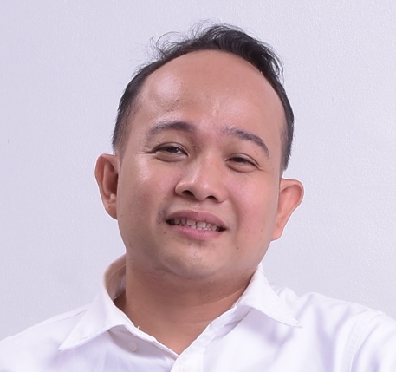
NOEL B. ACOSTA
Home Address: Blk 5 Lot 30 Yale St.
Victoria Homes, Tunasan, Muntinlupa City, Metro Manila PH 1773
Contact Number: 09479176273
E-mail Address: acostanoel3004@yahoo.com

CAREER SUMMARY
- Reliable and Skilled Building Maintenance Electrician in the Electrical industry.
- Excels in residential building, mall building, condominium building and hotel building.
- Preparations and clean-up site.
- Able to read blueprints of Building plan.
- Skilled and safe operation of Electrical equipment focused on efficient and timely completion of projects.
- A team player and always willing to learn.

SKILLS AND QUALIFICATION

- Experienced in High rise Building
- Skilled in lay-out of piping and roughing ins
- Terminating and troubleshooting of electrical
- Able how to use tester
- Experience how to conduct proper preventive maintenance of electrical system
WORK HISTORY

WOODLANE EVENTS PLACE (2022 UP TO PRESENT)
Building Electrical Supervisor
- Piping and Lay-out of Electrical Lightning, Power, and Main Breaker
- Conduct Monthly Preventive Maintenance of Electrical System
- Retightening of Electrical Panel
- Conduct Insulation Resistance Megger Testing
- Gathering Parameters of Electrical System Conduct Cleaning of Electrical Panel
- Analyse Electrical Plan

AZUMI BOUTIQUE HOTEL (2021 TO 2022)
Supervisor/Electrical Technician
- Lead and guide a team of 10 in working efficiently adhering to safety standards
- Troubleshooting of Electrical System, Aircon System, Mechanical, Civil and Plumbing
- Conduct Monthly Preventive Maintenance of Equipment/Electrical system
- Conduct Daily Checking of electrical
- Gather Parameters of electrical
- Piping and lay-out of Electrical System
- Conduct Testing of Genset With load and No load

GLORIETTA MALLS MAKATI (2014 TO 2021)
Electrical Technician
- Piping and Lay-out of Electrical Lightning, Power, and Main Breaker
- Conduct Monthly Preventive Maintenance of Electrical System
- Retightening of Electrical Panel
- Conduct Insulation Resistance Megger Testing
- Gathering Parameters of Electrical System Conduct Cleaning of Electrical Panel
- Analyze Electrical Plan

STELSEN CORP. MAKATI (2010-2014)
Electrical Technician
- Install, Repair, Lay-out and Maintain Electrical System including Lighting Fixtures Electrical Outlet and Wiring
- Lead quality installation based on system design specification and repair faulty equipments
- Inspected electrical system to identify safety hazard and faulty equipment ensuring compliance with electrical code
- Analyze Electrical Plan

TRAINING
- Basic Occupational Safety and health with 2 hours training of trainer and Safety officer

____________________________________________________________________________________________________
I hereby certify that the above information is true and correct to the best of my knowledge.

NOEL B. ACOSTA
Applicant

