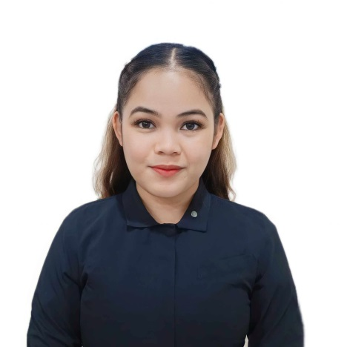

ANGEL BETH M. ALABAT



- Basic Computer Literacy Skill
- Organizational Skill
- Time-management Skill
- Adaptable

JOB EXPERIENCE
Caraga Regional Hospital | February – May, 2023

IT Support Intern
- Provided technical support to employees, resolving hardware and software issue.
- Assisted in the maintenance and troubleshooting of the company's IT infrastructure.

- .
- Coordination des calendriers et des réunions pour l'équipe de direction selon les priorités.
Monitoring Clerk
Espoir School of Life, Inc. | February – March, 2022

angelbethalabat5@gmail.com

©AZURIUS - My-resume-templates.com
PROFILE
Motivated and results-driven information system graduate seeking a challenging as any position. To manage secretarial duties like sorting and sending mail as a professional.

LANGUAGES
- English
- Bisaya
- Tagalog
+63 9631504700
- Dancing
- Recreational & Outdoor Activities
- Cooking
CONTACT
SKILLS
HOBBIES

- Monitored operation and reviewed records and metrics to understand company performance.
- Sort and distribute correspondence as soon as possible.
- Ensure information is accurate and valid by creating and updating records.

Caraga Regional Hospital | 2023 – Up to Present

Clerical Aide

- Help colleagues and set up the office in way that streamlines processes.
- Sort and distribute correspondence as soon as possible.
- Ensure information is accurate and valid by creating and updating records.

Surigao State College of Technology | 2016

High School Diploma
Surigao State College of Technology | 2018

Science, Technology, Engineering and Mathematics
Surigao del Norte State University | 2023

Bachelor of Science in Information System
EDUCATION

