Dan Palacio Gacoscosim
Block 3, Lot 14, BF Country Homes, Fuentes Road, Brgy. Pajac, Lapu-Lapu City, 6015, Cebu, Philippines
(+63) 953 096 9634 – gacoscosimdanp@gmail.com

OBJECTIVE

I currently work as an Explosive Ordnance Disposal Technician in the Philippine National Police but am looking to work as a welder in the fabrication industry.

SKILLS

- Attention to detail
- Good mathematical skills
- Physical endurance and strength
- Teamwork
- Good time management
- Excellent work ethic

WORK EXPERIENCE

PHILIPPINE NATIONAL POLICE
December 1, 2021 - Present | Explosive Ordnance Disposal Technician  - Handle explosives  - Detect, identify, recover, disarm and dispose of unsafe explosives and ordnance  - Analyze unknown munitions and explosives for intelligence agencies  - Maintain equipment, technical data, and vehicles
13 years in service | Police Investigator  - Handle and investigate cases, serve warrants, gather evidences  - Interview witnesses, identify and arrest suspects  - Writing reports, file cases, testify in court  - Respond to emergencies

EDUCATION

Graduated with Bachelor of Science in Secondary Education in Osmeña Colleges from 1999 – 2003.

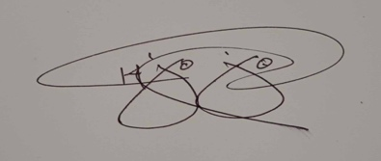

DAN PALACIO GACOSCOSIM
Signature

