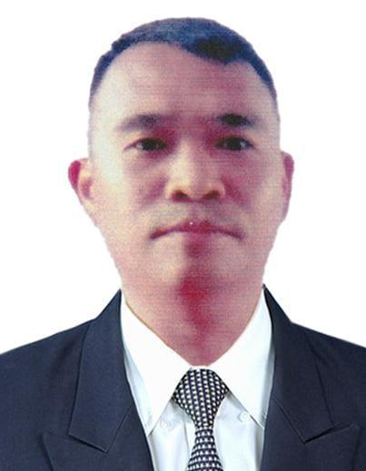

Jofel Cagas Jamodiong

Phone Number: 09703665236

Email: genojiamodiong@gmail.com

Location: Purok Santan, Cabalantian, Manticao, Misamis, Oriental

Nationality: Pilipino

Marital Status: Married

Religion: Aglipay (I.F.I)
Birthday: May 07, 1982

Objective
- To Ensure the client is satisfied with the services performed. Clean and maintain hygienic and tidy Barber station. As the ultimate goal is to build a clientele of repeat customers, as well as new customers through customers referral.
- Skilled in asking for and using customer feedback to make the customer experience better. Dedicated to providing great service and making customers happy.

Work Experience
Genoj Barber  Barber  - Haircutting  - Beard Trimming  - Shaving  - Haircoloring | 01/2018 - Nowadays
ASJ Barber Shop  Barber  - Haircutting  - Beard Trimming  - Shaving  - Hair Coloring | 01/2012 – 12/2015
Headway Barbershop  Barber  - Hair Coloring  - Haircutting  - Beard Trimming  - Shaving | 01/2010 – 03/2011

Reference

Geneve Larigo
Owner: Genoj Barbershop
Tel: 09500053650
Email: genevelarigo@gmail.com
Skill
- Haircutting

- Trimming

- Beard Trimming

- Hair Dyeing

- Shaving
Activities
- Cleaning and sterilizing scissors, comb, clippers, and other instruments. Maintain a clean and organized work area.
- Shape and trim beard and mustache using scissors or a trimmer.
- Cut and trim according to the clients’ instructions.
- Keep up to date with the latest trend and style.
- Barbers regularly learn new skills and techniques to keep up with the latest trends in grooming and hairstyling. They take training to be even better at their job.

