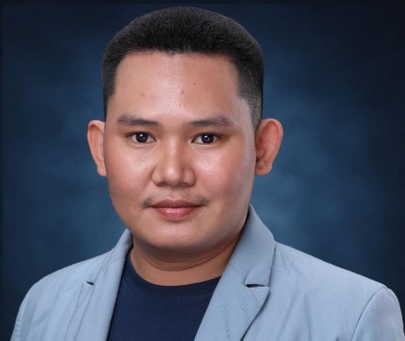
JHALBERT B. BELMONTE
#118 Gen. Tirona Street Bagong Barrio Caloocan City.
Email address: jhalbertbelmonte1992@gmail.com
Contact No.: +639455113939

AIRFRAME AND POWERPLANT LICENSE NO. 132487-AMT

POSITION APPLIED FOR: AIRCRAFT SHEETMETAL TECHNICIAN

JOB OBJECTIVE:
To work in a demanding environment where all my skills and efforts are deployed, to explore and familiarize myself in varied fields, to comprehend my potential, and add to the growth of organization with inspiring performance.

EMPLOYMENT RECORD:

SHEET METAL TECHINICAL INSTRUCTOR
WCC AERONAUTICAL COLLEGE CALOOCAN CAMPUS
WILLIAM SHAW ST. GRACE PARK CALOOCAN CITY
AUGUST 2018 – PRESENT

SHEET METAL TECHNICIAN
AJS3 SHEETMETAL FABRICATION
TAGAYTAY ST. A BONIFACIO CALOOCAN CITY.
MARCH 2016 - 2017

AIRCRAFT MAINTENANCE AND STRUCTURAL REPAIR
ACATECH SUPPORT SPECIALIST,
CAAP APPROVED TRAINING ORGANIZATION
MARCH 2015 - FEBRUARY 2016

JOB DESCRIPTION:

- Efficient at handling different hand and power tools skillfully.
- Fabricate local parts according to manufacturer’s recommendation and approval.
- Laying out works derived from blue prints and working drawings.
- Locates marks reference points on parts/assemblies, structure and sheet metals.
- Selects, measures, shears, cuts, bends, forms sheet metal into various shapes and contours,
Seals, fabricates, fits, inspect components in accordance to drawing specification.
- Drill countersinks, dimples and reams and tap holes for bolting, screws, riveting.
- Perform re-skinning, removal and installation of rivets, patching and splicing.
- Assisting in doing both airframe and powerplant checkups with the engine maintenance section doing removal and installation of work, assembly and disassembly and functional testing.

EDUCATIONAL ATTAINMENT:
BACHELOR OF AIRCRAFT MAINTENANCE TECHNOLOGY
WCC AERONAUTICAL COLLEGE CALOOCAN CAMPUS
2011 – 2015

SALVADOR ARANETA MEMORIAL INSTITIUTE
2004-2008

MORNING BREEZE ELEMENTARY SCHOOL
1999-2004

PERSONAL DATA:

PASSPORT NO. P7713202A
DATE OF BIRTH MARCH 20, 1992
CIVIL STATUS SINGLE
SEX MALE
CITIZENSHIP FILIPINO
HEIGHT 172 CM
WEIGHT 165 LBS.
SPOKEN LANGUAGE ENGLISH|TAGALOG

SPECIAL SKILLS: SOFT AND HARD SKILL

- Sheet metal structural repair
- Aircraft mechanic
- Computer literate
- Meeting deadlines
- Effective teamwork
- Ability to Work Under Pressure
- Good Communication

CHARACTER REFERENCE:

Engr. Jossa Mae G. Medidas
Academic head, WCC Aeronautical college- Caloocan Campus
+639324679527

Julnalyn L. Challoy
Technical Instructor, WCC Aeronautical College- Caloocan Campus
+639152651332

