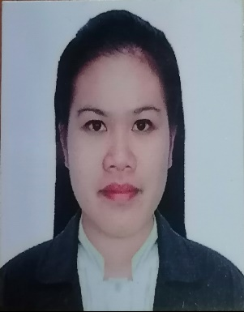
Femie Rose Bartolome Respicio
femieroserespicio@yahoo.com
+639511611362

Present Adress:
Brgy.21 Sta Maria Piddig, Ilocos Norte

Basic Information

Age Birth Date Gender Civil Status
31 Feb. 25,1992 Female Single

Height (cm) Weight Nationality Religion
158 64 Filipino Born Again Christian

Work Experience

Nov. 2020- PRESENT Administrative Aide III
Local Government Unit of Piddig
Government
Piddig, Ilocos Norte Philippines

- Provided support in the areas administration, research and analysis, public relations and communications to the Sangguniang Bayan Member,
- Serve as the Sangguniang Byan Members representative and liaison,
- Serve as a personal assistant to the Sangguniang Bayan Member, handling travel and scheduling, and as office or operation manager.
- Monitored legislation and tracks issues specific to the Sangguniang Bayan Members district and committees,
- Attended meetings and hearings and performs other information gathering duties,
- Performed other functions as maybe required by my immediate supervisor.

April 2014-April 2020 Production Operator
Microwave Optical Semiconductor Taiwan Corp.
Electronics and Semiconductor
Yangmei Taoyuan Taiwan

- Setting up, monitoring, and maintaining machines and equipment used in production lines.
- Feeding raw materials into machines, operating machines, making minor repairs, replacing products, and testing finished products for compliance.
- Read blueprints, performs tests and packing the product for shipping.

Jan. 2013-Jan.2014 Controller
Kookee House Inc.
Bakeshop and Pastry Store
Laoag City Philippines

- Ensuring that all food items, from raw ingredients to final baked products, adhere to set standards.

Educational Attainment

June 2008-April 2012 Mariano Marcos State University
Bachelors/ College Degree
Bachelor of Science in Industrial Education

June 2004-April 2008 Don Salustiano Aquino Memorial National High School
High School Diploma

June 1998-April 2004 Sta. Maria Elementary School
Elementary Diploma

Government Document

Passport ID Number: P9645200B
Place of Issue: DFA Ilocos Norte
Date of Expiration: April 17,2032

Language Tagalog
English

