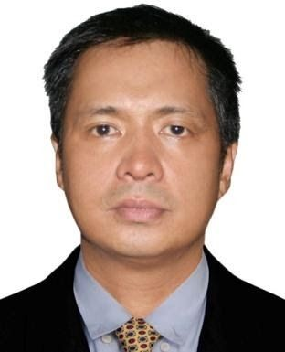
JAYSON CASTILLO NOMINADOR

Brgy. San Joaquin, Sto. Tomas, Batangas Contact No. 0906-348-1627
Email to: jnomi1627@gmail.com

WORK EXPERIENCE:

Warehouse Personnel October 2021 to July 2023

NDM Sanchez Brgy. San Agustin Sto. Tomas,
Builders Development Corporation Batangas, Philippines

JOB DESCRIPTION:
- Facilitates receiving, storing and issuance of materials, equipment, tools & supplies.
- Maintains orderliness and proper storage of materials and supplies.
- Handles the safekeeping of borrowed tools.
- Delivers materials, equipment and supplies to designated Project.
- Handles the inventory, safekeeping, issuance and record accountability of tools and equipment.
- Maintains accurate recording, accounting and controlling of material deliveries and issuance.
- Handles the maintenance, orderliness, security, safe and proper storage & shipping of all materials including complex & controlled substances.
- Create PR request
- Prepares the monthly inventory report.
- Prepares and validates reports/documents pertaining to receipt of delivered items.
- Submits documents to Accounting on payment of delivered items.
- Coordinates with Purchasing and other Project Teams to effective monitoring of orders.
- Facilitates the regular physical materials for counting.

ASIA PRO COOPERATIVE (MDC) Batangas, Phillipines
Warehouse man/Delivery Coordinator October 2014-October 2021

Future Pipe Industries Doha Qatar
Calibration Operator June 2013-June 2014

Ekay Tech Innovative Solution Taoyuan Taiwan
Production Operator/Technician May 2006- Dec.2008

REFERENCES:
Steward Goscoro - Purchasing Manager of NDM Sanchez Builders Development Corporation
Contact: San Ajustin Sto.Tomas Batangas, ndmsanchez.builders@yahoo.com-09175045362

Rhesilyn Tolentino - HRD- Head of NDM Sanchez Builders Development Corporation
Contact: San Ajustin Sto.Tomas Batangas, ndmsanchez.builders@yahoo.com-09175045362

EDUCATIONAL BACKGROUND:

College : STA.ROSA COLLEGE OF BUSINESS AND COMPUTER
Sta.Rosa Laguna

Course : Bachelor of Science in Business Administration (BSBA)
(Undergraduate)

SKILLS:

Knowledgeable in Basic computer technician, and Microsoft programs
  - Excellent communication skills
  - A confident decision-making ability
  - Capable of working under pressure both independently and in a team environment.

Can drive car and motorcycle and forklift
  - Rigger 1 and 2
  - Shield Metal Arc Welder 1

PERSONAL DATA:

Date of Birth : May 27, 1979
Place of Birth : Mabini Batangas, Philippines Nationality : Filipino
Civil Status : Married

I hereby certify that the above information is true and correct to the best of my knowledge and belief.

J ayson Castillo Nominador
Applicant’s Signature

