FULGENCIO J. BERSALUNA JR,
Address: Lot 255 Blk-4 Bagong Silang Sucat Muntinlupa City
Contact Number: 09452895634 / 09551763165 Email: bersalunafulgenciojr@gmail.com
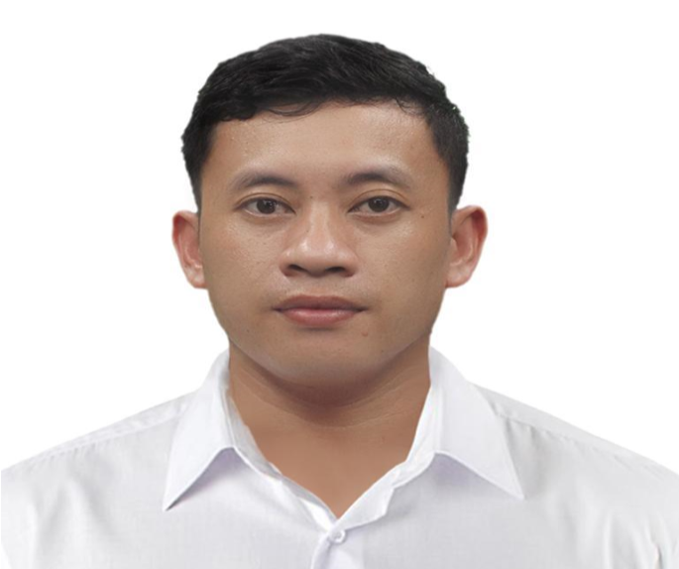
OBJECTIVES: To contribute to the company of the hotel’s customer by consistently maintaining the cleanliness and upkeep of the various rooms or public and facilities.
Summary: Reliable housekeeping worker dedicated to keeping areas clean, organized and tidy.
Knowledgeable about cleaning infection-prone areas such as making bed cleaning bathroom with care and attention to detail. Well organized team player committed to guest satisfaction.

WORK EXPERIENCES:
Housekeeping Attendant at Holland America Line
SHIP MS Volendam
UPL One Fort Santiago, Plaza Santiago Building, Intramuros Manila
January 03, 2023 - June 28, 2023

Duties and Responsibilities

- Clean and supply all assigned areas in accordance with current housekeeping procedures.
- Cleaned and service assigned room or areas according to hotel’s standard and procedure including making bed.
- Maintain all housekeeping equipment and cleaning tools in good working order in the course of performing the assigned housekeeping duties, and to return the equipment in clean condition to the designated area after use.( Some equipment may require sanitizing)
- Collect guest luggage for disembarkation and distribute embarking luggage with care.
- Clean and tidy casino public areas maintain washroom; mop, vacuum dust, wax and strip floor, spray buffing of marble floor. Operate sweeper, scrubbers and pressure cleaner.
- Interact with guests and co-worker in a positive and professional manner.
- Adhere to the ship's relevant health and safety procedure as required.
- Report any safety or maintenance concern to the immediate supervisor.

Public Attendant at Conrad Luxury Hotel Manila (Hilton)
Seaside Boulevard, coral way, Pasay City, 1300 September 14, 2021 – December 16, 2022
Duties and Responsibilities:
- Clean all public areas to the standard required.
- Report any damaged or missing items to the Public Area Supervisor.
- Complete deep cleaning project, as required.
- Answer any Guest inquiries, politely and efficiently.
- Maintain equipment and work areas, including key security.
Public Area Attendant at Capital one Support Services Corp. manila
North Gate Alabang Muntinlupa City July 16, 2017 – August 10, 2021
Duties and Responsibilities:
- Vacuuming floors, dusting and polishing furniture
● Empties ashtrays and urns.
- Swept mopped and removed debris from floor, stairways of assigned areas.
- Sweep and vacuum of carpet, spotting us needed.
- Washes disinfected and replenished public restroom with amenities as needed.

Public Area Attendant at Crimson Hotel Filinvest City Manila
Entrata Urban Complex, Filinvest City, 2609 Civic Drive
Alabang Muntinlupa City, 1781 Metro Manila Philippines February 14, 2014 – June 12, 2017
Duties and Responsibilities:
- Keeps the front of the hotel free from trash.
- Cleaned and maintained restaurant and banquet halls.
- Cleaned rugs, carpet and upholstered furniture using vacuum cleaner, broom and shampoo machine.
- Substantial experience of performing cleaning and upkeep of assigned public areas.
- In-depth knowledge of housekeeping and customer services practices.
- Ability to understand and fulfill guest’s service requests promptly.
- Remarkable knowledge of company safety, cleanliness, and grooming standards.
Skills:
- Strong time management skill and proven history of the workplace punctually.
- Attention to Detail and meticulous use of proper safety procedure.
- Experience with a variety of cleaning products and tools.
- Good interpersonal and communication skills.
● Self-directed and motivated.

Personal Information:
Date of Birth: September 07, 1987 Birth Place: Malabuan, Makilala Cotabato
Age: 34 Civil Status: Single
Citizenship: Filipino Religion: Roman Catholic
Weight: 60 klg Height: 5’4”
Language Dialect: English, Tagalog, Visaya

EDUCATION AND TRAINING
Enderun Colleges, McKinley Hill, Taguig City, Philippines
Housekeeping Training Course
October 24-28, 2022

Vocational Course: TECHNICAL EDUCATION AND SKILLS DEVELOPMENT AUTHORITY
NATIONAL CERFICATE NC II in HOUSEKEEPING
Certificate No: BFJ-87-327-12098-001
Issued on : September 06, 2022
LAS PINAS MANPOWER TRAINING CENTER, Padre Diego Cera Ave., Pulanglupa Uno, Las Pinas
CERTIFICATE OF TRAINING IN HOUSEKEEPING
March 16, 2019 - June 28, 2019

Secondary Education: San Roque High School
Sy: 2001-2005
Primary Education: Malabuan Elementary School
Sy: 1994-2000

CHARACTER REFERENCES:
Barry Raposon Ebora
09084860546
Assistant Chief Housekeeper at MSC Mata Seaferers Company Limeted
Syril De Guzman Benido
09278044083/09392874506
Asst. Executive Housekeeper at Conrad Luxury Hotel Manila
Lysander Cesar
09562291140
Housekeeping Supervisor at Conrad Luxury Hotel Manila
I hereby certify that the above information given are true and correct to the best of my knowledge and belief.
FULGENCIO J. BERSALUNA JR, APPLICANT

