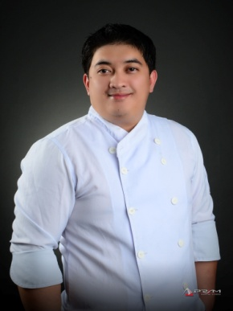
Minandro B. Dulag
Address: KM5, Central Balili, La Trinidad, Benguet
Phone: +639 297 969 141
Email: lifshram@gmail.com
Skype or Zoom ID: live:lifshram
Marital status: Married
Number of children: 1
Ages of children: 11 years old
Birthdate: April 25, 1986

SUMMARY OF QUALIFICATIONS

- Almost seven years of experience in food industry working as a chef and baker
- Strong background in cooking, baking, menu planning, staff organization
- Proven skills in cookery
- Demonstrated ability to work under pressure and multi-task
- Professional communication skills include fluency in English and Filipino

WORK HISTORY

Head Chef, Co-owner 08-2016 to Present
Ghasats Resto
Benguet, Philippines

- Constructing menus with new or existing culinary creations ensuring the variety and quality of the servings
- Preparing, seasoning, and cooking all food served
- Planning, preparing, and cooking for big events including both private and government functions
- Directing food preparation process and any other relative activities
- Training kitchen team on how to properly prepare and cook the food on the menu
- Directing, supervising, and evaluating work of all kitchen staff
- Approving and polishing dishes before they reach the customer
- Ensuring team meets service, productivity, and quality goals
- Planning orders of equipment or ingredients according to identified shortages
- Complying with nutrition and sanitation regulations and safety standards

Baker 09-2015 to 08-2016
Health100 Restoreant
Baguio City, Philippines

- Opened the bakery early in the morning
- Cleaned kitchen equipment and tools before use
- Baked different bread types such as cinnamon, loaf, and cakes
- Adjusted oven temperature and ensure proper baking
- Recommended recipes to renew the menu
- Tracked food supplies and place orders, as needed
- Cleaned and organized properly all baking equipment including oven, mixers, proofers, floors, freezers, and refrigerators,

Baker 12-2014 to 06-2015
Café by the Ruins Dua
Baguio City, Philippines

- Prepared, produced, and baked breakfast pastries, breads, rolls, and some desserts
- Shaped dough to prepare different types of pastries including croissants, cookies, and sweet rolls
- Prepared custom-made pastries based on customer’s preferences
- Mixed various ingredients to create fillings for cakes and breads
- Set time and speed controls for mixing machines or blending machines
- Kept spoilages to minimum by ordering and utilizing proper quantities and rotating products

EDUCATION HISTORY

Bachelor in Hotel and Restaurant Management June 2006- April 2008
Undergraduate
University of Baguio, Philippines

Lepanto National High School June 2002- March 2006
Mankayan, Benguet, Philippines

Lepanto Elementary School June 2001- March 2002
Mankayan, Benguet, Philippines

TRAININGS

BREAD AND PASTRY PRODUCTION 2014
Baguio City School of Arts and Trades, Philippines

EXECUTIVE CERTIFICATE IN PROFESSIONAL CULINARY ARTS 2015-2016
Honours of Mastery in Sauces
COOKERY
SKD ACADEMY, PHILIPPINES

REFERENCES
GLYDEL SHANE AMOR
Assistant Manager, Gestdan Centrum
+639 260 856 696

DESSA MAE PARAN
General Manager, Ghasats Resto
+639 457 718 403

PAUL BAGANO
Proprietor, Alapu Restaurant
+639 493 649 622



