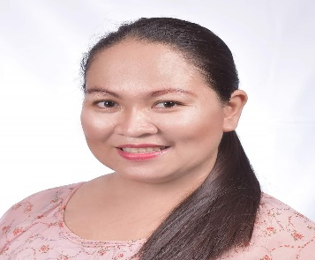

rorena o. pia
09702756969
rorena.pia@deped.gov.ph

Address: Purok Dahlia Coronon, Sta. Cruz, Davao del Sur
Date of Birth: September 5, 1984
Age: 38 years old
Place of Birth: Nabunturan Compostela Valley Province
Sex: Female
Religion; Catholic
Nationality: Filipino
Spouse: Jonathan C. Pia
Children: Joshua Reyian O. Pia
Jiana Alleya O. Pia
Jewel Bless O. Pia
Parents:
Father: Salvador Cadiz Olvina Jr.
Mother: Parona Quijada Olvina

Education

College:
University of Southeastern Philippines April 08, 2005
Bachelor of Secondary Education
Major in Physical Education, Health, Arts and Music (PEHM
Bo. Obrero, Davao City

Secondary:
Bernardo D. Carpio National High School March 2001
Buhangin, Davao City

Elementary:
Buhangin Central Elementary School March 1997
Buhangin, Davao City

PROFESSIONAL EXPERIENCE

July 3, 2013 to Present Department of Education
Division of Davao del Sur
Federico Yap National High School

Position: Secondary School Teacher 1
MAPEH Teacher
Federico Yap National High School
CORONON EXTENSION

certificates

Integration of Comprehensive Sexuality Education
Department of Education
April 19, 2022
Sta. Cruz Davao del Sur

Division Echo- Workshop on Responsible Parenthood and Reproductive Health (RPRH)
September 19-21, 2018
Department of Education
Division od Davao del Sur
Digos City, Davao del Sur

Orientation on Gender and Development
October 24, 2017
Provincial Population Office
Provincial Government of Davao del Sur

Sexual Harassment and Uniform Rules Education (SHURE)
Civil Service Commission
November 11, 2009
Sta. Cruz Davao del Sur

Career Workshop
LDS Employment Resource Service
December 4-5, 2006
Davao City Philippines

Reference:

Mr. Calito D. Ramos
School Principal II
Federico Yap National High School
Astorga Sta. Cruz Davao Del Sur
+63 955 549 0387

Mr. Abdulpatta U. Kamdon
District Supervisor
Sta. Cruz North District
Sta. Cruz Davao Del Sur
+63 927 600 1646

