IRENEO U. ORPIANO JR.
Production Engineer
ABOUT ME

I am an energetic, ambitious person who has developed a mature and responsible approach to any task that I undertake, or situation that I am presented with. As a graduate with 17 years of experience as leader in the production line, I am excellent in working with others to achieve a certain objective on time and with excellence. In my previous role, I improved the performance, operations and productivity of my team.

WORK EXPERIENCE

Production Engineer Jan. 2021 – Oct. 2021
Asia Brewery Incorporated

The Production Engineer is responsible in planning, leading, organizing and controlling resources of the department to meet production target at optimum cost. Directs the activities in keeping the machines and equipment in good running condition. Formulates measures to improve production methods and equipment performance.

- Direct/monitor production activities to ensure operation efficiency, output quality and minimize downtime and losses on a daily basis.
- Monitor the actual operations of the line according to the standard operational procedure.
- Supervise/control production personnel.
- Directly coordinates with various sections and departments regarding the supply and adequacy of packaging materials and other operational requirements in preparation for the scheduled production.
- Ensure that all manufacturing equipment and machineries are properly operated and within the prescribed running conditions.
- Establish work schedule, methods, procedures and priorities.
- Comply, maintain and promote a safe working conditions and safe practices within workplace.
- Perform other duties and tasks that may be assigned from time to time that support company and team objectives.

Technician 2 Nov. 2016 - Dec. 2020
AB Heineken Philippines

The Technician 2 is responsible to ensure safety agenda is implemented in the daily job. Operate simple and complex machines. The process and product related tasks are executed in a quantitative way. Improve the key performance indicators and production losses, leading to a safe working environment on machine and work area.

- Works in line with the defined and implemented safety and food safety standards. Following the 5s, Housekeeping and HACCP related to the work place.

- Ensure the execution of SHE objectives, in line with the applicable procedures, standards and regulation.
- Implementation o safety procedure on the daily activity.
- Reporting of near-miss, unsafe condition and behavior.
- Implement personal hygiene.
- Implement cleaning of equipment, production facilities and workplace in daily activity to meet hygiene standard.

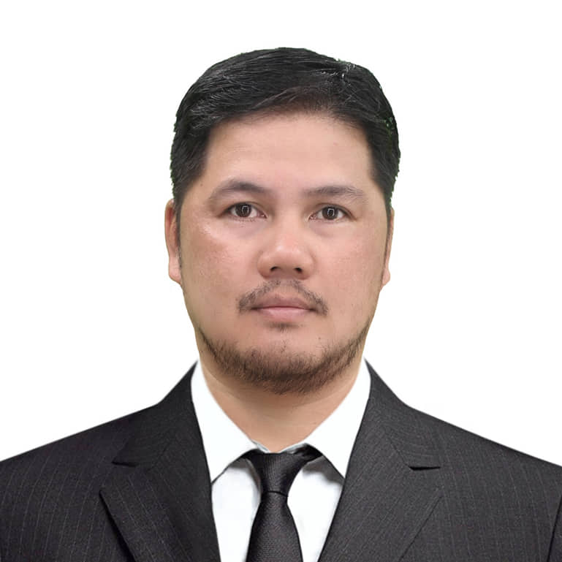

CONTACT

Mobile:
0908 134 6279

Address:
19A Wisconsin st. Town and Country, Southville, Sto. Tomas, Biñan City, Laguna

Email:
neo.orpiano @gmail.com

EDUCATION

BS MECHANICAL ENGINEERING
June 1997 - April 2003
Mapua Institute of Technology
Intramuros, Manila

PERSONAL SKILLS

- Co-operation

- Communication

- Organizing

- Leadership

- Critical -thinking

REFERENCES

Mr. Reden Pitogo
Team Leader (Former)
AB Heineken Philippines

Mobile:
0917 125 9421
0942 569 6776

Email:

CONTACT

Mobile:
0908 134 6279

Address:
19A Wisconsin st. Town and Country, Southville, Sto. Tomas, Biñan City, Laguna

Email:
neo.orpiano @gmail.com

EDUCATION

BS MECHANICAL ENGINEERING
June 1997 - April 2003
Mapua Institute of Technology
Intramuros, Manila

PERSONAL SKILLS

- Co-operation

- Communication

- Organizing

- Leadership

REFERENCES

Mr. Reden Pitogo
Team Leader (Former)
AB Heineken Philippines

Mobile:
0917 125 9421
0942 569 6776

Email:

IRENEO U. ORPIANO JR.
PRODUCTION ENGINEER

- Makes timely supply of all packaging, auxiliary material and chemicals on the line. Makes all the quality checks in line with the standards and procedures on simple and complex packaging machines.
- Keep overview of the whole process and act as needed.
- Ensure that all manufacturing equipment and machineries are properly operated and complying to rules, standard and procedure.
- Measure and record losses (materials, utilities, extract loss, etc.) and propose corrective action.
- Execute tagging process, CILT and applies problem solving tools. Participates and start leading the improvement teams.
- Performance of Autonomous Maintenance and Planned Maintenance.
- Finding abnormalities proactively.
- Proactively implement TPM in daily activities, e.g. (5S, HOC, CILT Audit, RCFA, OPL, etc.)
- Proactively conduct self-learning and development to increase competency level.
- Implementation of new standards.
- Contribute to reach planned KPI Targets.
- Create, revise and update Standard Operating Procedures (SOPs) as per ISO requirements.

- Executes all packaging operations on simple and complex machines in line with the valid standards. Manages documentation and reporting for the working area.
- Measure and records quality controls parameters.
- Reporting non-conformity and propose corrective action.
- Identify and highlight problems. Provide solutions, coach and train operators.

- Operates the simple and complex packaging machines (e.g. palletizer, depalletizer, packer, unpacker, crate washer, carton packer, bottlewasher, EBI, filler, labeler and pasteurizer).
- Machines are running the desired speed and performance.
- Monitor and ensure the availability of packaging materials needed.
- Record and report all machine stoppages and intervention. Propose corrective actions and countermeasures.

Production Engineer June 2004 - Nov. 2016
Asia Brewery Incorporated

The Bottling Production Engineer is responsible for ensuring that finished products are of the best quality by directly implementing Bottling Production policies and procedures within his area of responsibility.

- Directly coordinates with various sections and departments regarding the supply and adequacy of raw and packaging materials and other operational requirements in preparation for the scheduled production.
- Ensure that all full goods are of the best quality and are properly accounted for.

IRENEO U. ORPIANO JR.
Production Engineer
RENEO U. ORPIANO JR.
Production Supervisor

- Monitor all full goods stacking area and ensure that all full goods are properly tagged and recorded.
- Monitors and records losses caused by breakages, inverted reject, foreign bottles, bad labels etc., and ensure that they are properly tagged and accounted for.
- Gathers and ensure accuracy of data needed for the formation of periodical production reports.
- Coordinates with various departments for the disposal/placement of raw and packaging materials no longer needed in the operation.
- Ensures that assigned machine lines are in optimum working condition.
- Directly monitors all materials and utilities withdrawal and consumption to ensure proper and effective utilization.
- Directly supervise and monitor the schedule and performance of assigned personnel to ensure that they are properly and effectively utilized and in conformance with the established standards, procedurews and work instructions.
- Ensure proper acceptance and turnover of duties and responsibilities to the succeeding team.
- Directly implements Good Manufacturing Practices (GMP).
- Maintain proper order, safety and cleanliness within area of responsibility.
- Performs other duties and tasks that mat be assigned from time to time that support Company and team objectives.

CARREER ACHIEVEMENTS

Steam Consumption Reduction (KAIZEN) May 2021 -Oct. 2021

Supervise and support the team on the KAIZEN activity wherein
the team able to surpass the target of 15% reduction on steam consumption of the Pasteurizer machine.

Operational Risk Reduction (ORR) Mar. 2020 - July 2020

Lead the Operational Risk Reduction (ORR) activities in the department. The activity reduces the residual risk of the machines in the production area into acceptable risk level and developed safety standards and procedures.

Machine Total-Clean-Out (TCO) July 2019 - Aug.2019
Lead the team in the implementation of TCO (Total-Clean-Out) of machines in the production area. This resulted to improving the machine performance and developed operators deep understanding on their respective machines.

CONTACT

Mobile:
0908 134 6279

Address:
19A Wisconsin st. Town and Country, Southville, Sto. Tomas, Biñan City, Laguna

Email:
neo.orpiano @gmail.com

EDUCATION

BS MECHANICAL ENGINEERING
June 1997 - April 2003
Mapua Institute of Technology
Intramuros, Manila

PERSONAL SKILLS

- Co-operation

- Communication

- Organizing

- Leadership

REFERENCES

Mr. Reden Pitogo
Team Leader (Former)
AB Heineken Philippines

Mobile:
0917 125 9421
0942 569 6776

Email:

