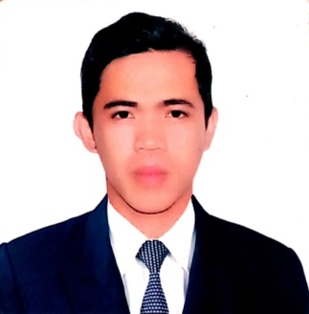
DIJI A. AGUSTIN
Baybay, Aguilar, Pangasinan
dijiagustin0330@gmail.com
09776691801

OBJECTIVE:
To be able to work for a position that fits my skills, knowledge, potentials and interests which would be of great help to your prestigious company.

WORKING EXPERIENCES:

HOUSEKEEPING
Princess Cruise
October 20, 2016 – Present
MAGSAYSAY MARITIME, INC.
Ermita, Manila
ROOM ATTENDANT
April 6, 2015 – April 5, 2016
BAYVIEW PARK HOTEL
Roxas Blvd. cor. UN Ave., Manila

SERVICE CREW
September 10, 2013 – March 30, 2015
JOLLIBEE FOOD CORPORATION
Carmona, Cavite

JOB DESCRIPTIONS:

- HOUSEKEEPING
To maintain the clean, sanitary, comfortable and tidy environment for either private households or commercial business establishments, maintaining the cleanliness of the ship and cleaning the cabins

- ROOM ATTENDANT
Responsible for cleaning and servicing guest rooms in order to provide a pleasant and comfortable experience for guests

- SERVICE CREW
Prepare and serve food, process customer payments and provide customer service

EDUCATIONAL ATTAINMENT:
TERTIARY: BS Hospitality Management
Pangasinan State University –Lingayen Campus Lingayen, Pangasinan
S.Y. 2008-2012
SECONDARY: Camiling Collges
Camiling, Tarlac
S.Y. 2004-2008
PRIMARY: Baybay Elementary School
Aguilar, Pangasinan
S.Y.2001-2007

PERSONAL INFORMATION:
Age : 30
Birthday : March 30, 1990
Birth Place : San Carlos, Pangasinan
Nationality : Filipino
Religion : Roman Catholic
Gender : Male
Civil Status : Single

TRAININGS AND SEMINARS ATTENDED:

  - SEMINARS

- STAY& LEARN SEMINAR ON FRONT OFFICE MANAGEMENT
August 12-13, 2011
Microtel Cabantuan
Nueva Ecija

- STAY& LEARN SEMINAR ON HOUSEKEEPING OPERATION
August 12-13, 2011
Microtel Cabantuan
Nueva Ecija

- STAY& LEARN SEMINAR ON TRAVEL & TOUR OPERATION
August 12-13, 2011
Microtel Cabantuan
Nueva Ecija

  - ON THE JOB TRAINING 5400 Hours)

- THUNDERBIRD RESORTS
November 28, 2011 – February 10, 2012
F&B HOTEL DEPARTMENT

I hereby certify that all the above mentioned information are all true, correct and give to the best of my knowledge and belief. Any false information may be cited valid reason to render this application void.

DIJI A. AGUSTIN
Applicant

