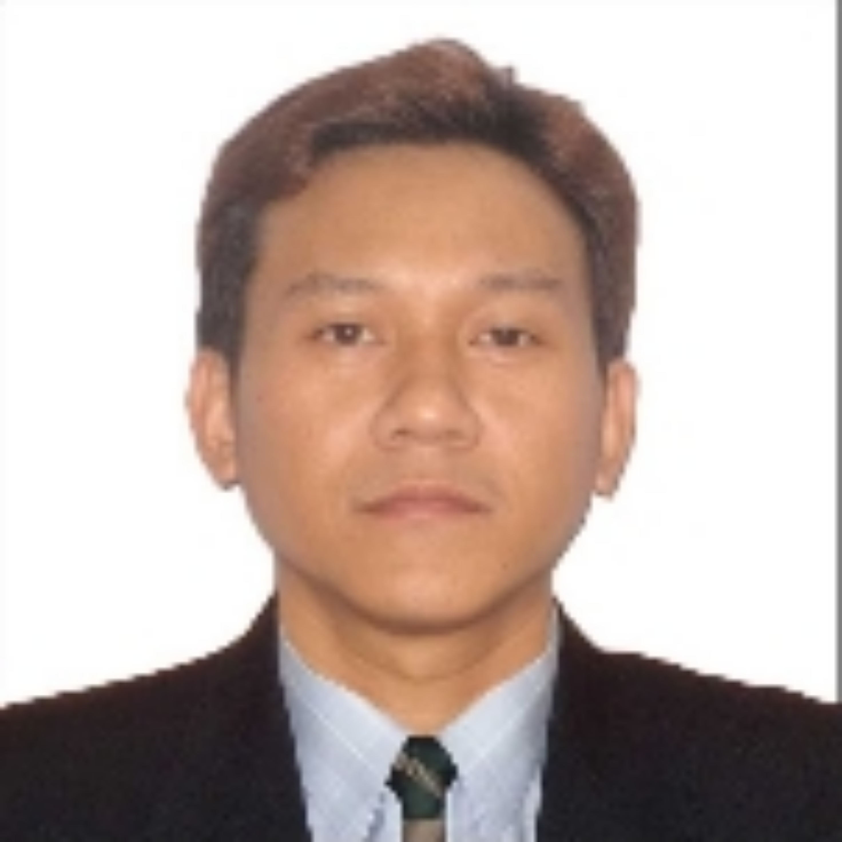
ROBERT CHENG GO
Mob no. +63 921 076 4313
Email: rcheng.go@gmail.com
Address: Lupang Arenda, Sta. Ana Taytay

SUMMARY
As a highly motivated and creative individual, I aspire to provide exceptional services in any field that suits my job while utilizing my knowledge skills.

PROFESSIONAL EXPERIENCES

Supervisor/Barista, Dec - 2019 to Dec- 2023, Abyan Co. Ltd Dammam, Saudi Arabia
- Accomplishes staff job results by coaching counseling, and disciplining employees. Plans, monitors, and appraises job results.
- Conducts training. Implements and enforces systems, policies, and procedures.
- Provide customer service for positive outcome
- Greeted guest in a friendly manner as they entered and informed about daily coffee and specialty
- Keep the restaurant, line, backroom clean and tidy all the time
- Tracking and ordering inventory for café and beverages supplies
Production worker/Operator, Mar - 2019 to Sept - 2019 Comfoods Reliance
- Operate machine for repacking
- Properly check of heat in oven 1-5
- Check cookies/biscuit spread, weight, height, color and texture.
- Proper maintaining of equipment and machine for daily use
Crew in Charge/Barista, Oct-2016 - Oct-2018 Tim Horton, Dammam Saudi Arabia
- Managed and planned weekly and monthly inventory.
- Planned and prepared purchase orders.
- Daily calibration of equipment’s.
- Welcomed guests into the coffeehouse by determining their needs and interests.
- Promoted coffee consumption through educating customers with recommendations based on their preferences.

Coordinator Support Services, Jun-2010 - Mar-2016 Riyadh International Catering Corporation (RICC), Saudi Arabia
- Scheduled McDonalds-RICC facilities' maintenance to ensure adherence to all regulations.
- Made sure all divisions/departments had the necessary office supplies according to RICC standards.
- Evaluated the level of service provided after maintenance work was completed by inspecting facilities/equipment against McDonald's-RICC standards.
- Trained three administrative assistants in customer service procedures while maintaining other office procedures as well as organizing an office transition from paper invoices to online ones.
- Created a weekly schedule for visiting villas along with handling the process of acquiring a Saudi License for employees; arranged department monthly budgets.
Store Activity Representative (STAR) Nov-2008 - Jun-2010 Riyadh International Catering Corporation (RICC), Saudi Arabia
- Held various positions including hosting events such as birthday parties both inside/outside the restaurant while ensuring kid night activities were conducted properly resulting in satisfied customers

EDUCATION
Associate in Computer Technology, STI College Recto, (2004-2006), Graduate.

ADVANCED SKILLS
Can work under-pressure Flexible & Fast learner Self-motivated
Excellent communication Team Leader Time Management
Driving skill (Saudi License) Customer Service

PERSONAL PROFILE
Date of birth : January 10, 1984
Nationality : Filipino
Language : English, Basic Arabic

