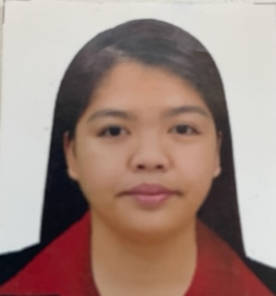
RUFFA A. MANA-AY R.N
PHONE NO: 09283344465
EMAIL ADD: ruffaamar@yahoo.com

PROFESSIONAL SUMMARY
I am a registered nurse for 10 years, with 3 years of clinical practice in senior facility/home as a private duty Nurse. A Staff nurse for 6 years up to present in a government hospital with a 500-bed capacity. I was assigned at pediatric ward for 1 year and at ER nurse for 5 years up to present. May areas of expertise are Geriatric, Pediatrics and ER cases. As an ER nurse we handled different cases like Surgery/Trauma, Medicine, Pediatrics, EENT and Optha patients.

work experienced
Nurse II
Rizal Medical Center
May 4, 2020- present
Duties and Responsibilities:
- Responsible in delegating nursing assignment and duties.
- Monitored patients flow during admission and discharge.
- Supervised the ER team.
- Addressed patient or relative concerns and complains.
- Oversee patient care in ER and referred to medical team.
- Maintain the adequate medical supplies and emergency medication.

Nurse I

Rizal Medical Center
October 2016–May 4, 2020
Duties and Responsibilities:
- Administered medication.
- Facilitated admission to wards
- Carry out doctors’ orders.
- Assist doctors during intubation and code.
- Assist patient’s needs.

Private Duty Nurse

Home Health Care
January 24, 2013– July 25, 2016
Duties and Responsibilities:
- Assigned at the Senior Residential Facility to provide nursing care and to make the elderly/medically fragile feel comfortable in a home setting.
- Deployed at patients homes for home health services assisting families with the day-to-day requirement to manage patient condition, including administration of complicated health care procedure normally done only in the clinic or hospital.

license/ EDUCATION
Registered Nurse
Since 2012

Bachelor of science in Nursing
University of Iloilo
Batch 2011

